NEWSLETTER 1/2024

We did it again! What an amazing day we had on Friday, 23 February. It was Siyabulela Pre-Primary’s 11th Golf Day and it was a lovely day for a game of golf. Once again we were blessed with a very successful Golf Day and raised R59 000 at the auction of which R32 000 was raised for projects we still want to do at the school.

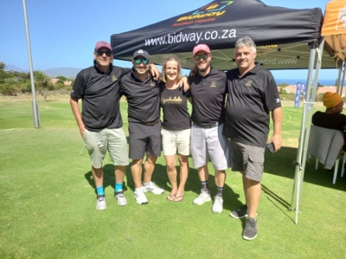
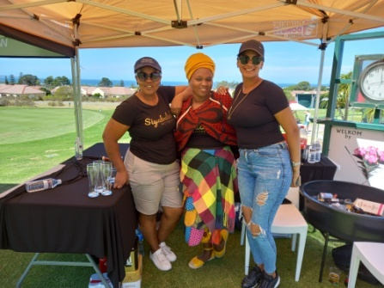
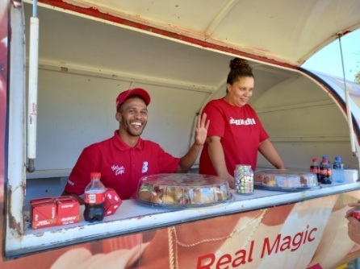

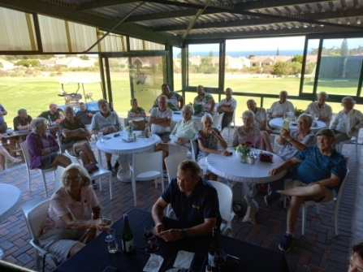
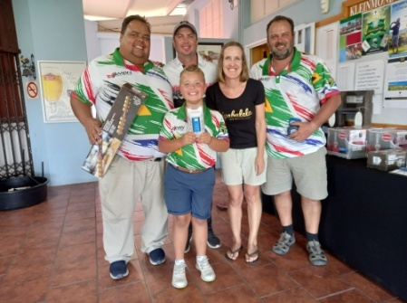
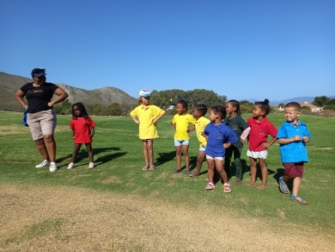

Everyone came with open hearts to support this event. There were 54 players who took on the golf course and later we we’re joined by more people who came to enjoy the dinner and auction. We would like to thank everyone who helped make this day a big success. Then to all our players, who are like family, it was lovely having you there. Last but not least, a big shout out to all our sponsors. Without all of these roll players the day would not have been possible.

Sponsors: Albertyn Apteek, Alto, Amanda Human, Arabella Golf Club, Ataraxia, Bellevue, Beyerskloof, Bidway (Stef Olivier), Bouchard Finlayson, Build It, Cabet du Toit, Cape Dry Padstal, Child Welfare Kleinmond, Corrie Gerber, Devonvale, Evert Cilliers, Kleinmond Golf Club, Kleinmond Spar, Leeuwenkuil, Mooiplaas, Newton Johnson, Sasol Kleinmond, Vriesenhof, Zidela Wines.
Siyabulela! We thank you!

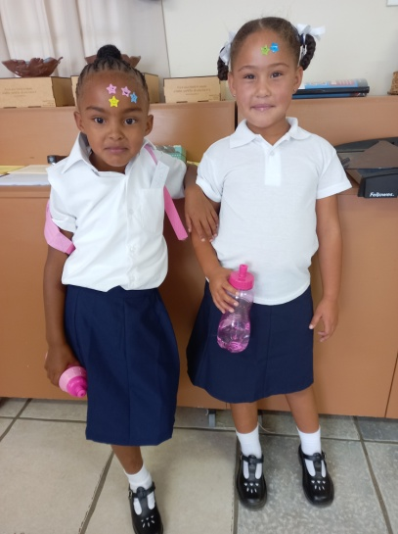
Our beautiful children who are in Grade 1 this year!
Each year when the school starts, our children who are in
Grade 1 will pass by the school all dressed up in their brand
new school uniforms.

We always hear good things about our children attending
the Primary school. They perform well and the parents say
that at the certificate evenings, Siyabulela’s children gets
the most certificates. If you look at all the stars on their
foreheads, you can see they are clever children.

That is why parents want their children to come here,
because they see results.
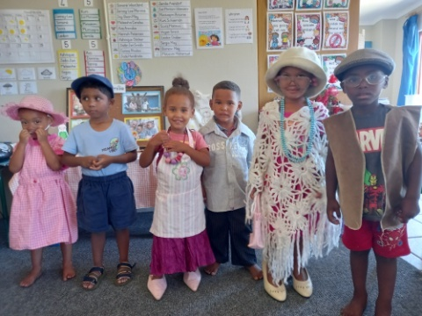
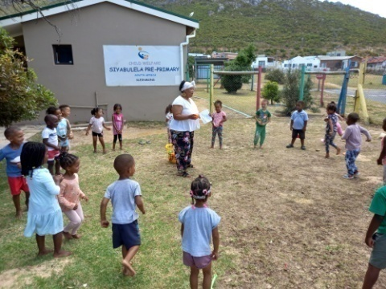
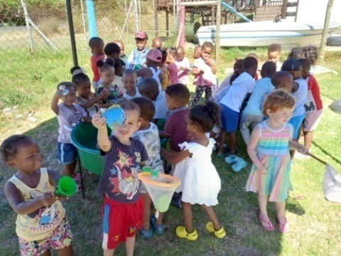

Every day we are busy in and outside the classes, because with everything else going on, the daily program must go on. We are working, eating, talking, listening, singing, dancing, sleeping and playing!

It takes a while for our new children to adapt to the new routine of being in school, but once they are used to it, they are happy children. They love being at school. Above we have a picture of water play, movement and music time.

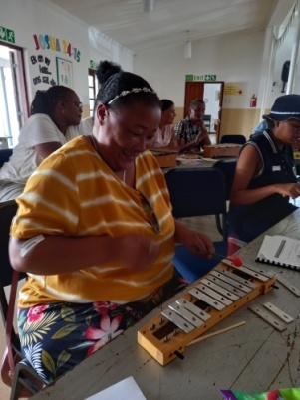
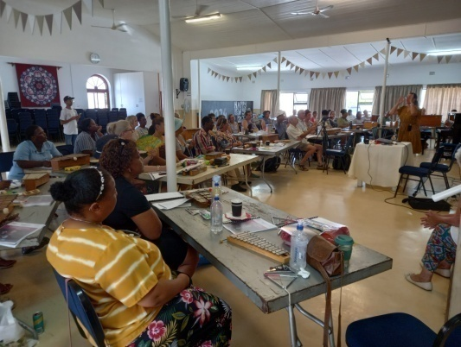
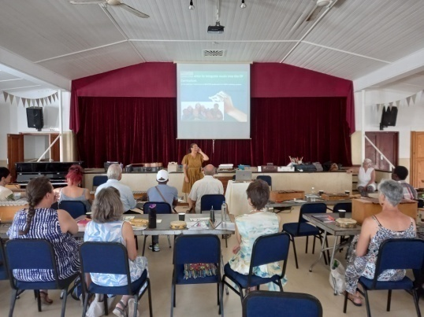

We started early this year with our first training. In January, Handevat Music, did training on music in Early Childhood Development. We are big on music and movement, so always keen to learn and share new ideas.

It was a very interactive workshop, so there were a lot of dancing, playing instruments and moving. On the picture Reese is busy playing on the xylophone. Reese in one of the Grade R assistants. The assistants and students always get the same opportunities as the staff, so they can also equip themselves for the future.

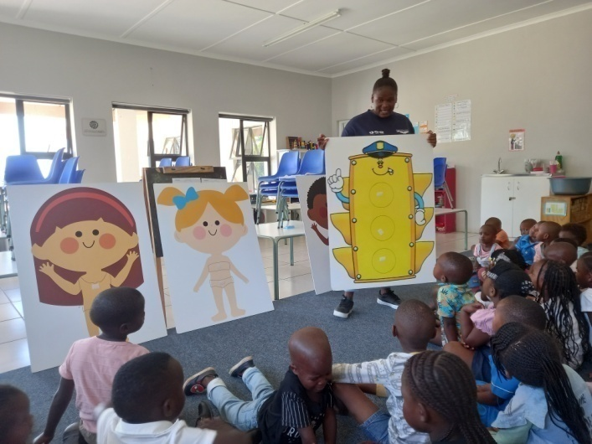
Mandlakazi, a social auxiliary worker, from
Hermanus came to do a body safety aware-
ness program with the children.

She talked very open and honest to them.
We could see in the way the children re-
sponded that they have a need to talk
about things grownups don’t usually want
to talk about.

In the times we live in, it is a very important
subject to discuss with all children.

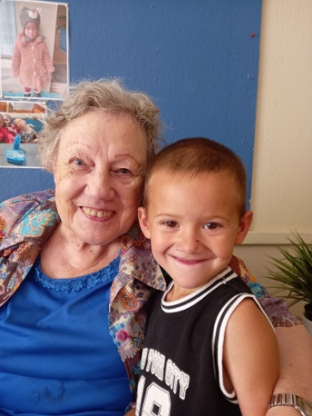
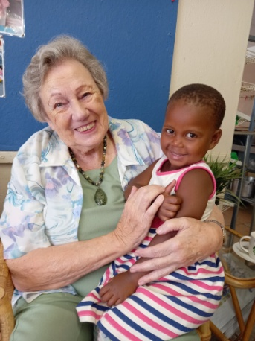
Then I just felt like sharing with you these
two photos of tannie Corrie with two of our
sponsored children.

Our sponsor children come from different
circumstances. Some of them have lost
either their mum and/or dad and are being
looked after by family. Some of them have
a single unemployed parent. Some are
from the Youth Care Centre in town and
some of them just have no one who looks after them properly and care for them. These are always the children who need to be in school most. To come to a place where they get fed, educated and loved. We have a big sponsorship group who gives these children the opportunity to be in school. Thank you for making a difference in these children’s lives on a daily basis. Some of our sponsored children...

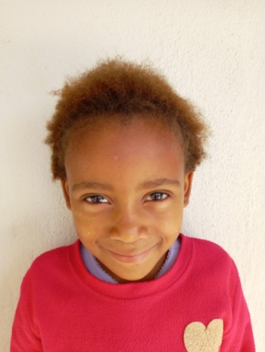
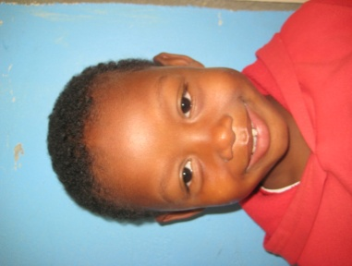
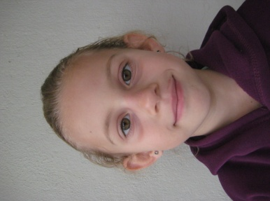
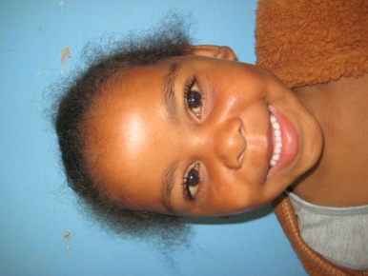
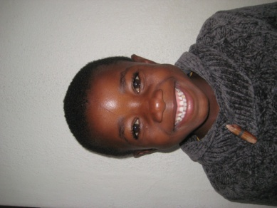

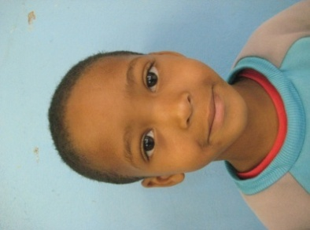
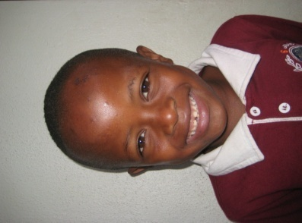
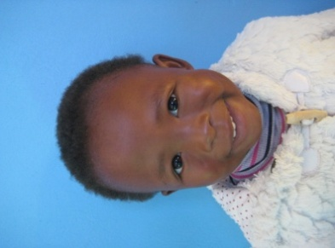

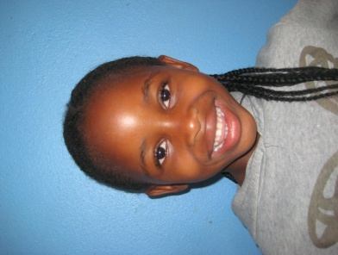
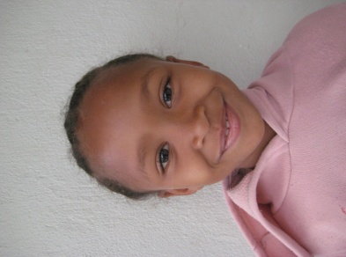

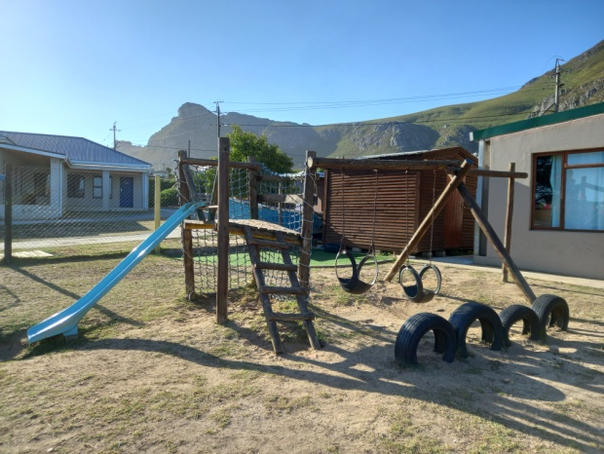
Before and after... At our Golf Day I put up a lot
of before and after pictures of different projects
we did at school. There were pictures of class-
rooms, kitchen equipment, grass, trees, paint
inside and outside, a new roof, chairs, carpets,
Wendy houses and our new jungle gym.

These projects were all made possible because
of donations made by individuals, organisations
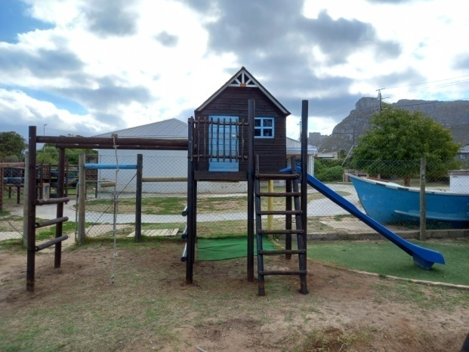
or companies. Without all these people in our
lives we would not be where we are today.

And as Jay Weatherill said: “I believe that in-
vesting in our children’s development from the
earliest age is the single most important contri-
bution we can make...”

The jungle gym on the left was sponsored by my sister
and her family.
After years of not competing against each other, Heideland and Siyabulela, had
an athletic day together this term. The community came out in numbers to support this event. The preschool children ran, parents and teachers ran and the bigger children also had a turn.

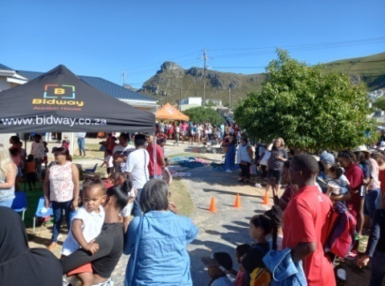
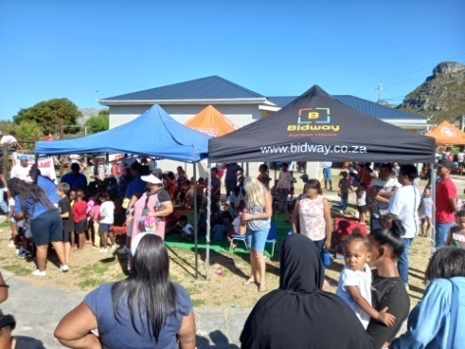
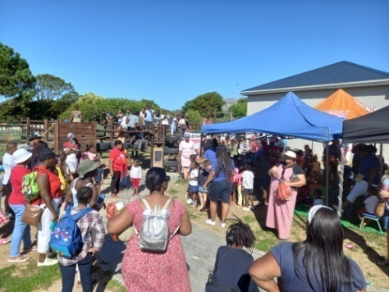
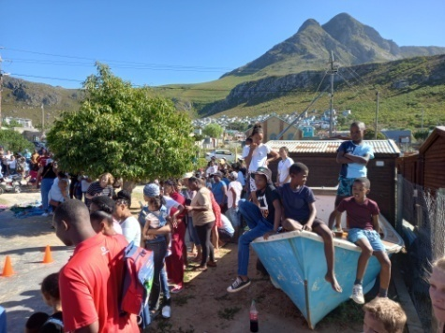
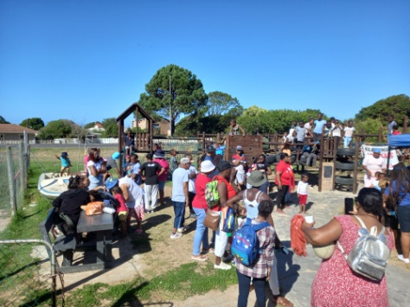

We had a tuck shop, boerewors roll sales and face painting. The face painting was very popular. After the event was over, there were children lining up for that. It was a very exciting morning and enjoyed by everyone who attended.

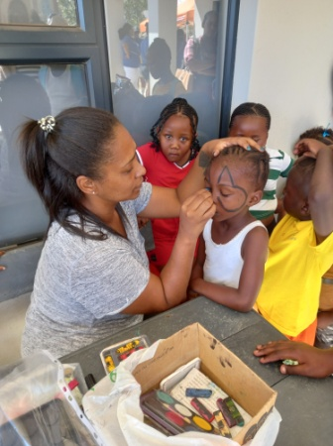
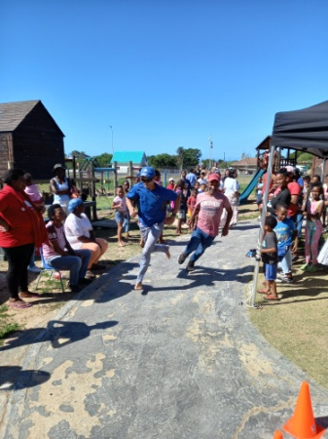
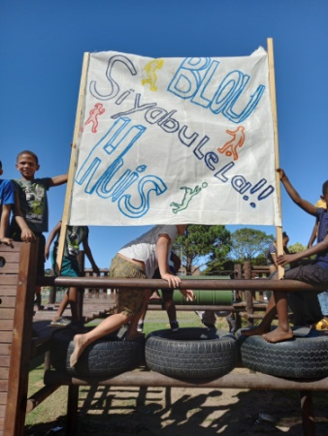
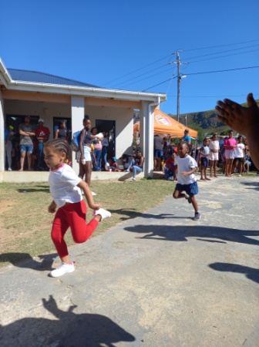

Thank you for taking your time to read our Newsletter. We know everyone has busy lives and appreciate each and every one of you who are part of our family and are interested in what is happening at the school.

We wish you all the best for the rest of the year.

All our love

Alta, the staff and children of Siyabulela Pre-Primary

Our wish list:
- Varnish for our Wendy houses and jungle gyms.
- Compost for our grass (R10 000).
- Building cement box for corrugation taps (R1 000).
- Small toilet for 3-4 year class.
- Carpets for some classrooms.
- Paving and shading for our ‘outside’ classroom.
- Natty Rubberising bicycle track: R300 per square meter.
- Higher fencing around our school to prevent breakings.
- Second hand items for our shop (old bedding, towels, kitchenware,
clothes etc.).

As I said before, we made R32 000 for projects on our wish list, so watch this space...
- A big tree for out playground.
- Mural for Grade R classrooms’ wall (still need R10 0000).
- Mud kitchen for outside play area (still need around R5 000).

Before:

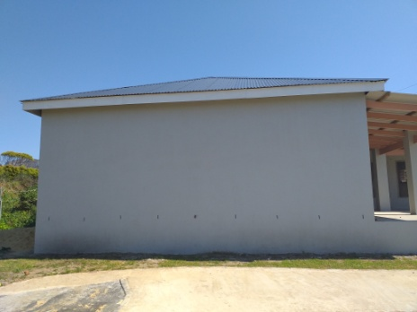
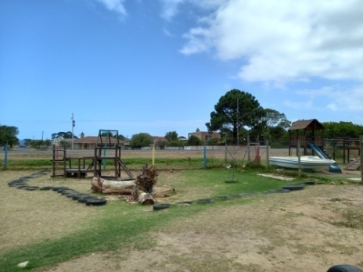
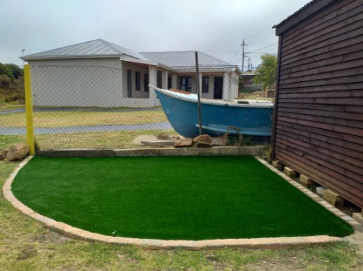

Inset:
We celebrated Valentine’s Day by wearing red, white and pink. We took pictures of all the children, because they all look beautiful!
