NEWSLETTER 1/2025

Wow! Wow! Wow! What a first term it’s been, as you will see in this longer than usual Newsletter. I don’t know if it’s because I’m getting older or if the years are just busier and going by faster. But being busy means being blessed, so I can’t complain.

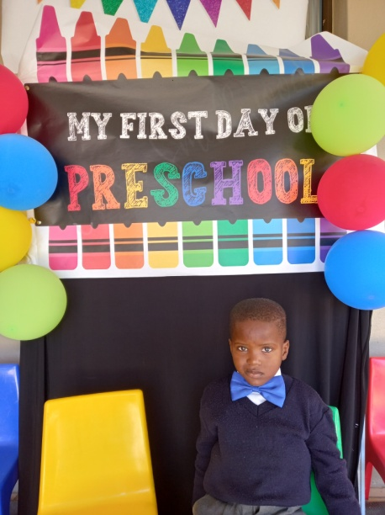
We always start the year with all our new children. For
some of them this will be their first year in a school, so
their first time away from home. You can imagine how
much of an adjustment this is for them.

So in the beginning of the year there’s lots of tears, but
as they adapt to school the smiles start coming and
they start enjoying school.

We had a beautiful photo corner we made for them this
year and it was also to welcome them. Parents could
take pictures of their first day at school, because I
believe that their first day of preschool is truly their first
day at school, not their Grade 1 year.

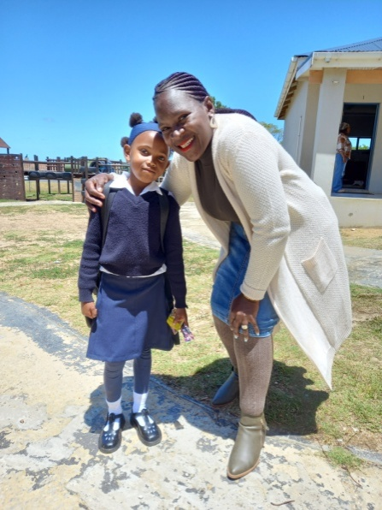
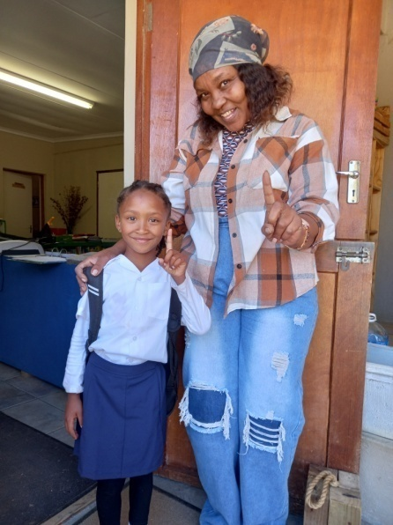
We are very proud when the
school year starts to see our
Grade R children from last year
in their school uniforms.

A lot of them come to school
to show us how beautiful they
look and come to greet their
teachers.

They all say they miss Siyabul-
lela and the food they had here.
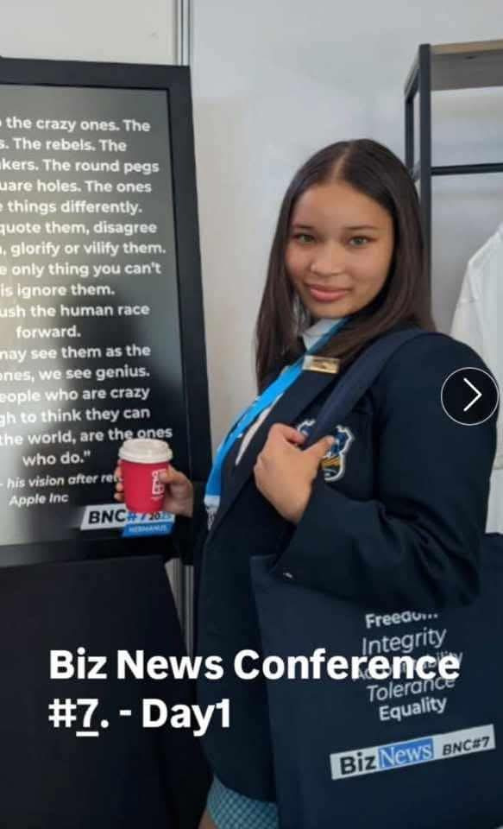
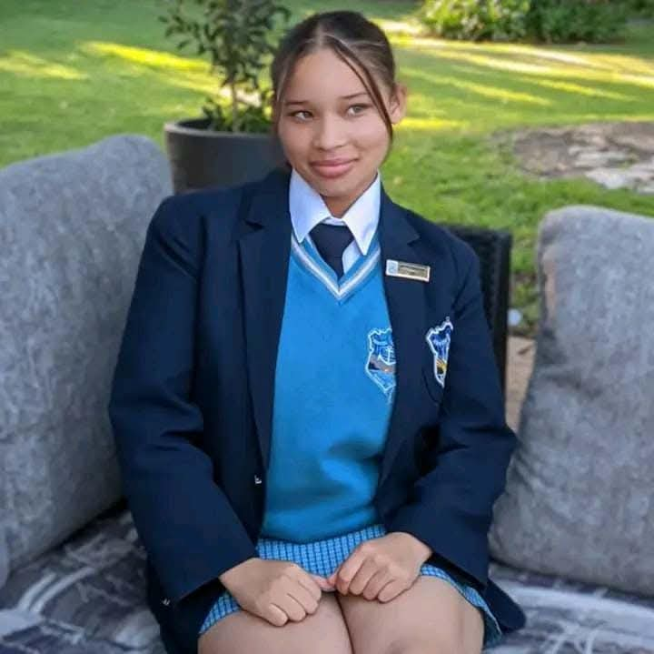
We are always proud when we hear
good things about our old children.
Shaunique Taute, now a Graad 12
learner at Hawston Secondary School,
were one of the delegates together with
big political figures like Helen Zille and
Gayton MacKenzie, representing the
voice of the youth at a conference in
Hermanus.

Shaunique is hardworking and likes to
broaden her knowledge and strongly believes that the youth can make a difference. Well done Shaunique, we see a great future lying ahead for her.

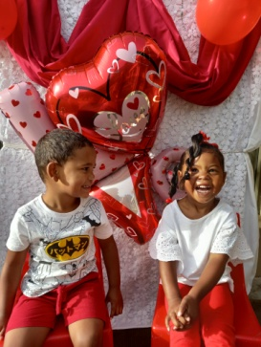
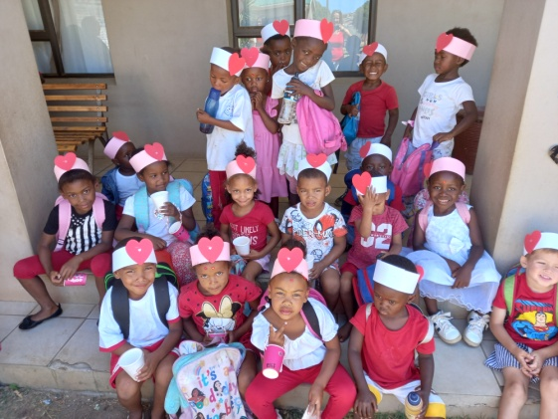
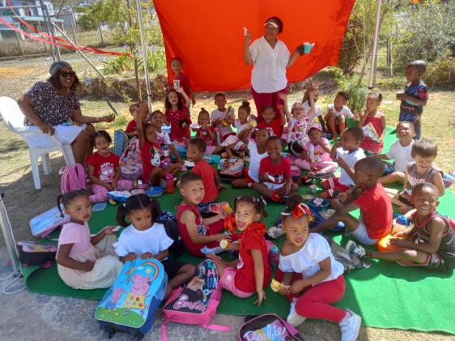

We celebrated Valentine’s Day in style. This year we had a photo corner, which was very popular with the parents. We took a photo of each child and send it home. The children could also pack in something nice for the day and each class had a picnic. They made cards and each of them went home with a heart hat. The children and staff looked beautiful in their red, white and pink.

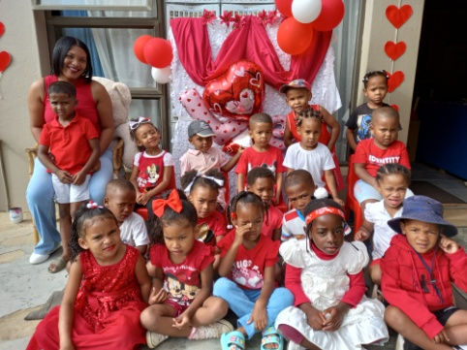
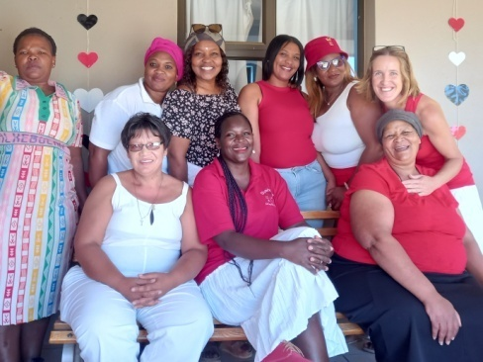
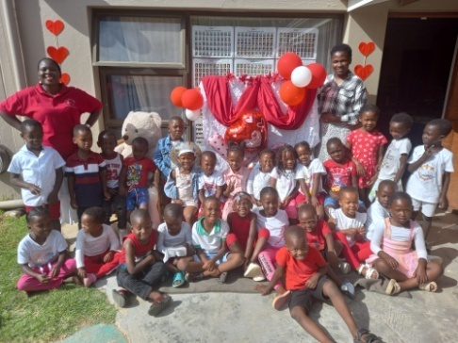
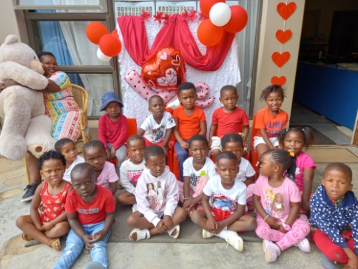
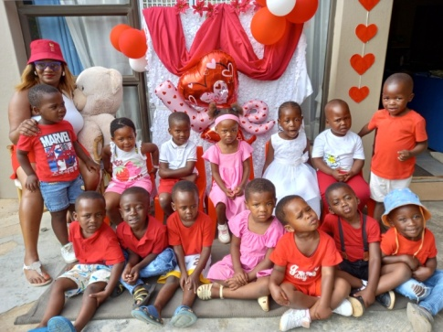
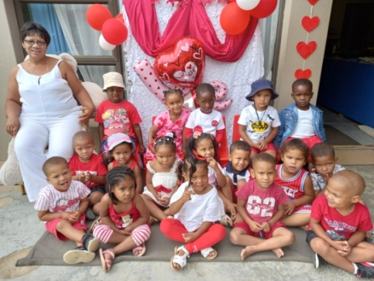

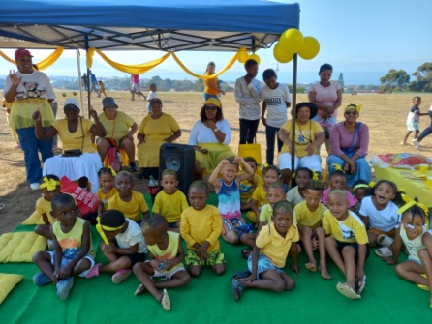
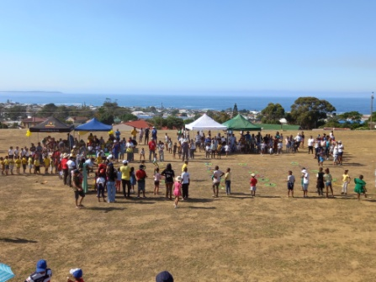
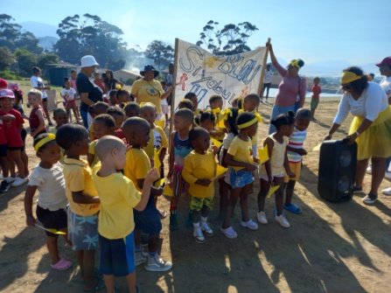

This year, for the first time, we had a Grade R Sports Day at Kleinmond Primêr. They invited us and Krappies and Krefies Grade R children. It was a fun morning of running and other games the children played. We were the yellow team and went all out yellow. For that we won the prize for the team with the best spirit.

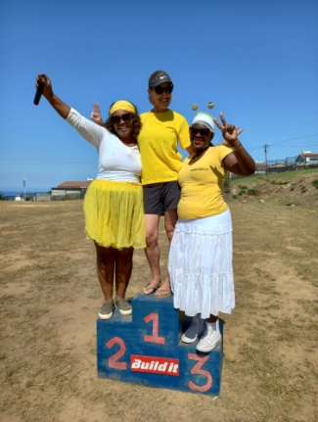
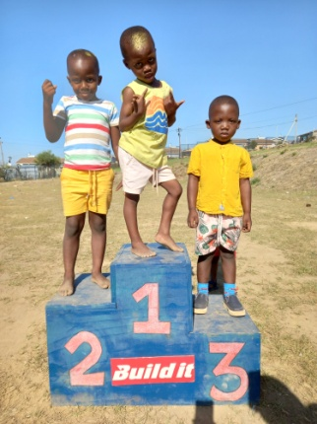
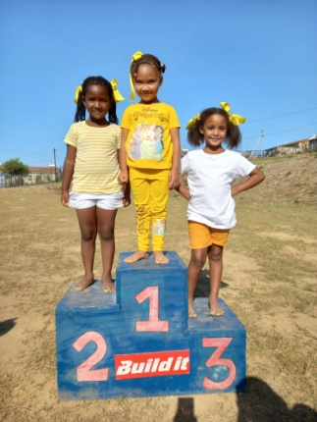
The day was not a-
bout winning or loos-
ing, but about parici-
pating and having
fun.

We and our children
did however enjoy
posing on the po-
dium.

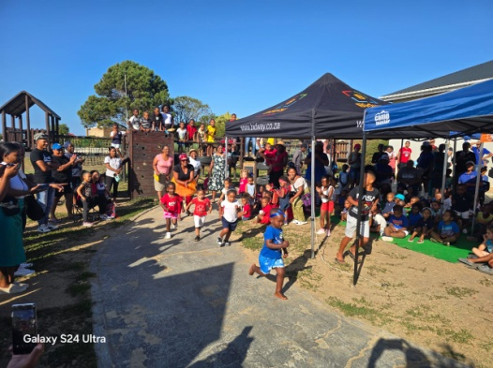
We had our annual Athletic Day with Heideland the
Saturday after the Sports Day. The community came
out in numbers to support this event. The children,
parents and teachers ran and the bigger children also
had a turn. It was a very excited morning and enjoy-
ed by everyone who attended.

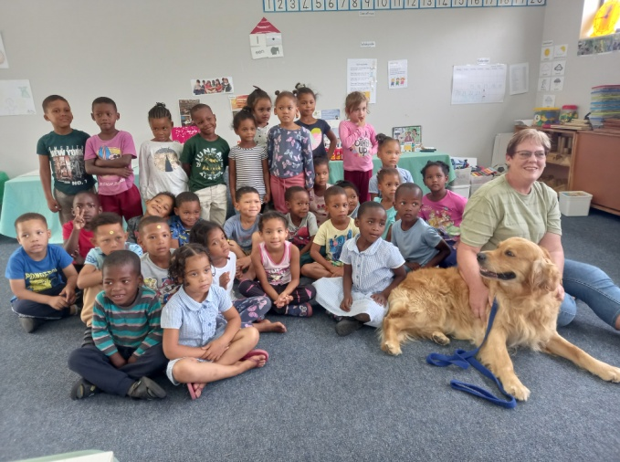

We had a visit from Annemarie and her
dog. She came to tell our children all about
safety around dogs and how they should
treat and take care of their dogs.

This is a very important subject to discuss
with our children, because there are a lot
of dogs running loose in the community
and there has been incidents where peo-
ple have been bitten.
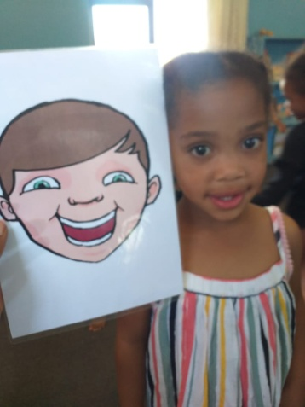
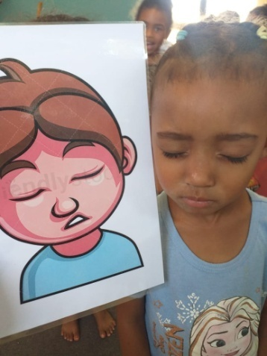
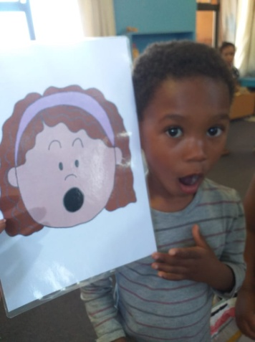
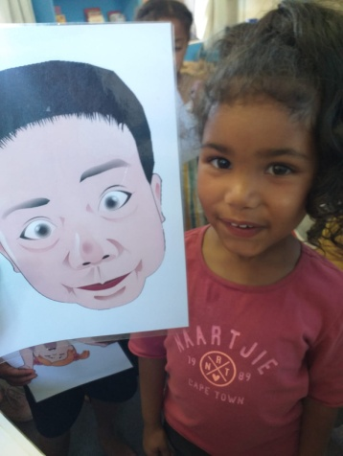

In the classrooms we continue working with our children. We’ve started implementing the new program and so far we are very positive about it. There were lots of ideas we could add to our existing program, especially educational and art activities.

One of the themes we do in the beginning of the year is My Emotions. I wanted to share these pictures with you, because I just thought they were so special. They have a game they play during a drama music lesson were pictures with different emotions are put on the floor, the music plays and when it stops they stand on an emotion picture and must express that emotion. I think they were rather spot on!

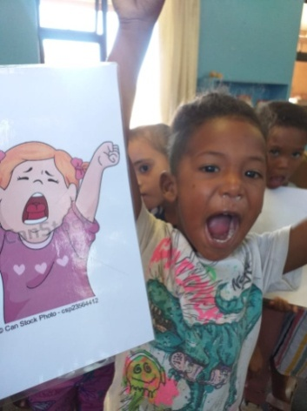
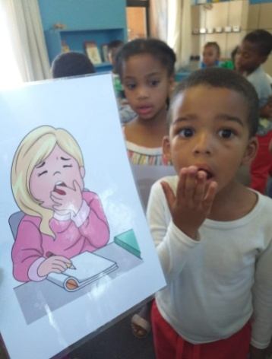
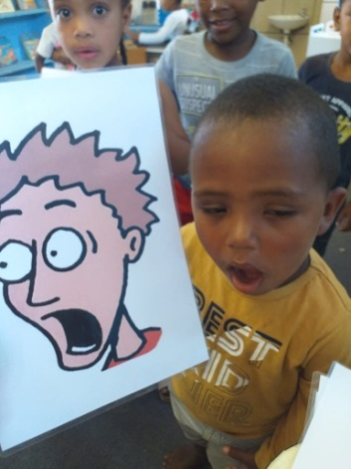
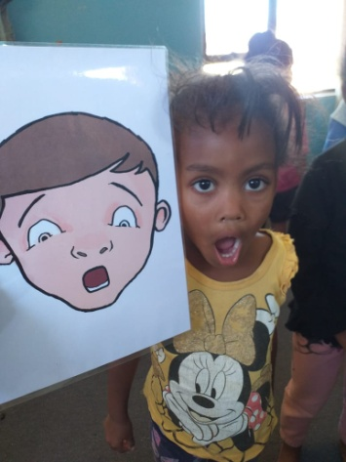

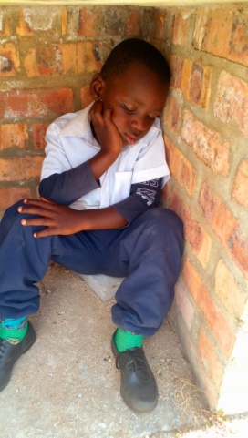
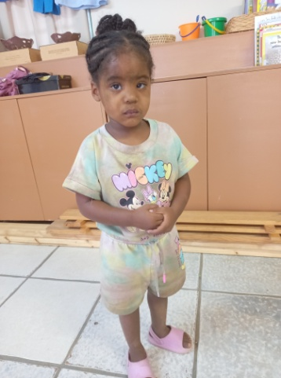
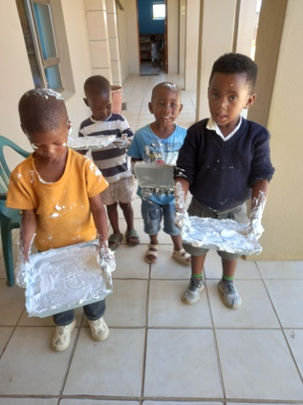
Then there are times when
they enjoy themselves so
much they make a big
mess, they get very dirty
and after a long day of
working and playing they
are very tired...

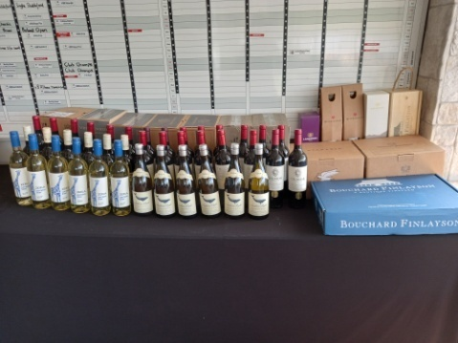
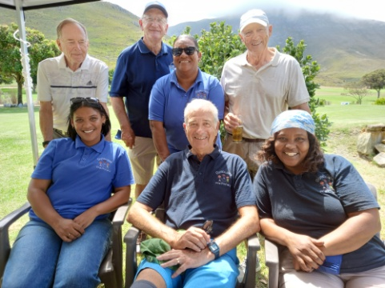
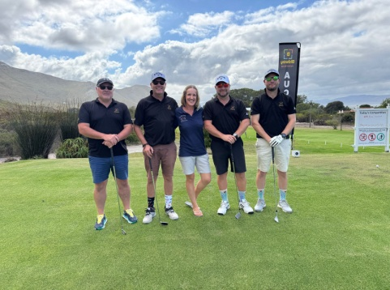

Wow! Wow! Wow! I cannot say it enough. What a blessed Golf Day we had this year! We had the least amount of players of all the years and we raised the most money we’ve raised at the action up to date. It just shows you quality is more important than quantity and what amazing people/businesses we have that support us each year.

The action on its own raised R72 300 of which R40 000 was raised just for our special project. I will tell you all about it later. I cannot thank everyone enough for making this day possible and for helping us to make all the dreams we have for our children a reality. Our date for next year has already been set, so keep Friday, 6 March open!
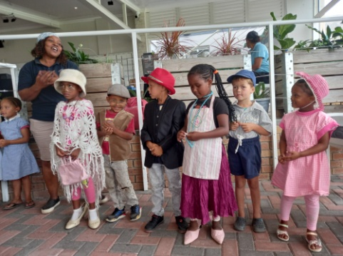
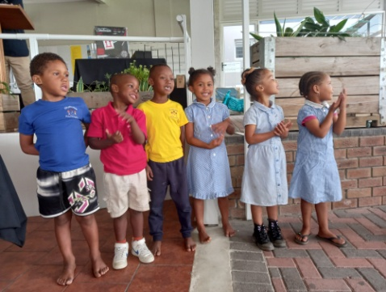
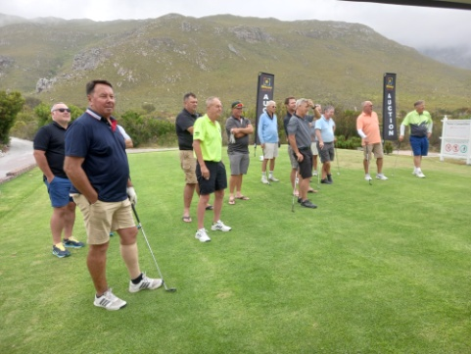

These people/businesses make a difference with their donations every year:

Albertyn Apteek, Alto, Arabella Golf Club, Ataraxia, Beyerskloof, Bidway (Stef), Bouchard Finlayson, Built It, Cabet du Toit, Cape Dry Padstal, Child Welfare
Kleinmond, Coke Cola, Corrie Gerber, Datastoor, Devonvale, Evert Cilliers, Hamilton Russell Vineyards, Kleinmond Golf Club, Kleinmond Spar, Lanzerac, Leeuwenkuil, Mooiplaas, Newton Johnson, Sasol Kleinmond, Vriesenhof, Zidela Wines.

I’ve been sharing these quotes in my Newsletters, speeches and articles. I believe in them very strongly.

I believe that investing in our children’s development from the earliest age is the single most important contribution we can make... Jay Weatherill

Giving is not just about making a donation. It is about making a difference. Kathy Calvin
So the next three pages are dedicated to giving, investing, donating and making a difference.
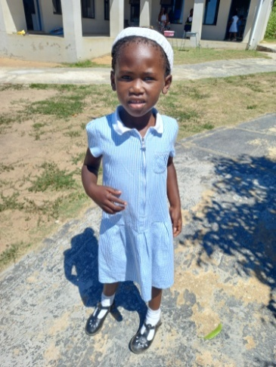
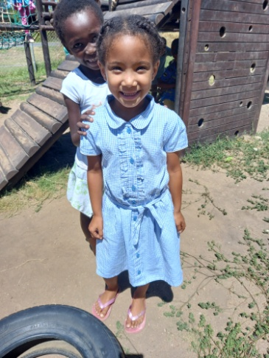
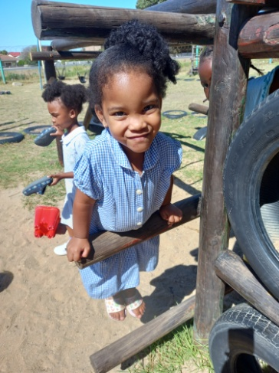
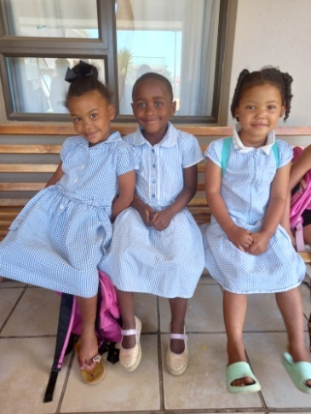

We were very lucky to receive a donation of school uniforms from Prestwood Primary School in the UK! Bettina Gothard, one of our sponsors, visited us last year and thought about the idea of the school donating their old uniforms to us, rather than throwing it away. The school was very keen on the idea of re-using and recycling, rather than wasting.

So this year we could give each of our girls a school dress. There were some boys shirts we handed out and there are more winter uniforms on its way! You can just imagine how excited our children were about the uniforms and how beautiful they look in it. A big shout out to Prestwood Primary School for this huge donation.

(It there’s anyone travelling from the UK and willing to bring some of the clothes over, please contact me.)
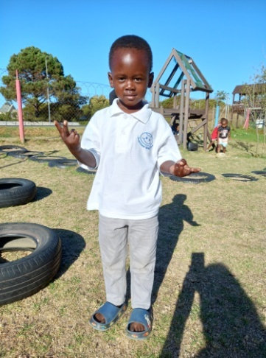
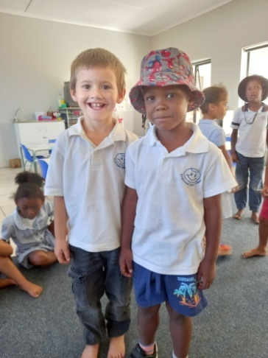
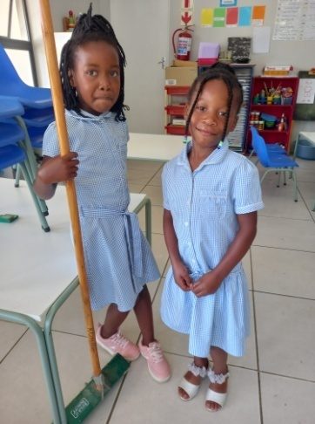
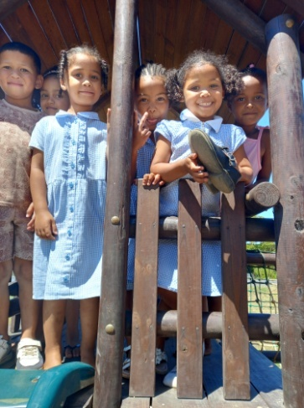

Bettina is also currently busy with a Lent appeal at two churches, Holy Trinity in Prestwood UK and St Mary Magdalen in Great Hampden UK, to raise funds for new fencing and gates for our school. The Gothard family with cover the rest. This is our biggest need and our first priority at the moment. Our fences and gates are in dire need of replacement. This will help with the safety of our children and prevent breakings and dogs coming into our school ground.
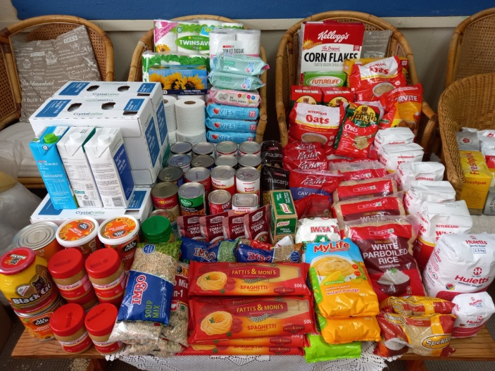
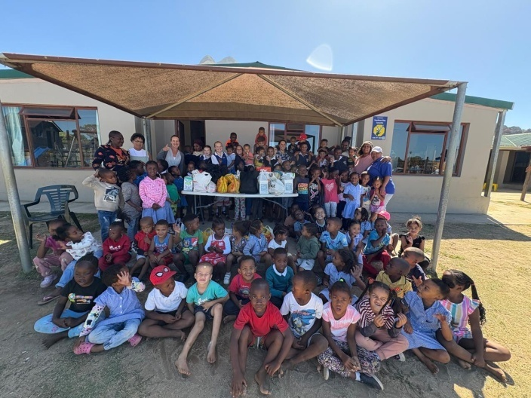

Laerskool Kleinmond’s Culture and Welfare Committee had a project running this term collecting food and other items for our school. When they came to drop of the items we were very surprised about the amount of food they collected. There were enough so that we could share with Bambanani Baby Crèche and Heideland Pre-Primary.

Feeding more than a 140 children every day is a big job and a big expense. Their donation made it easier, every bit helps. We appreciate it very much.

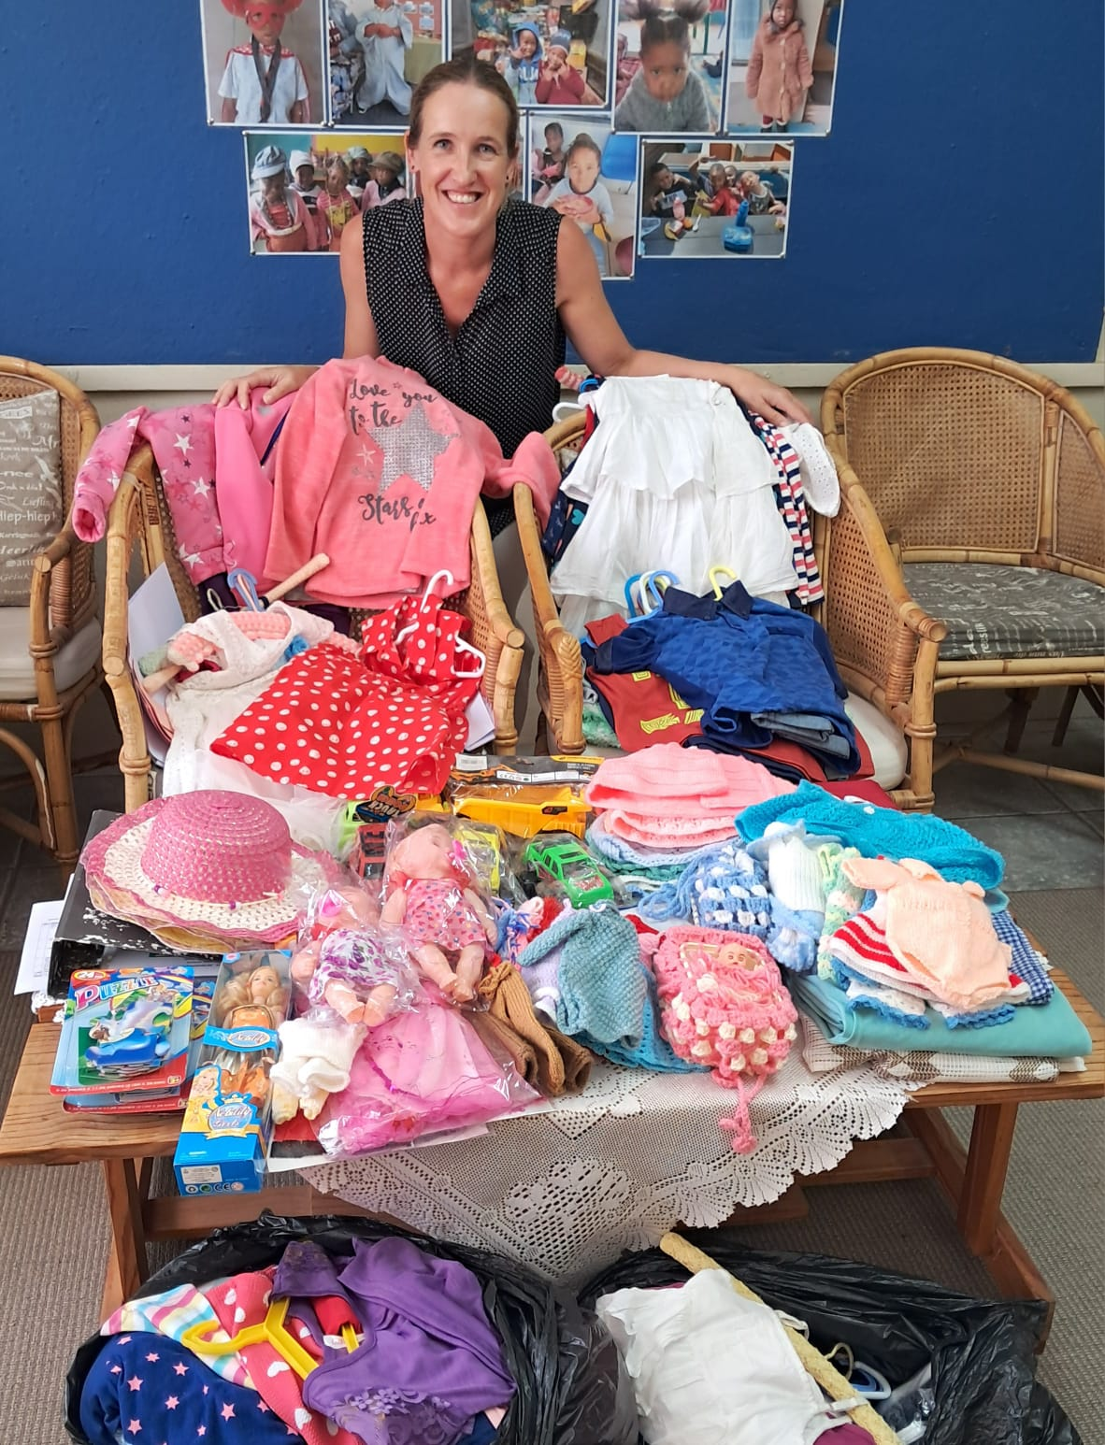
We also receive clothing and other
L items on a regular basis for our second
hand shop. We open our shop once a
month and sell the items for very
cheap. That way we help the commu-
nity and we raise funds for the school.

This is an ongoing initiative and we are
considering opening the shop on a
more regular basis.

You are welcome to donate any items
towards our shop. We literately take
anything. I will always take out the
items we and the other projects of
Child Welfare can use first. Things we
can’t ask money for goes on the free
table and then we send what we don’t
sell to churches and farms in the area.

Thank you to everyone who donates to
our shop. You make a difference.

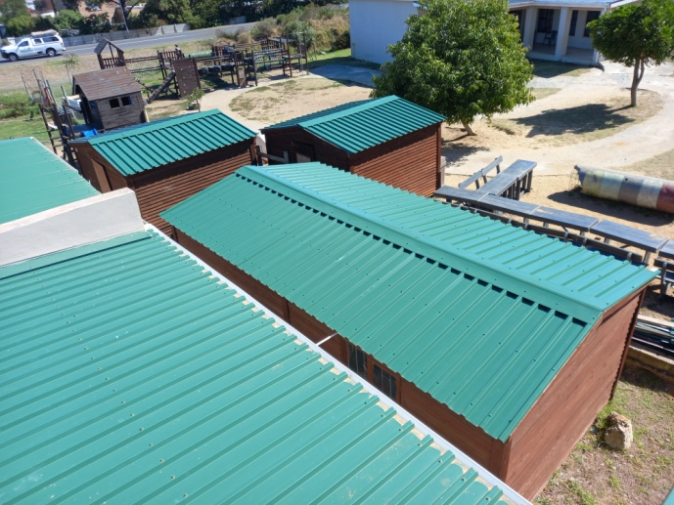
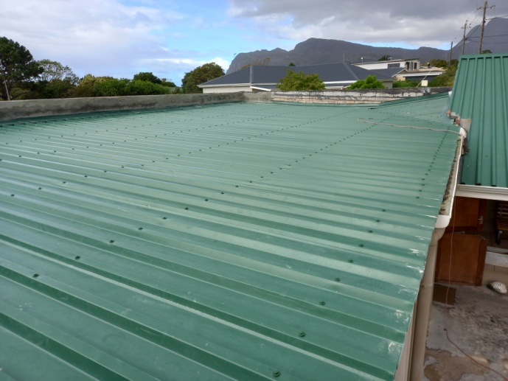

Last, but definitely not least, we got a new roof in December! I mentioned this at the end of last year’s newsletter. Since I started working at Siyabulela we’ve had leaking roofs. Over the years there have been donations towards fixing roofs and putting on a new roof over one of our oldest classrooms. We’ve had one more leaking roof; my office, staffroom, kitchen and storage room’s roof were still leaking.

Michael Merkel was kind enough to sponsor a whole new roof for us and after that he also made a donation towards new roofs for all the Wendy’s! I can now tell you that our buildings are there that we don’t need any more maintenance on it, except for painting that will still need to be done. Thank you Michael.

Because of this we can focus on upgrading our playground and other projects, like new fencing. The fencing is our first priority, but that has been taken care of thanks to the Gothards and the UK churches. Varnish for our Wendy’s are next in line, because the winter is coming and then our next big project is the upgrading and rubberising of our Grade R playground.

Our wish list:
- Higher fencing around our school to prevent breakings (R234 900).
- Varnish for our Wendy houses (R10 310).
- Natty Rubberising bicycle track: R1800 per square meter (R200 000).
- Compost for our grass (R5 000).
- Carpets for some classrooms.
- Puzzles and house corner furniture for our 3-5 year classes.
- Small toilet for 3-4 year class.
- Paving and shading for our ‘outside’ classroom.
- Second hand items for our shop (old bedding, towels, kitchenware,
clothes etc.)
- Mural for Grade R classrooms’ wall (still need R10 0000).
- Mud kitchen for outside play area (still need around R5 000).

When we dream, we dream big at Siyabulela Pre-Primary. We are not happy with second best, because our children deserve the best. We want to have a state of the art playground. One that is safe, that will last a long time and that will transport our children to a magical world. If other schools can do it, why not us?

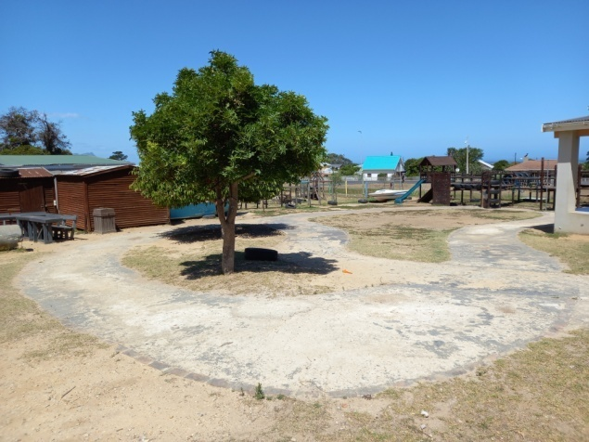
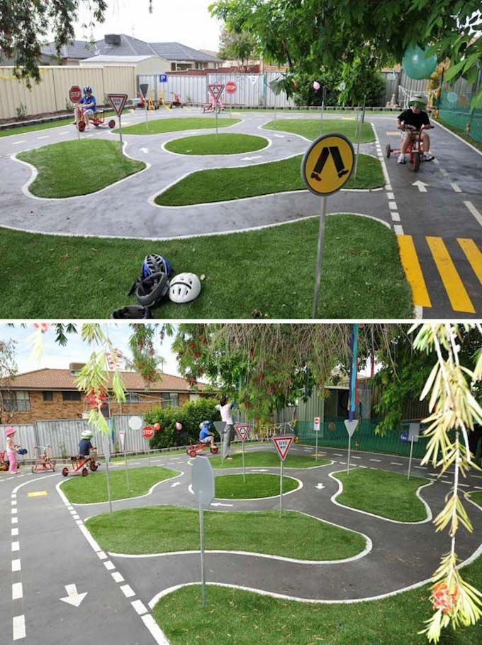

Above is how the playground currently
looks like. On the right is what we are
working towards. We raised R40 000
for this project at the Golf Day.

I want to get our school grounds, to a
place where it doesn’t need any more
work or maintenance. Where it will last
a life time for generations of children
still to come.

To everyone who has been a part of
our success story, we thank you.
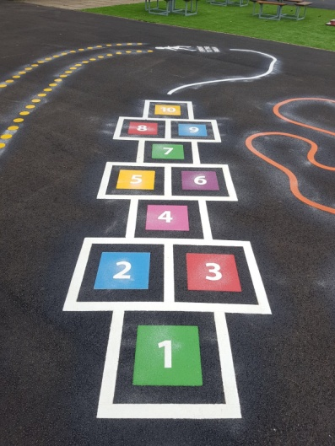
This legacy will last a life time.

All our love,

Alta, the staff and children of Siyabulela Pre-Primary

NEW BANKING DETAILS:

Account name: Siyabulela Pre Primary School
Branch code: 198765
Account type: Current Account
Branch name: Nedbank South Africa
SWIFT code: NEDSZAJJ
Bank name: Nedbank Limited

