NEWSLETTER 2/2024

I am going to call this one our Health and Safety Newsletter. I realised when I was downloading the photos; that this term we focussed a lot on health and safety. We started off with the themes Healthy Living and Healthy Eating. It is very important to us to teach our children about healthy eating, because they eat a lot of unhealthy food in their homes. It is also important that our children wash their hands and brush their teeth.

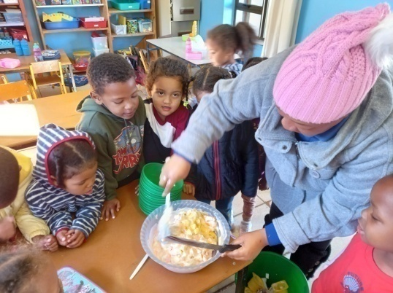
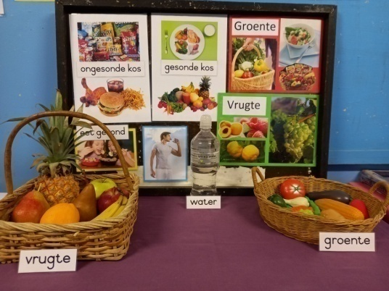
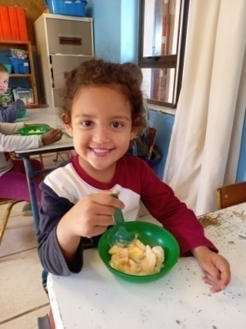

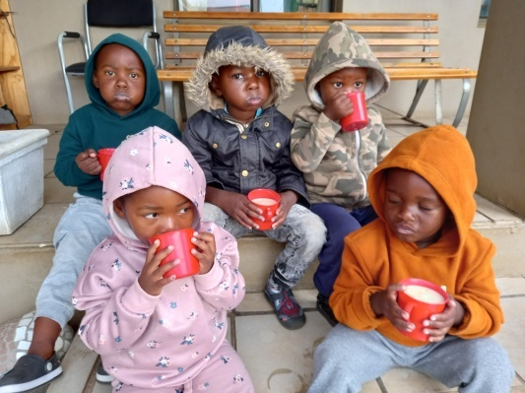
They made fruit salad in the classrooms and enjoyed
it very much. The e’Pap we give our children also
helps to keep them healthy and happy. It has a lot
of nutrition in and we can definitely see the differen-
ce it makes to our children.

Thanks to the GRCT for this ongoing project to pro-
vide this nutritious porridge to children all over
South Africa. A healthy child is a happy child!

We also did People who help us at the end of the term. This goes along with Health and Safety. The doctor, nurse, clinic sister and dentist keep us healthy and the fire men and police keep us safe.

We had a visit from Walking for Fire who came to talk to our children about fire safety. Again, a very important subject to address at our school, because in most of our children’s homes fire and gas are still being used to cook food and warm water.
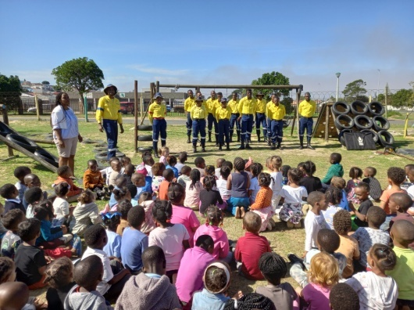
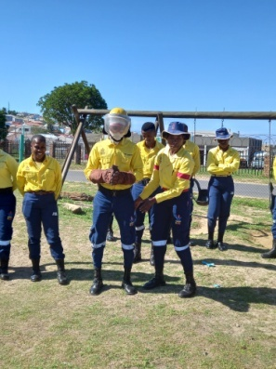
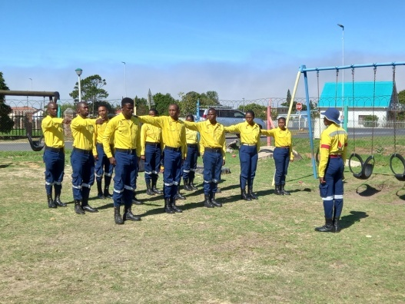

They talked to the children about what is unsafe in homes and what they should stay away from. They also demonstrated the safety clothes they wear to protect them from fires and they ended off by marching.

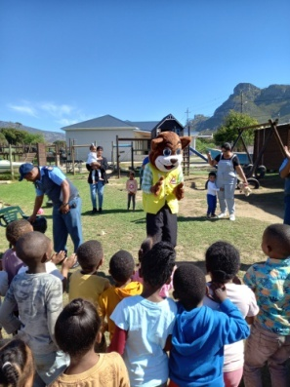
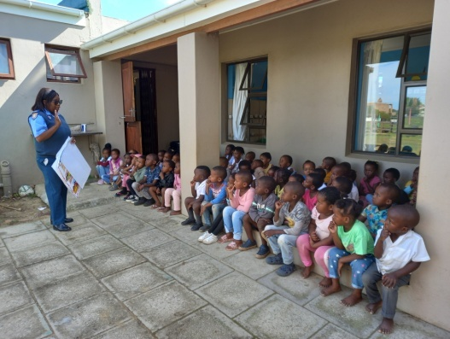
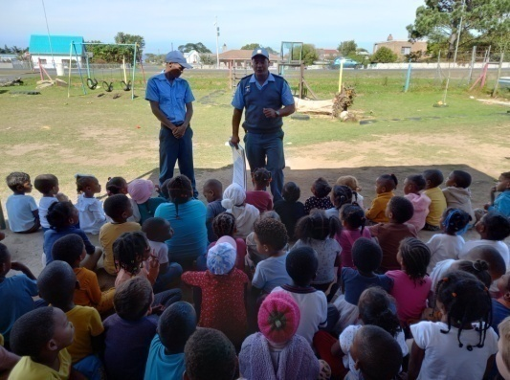

The traffic department came to visit and discuss road safety with our children. We have a very busy road in front of our school and the children should be aware of looking before they cross. Daantjie Kat surprised them with a dance and each class got the opportunity to take a photo with him.

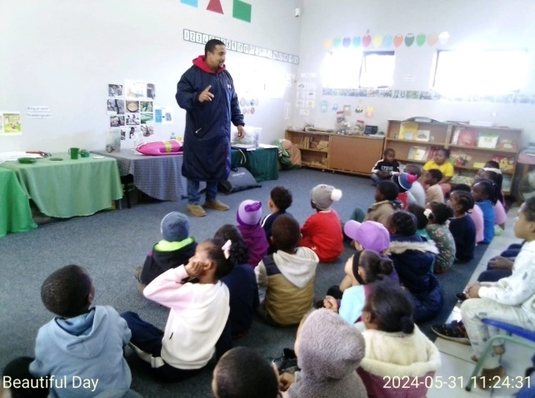
The last safety visit we had was the NSRI.
They came during Child Protection Week to
talk to the children about water safety.

They emphasize the importance of always
being accompanied by an adult when they go
down to the beach or the lagoon. It is also very
important that our children should learn to swim.
Water safety in an important subject that is not
addressed enough.
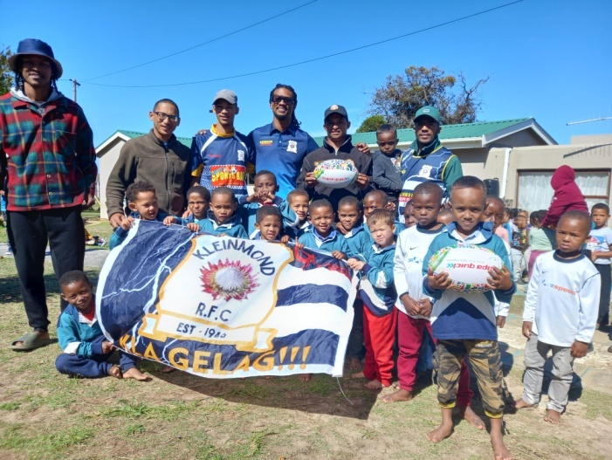
The last group of visitors we had at the
school, was our local rugby team. They
visited all the school’s in the area to
awoke an interest in rugby and an aware-
ness of the importance of taking part in
sport.

They handed over some rugby balls and
since then the boys have been playing
rugby every afternoon. I can confirm that
they play very ruff, they don’t obey the
rules, but they love the game!

We have been focussing on educational activities in the classrooms, especially number activities. We’ve noticed that the children struggle with number sense. They can count, but when they need to identify numbers or pack it out concretely, they struggle.
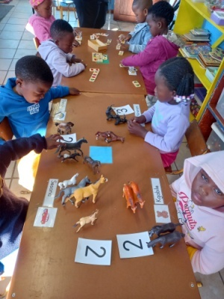
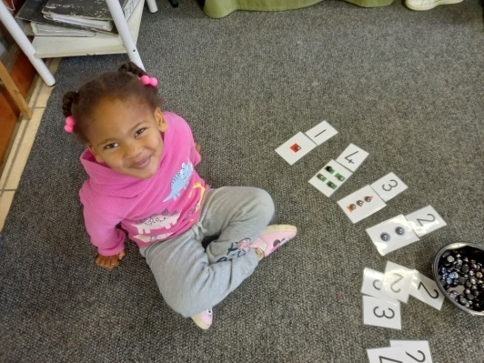
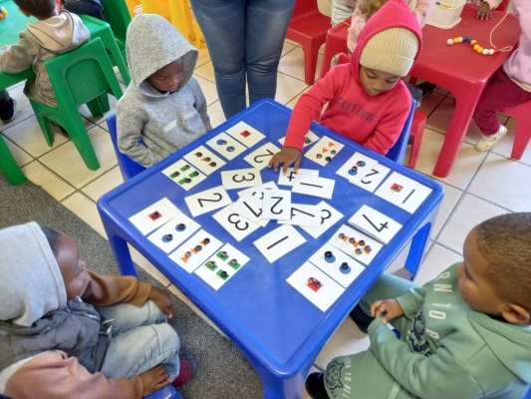

It is very important from an early age to start learning different Math concepts, so that the building blocks are laid down when they go to primary school. With our 3-5 year children we look at counting, recognising numbers, understand concepts of more/less and equal, position, shape, colour and size; patterns, measurement and data handling. The Grade R children look into the concepts much broader: numbers, operations and relationships; patterns, functions and algebra; space and shape; measurement and data handling.
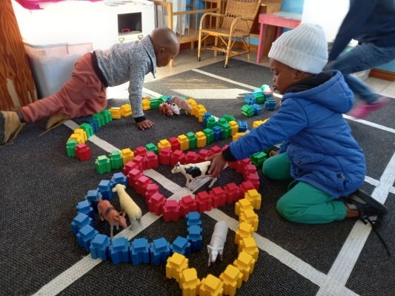
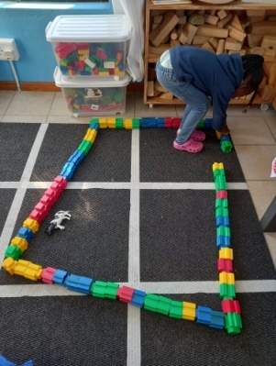
Mathematics are incorporated
throughout the day. During the
morning ring they count their
groups and do the calendar.
They use math concepts when it
is educational and creative time.
Even during story, music, move-
ment and play time math is
incorporated.
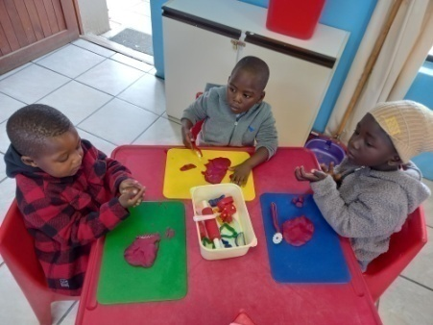
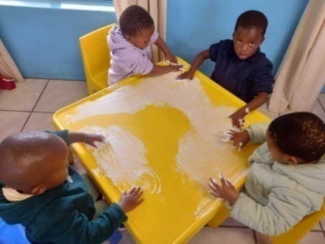
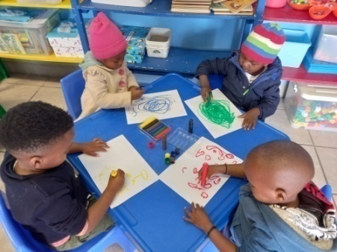

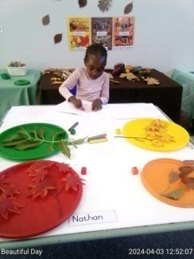
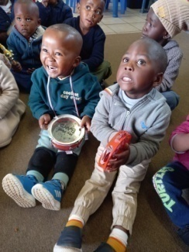
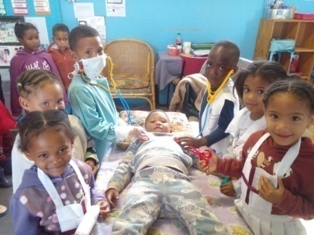
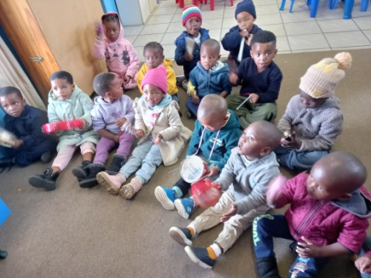

And then we continue with all our other activities in the classrooms...

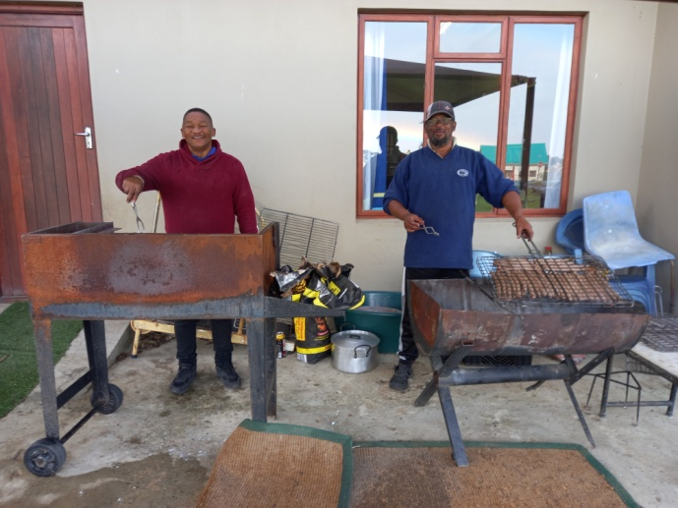
Our continued fundraisings are also very
important to the school. As you know by
now the small amount of subsidy we re-
ceive from the department of education
is not enough to cover all our expenses.

We do fundraising on a quarterly basis.
Our big fundraisings are our Golf Day and
Debutante. The other fundraisings we do
is our athletic day, sports day, market day
food sales and our second hand shop.

It is very important for us to keep up the standard at our school and keep improving. We worked hard to get where we are today.

We are very lucky to have our loyal supporters, donors and sponsors who continue to support us over the years. Because of you we can do maintenance, get educational toys and other equipment, and make sure children who need it the most can come to school.

We got a donation from the Narollah Trust to varnish our jungle gyms. This needs to be done on a regular basis, so the jungle gyms can last longer. Thank you!

We got donations at our Golf Day and from Barenbrug SA for some trees. At the end we could buy 11 trees for our school grounds. We are very excited to see them grow and make shade for our children. A big thank you to Barenbrug and Carin Malan, who sponsored compost and helped with choosing the trees and planting them.
We also got an irrigation box for free from WR Irrigation when they came with the compost. We did half the compost so long, because the playgrounds grass desperately needed some feed.

Before:
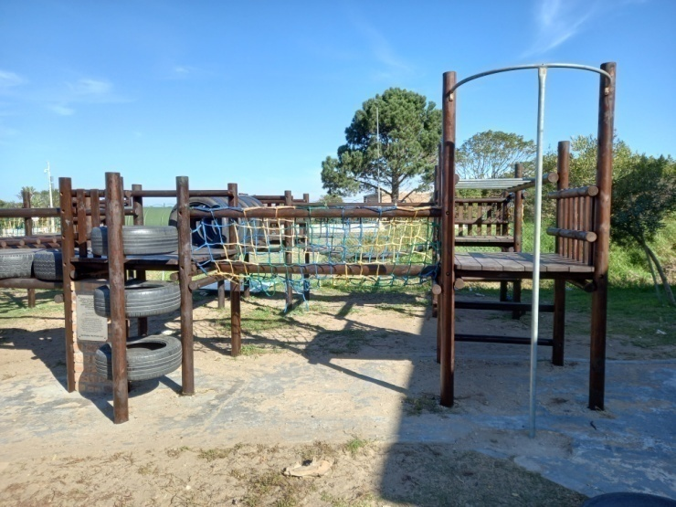
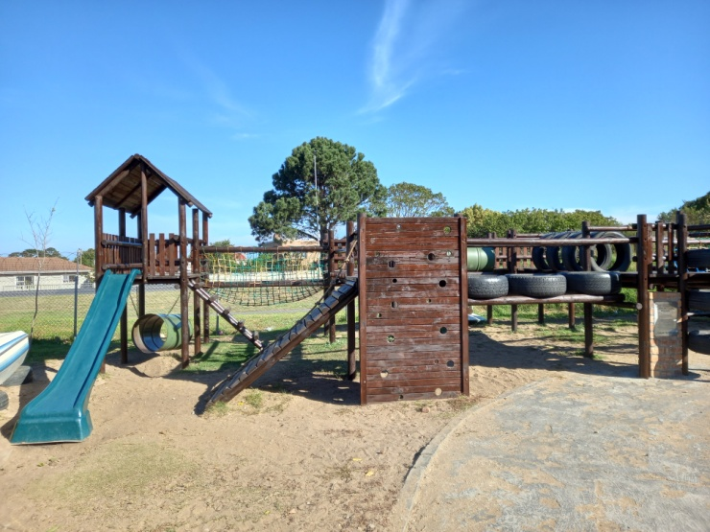
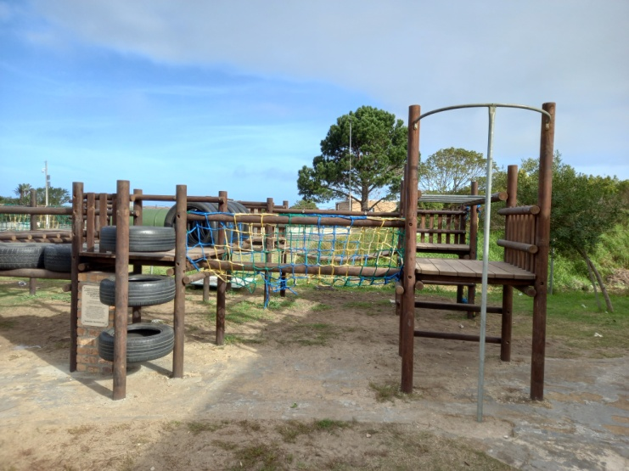
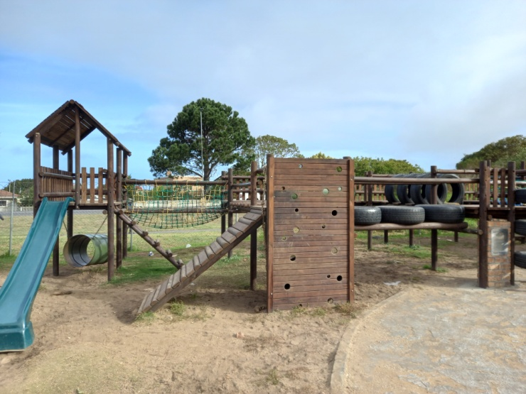

After:

Our trees:
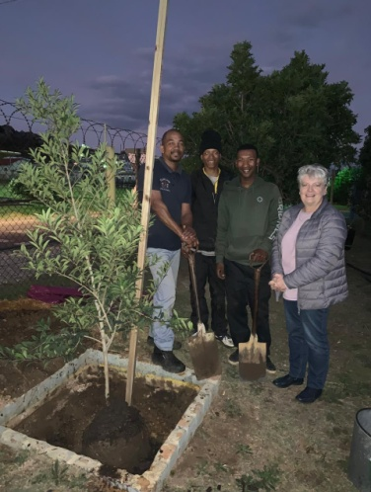
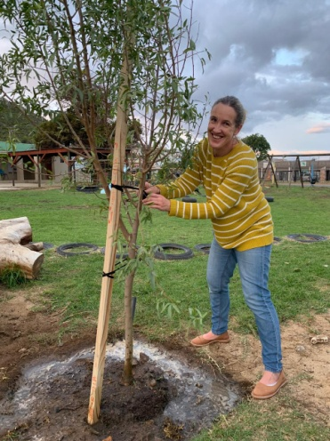
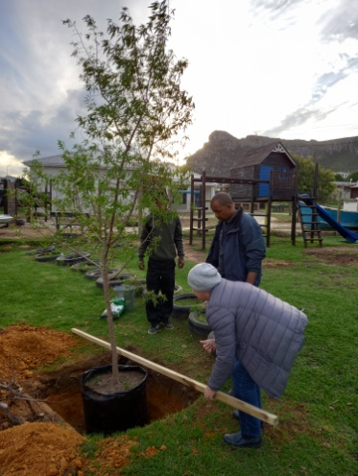
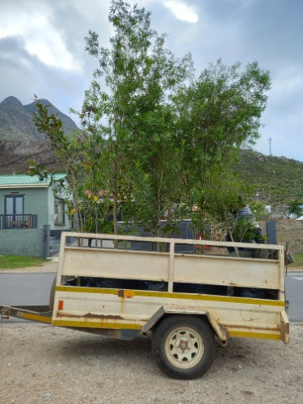

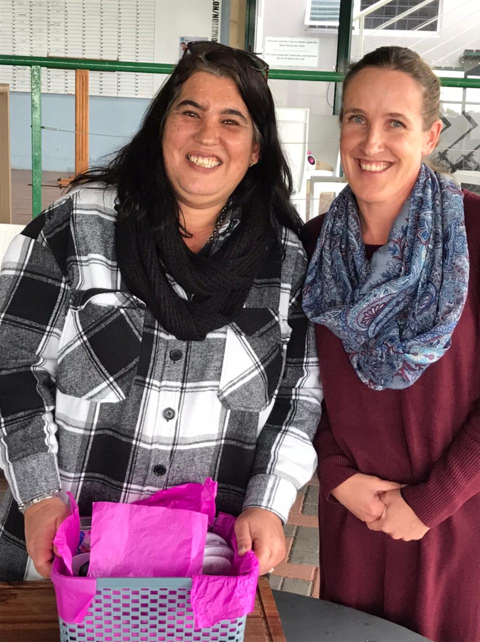
We had to say goodbye to Maretha this term.
A lot of you will know her as our bookkeeper.
She has been working with me since 2011.
She started at Siyabulela and over the years
has taken on all the projects of Child Welfare.

Maretha was very dedicated in her job and
very good at what she did. She is getting
married in December and found a new job
closer to her husband to be.

We left her with the message:
People will walk in and out of your life, but the
ones who really matter leave footprints. She
left lots of footprints. Her hard work and de-
dication did not go unnoticed.

We wish her all the best for the future.
She will be missed.

I want to end of the Newsletter with some photos of our children and the Mother’s Day cards they made.

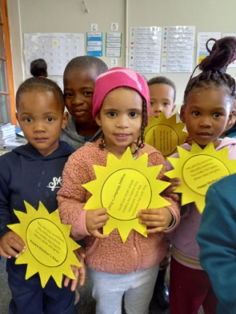
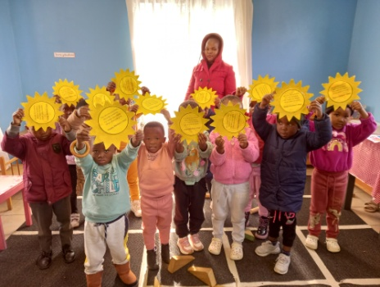
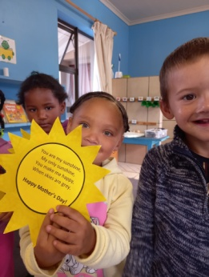
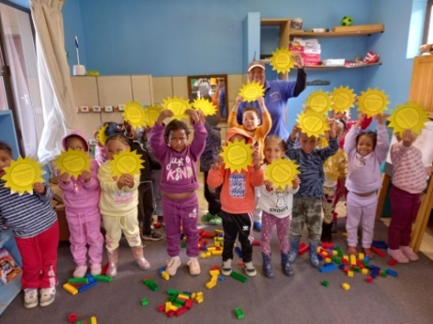
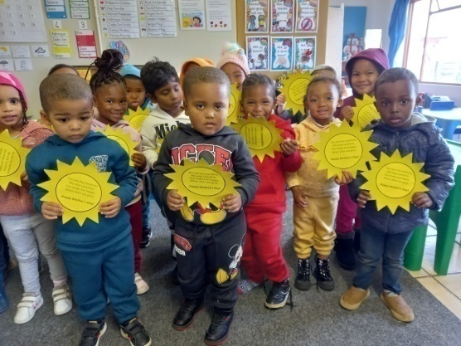
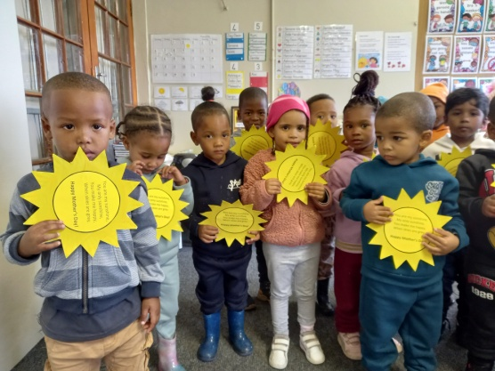

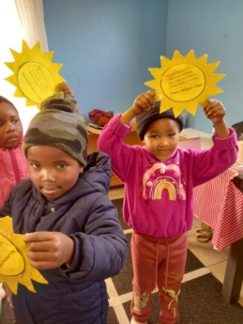

The card read: You are my sunshine, my only sunshine; you make me happy when skies are grey.

Lots of love; Alta, the staff and children of Siyabulela Pre-Primary

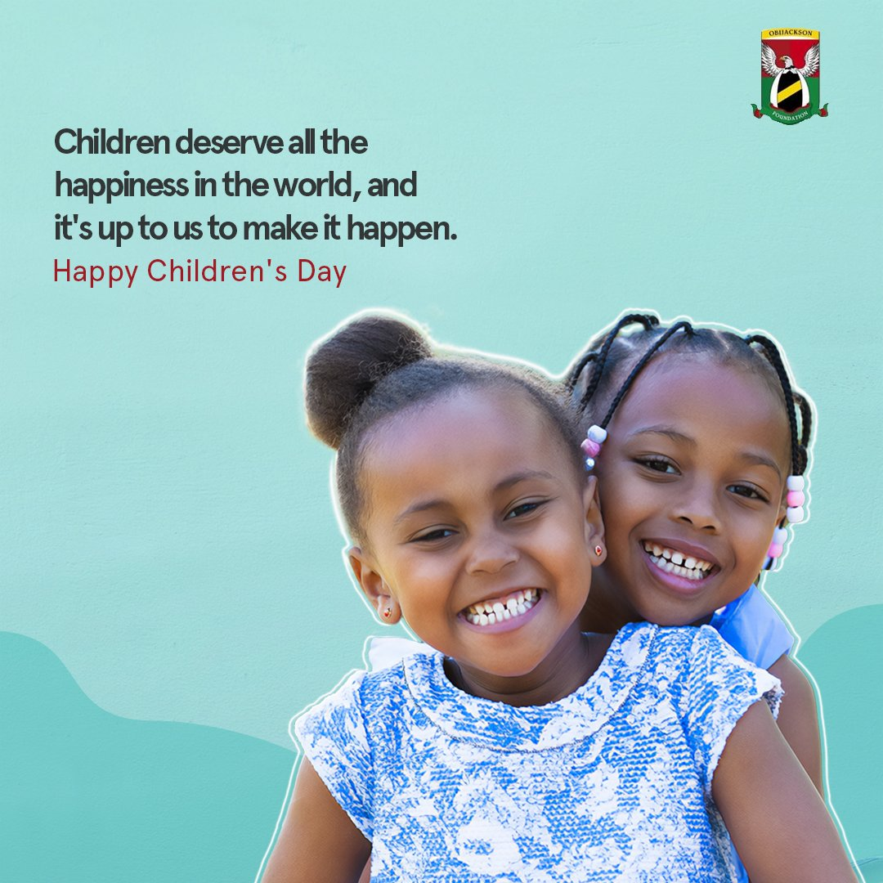

Our wish list:
- New roof for my office/staff room, kitchen and store room.
- Varnish for our Wendy houses (R10 310).
- New roofs for our Wendy houses (they are all rusted).
- Compost for our grass (R5 000).
- Puzzles and house corner furniture for our 3-5 year classes.
- Small toilet for 3-4 year class.
- Carpets for some classrooms.
- Paving and shading for our ‘outside’ classroom.
- Natty Rubberising bicycle track: R300 per square meter.
- Higher fencing around our school to prevent breakings.
- Second hand items for our shop (old bedding, towels, kitchenware,
clothes etc.).

As I said before, we made R32 000 for projects on our wish list and we can already tick off the first one:
- A big tree for our playground (trees for our playground).√
- Mural for Grade R classrooms’ wall (still need R10 0000).
- Mud kitchen for outside play area (still need around R5 000).

