NEWSLETTER 2/2025

We started this term with three short weeks and then there was a week’s holiday.
So this newsletter might be a bit shorter than usual because of it. We however have exciting news to share with you; and we have been busy with training for our teachers and programs for our children. We have started rubberising our bicycle track!

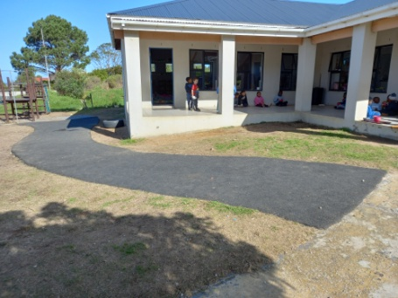
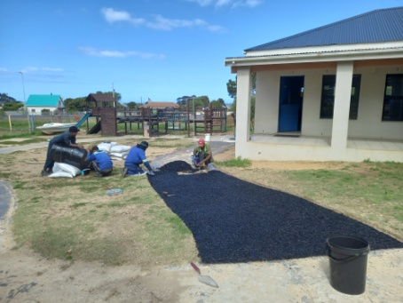
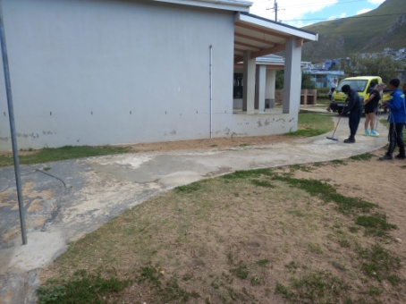

In our last newsletter I told you about the money we made at our Golf Day that would go towards this project. We are happy to share with you before, during and after photos. And what a big difference it makes! We only did a bit of the road and the rest of the project will be finished later in the year thanks to Robert Fraser, who gets just as excited as me when it comes to finishing projects.

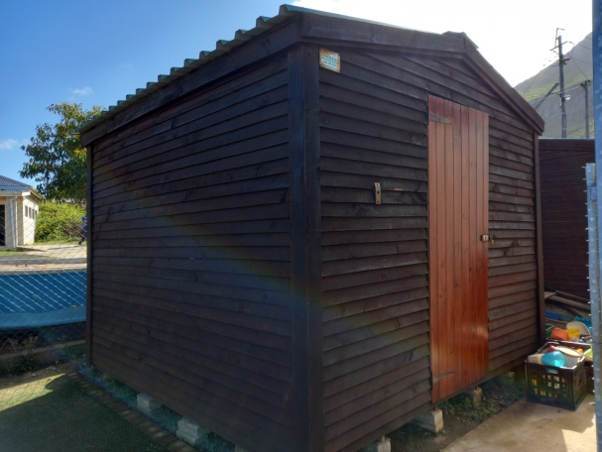
We could also do the varnishing of our Wendy
houses, so now they have new roofs and the
much needed maintenance have been done.
Thank you Micheal.

Our next big project that will start is the new
fencing. This will be a three year project and
made possible by donations done by two
UK churches, Holy Trinity in Prestwood and
St Mary Magdalen in Great Hampden and a
family trust. We are very excited about this
project!
We have received more school uniforms from the Prestwood Primary School. This time there were more winter uniforms like jumpers, jerseys, grey pants and tracksuits.

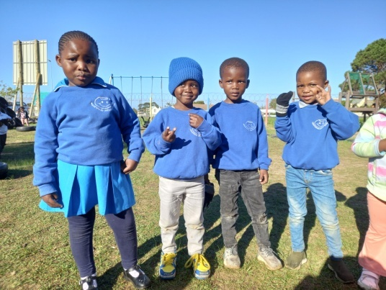
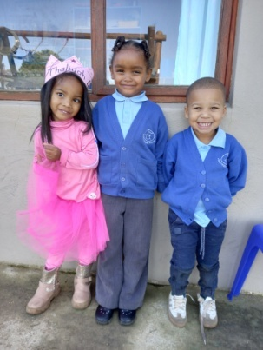
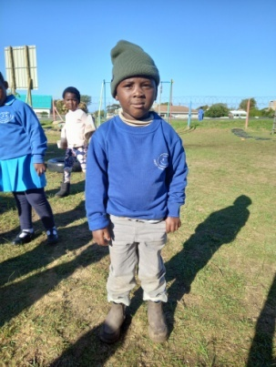
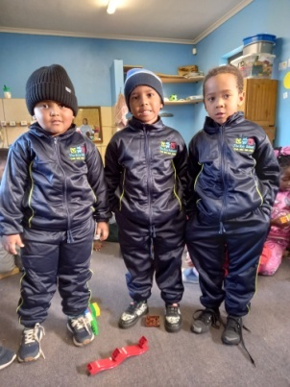

The uniforms are lovely and warm and we are very grateful for this donation.

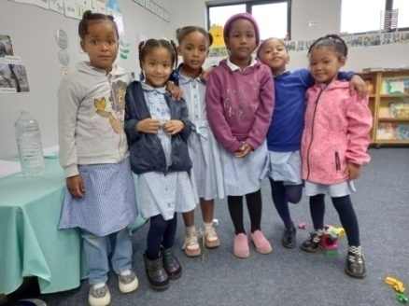
The girls are still wearing their school dresses during the
winter months. They are all covered up with tops, jackets,
tights and stockings. They love it that much!

We kept some of the winter uniforms so that we could take
professional school photos of the children while wearing it.
The photo (at the end of the newsletter) is just one I took,
so it’s a preview. We will still share the professional photos.

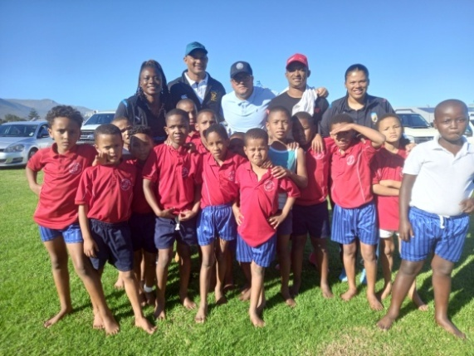
They also donated clothes to the local primary
school. Here are some of the boys wearing the
sport kit at the rugby match they played.

What a pleasure it has been to get involved with
Prestwood Village Schools and getting excited
with our parents and children about second
hand school uniforms. I also love the fact that
we are recycling, re-using and thus reducing.
It is so important in the day and age we live in.

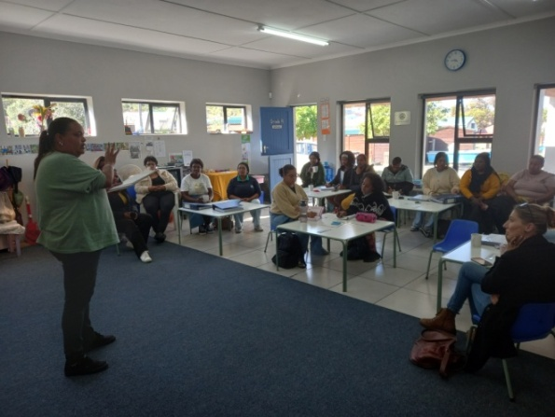
We have started our training on the new program
we are using. We started with the Maskot program
in the beginning of the year and Enlighten Trust
are doing training on it.

We have found the program very useful and there
are lots of activities and ideas we can incorporate
in our daily program. It is a very practical program
and easy to use.
Maskot program by Masikhule ‘Let us grow.’
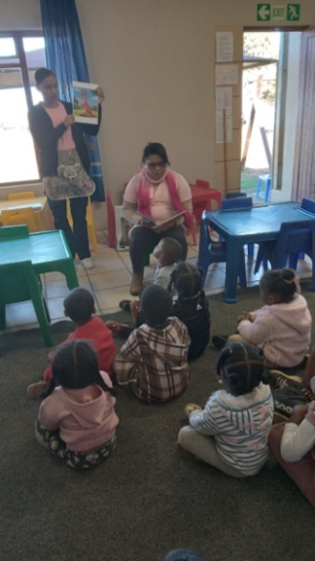
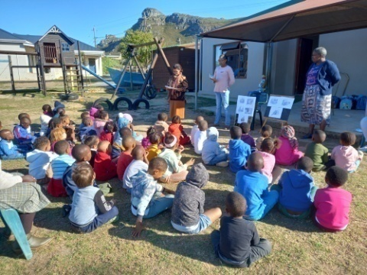
Child Welfare and the local library
came to visit us. Child Welfare
was here during Child Protection
Week and did a talk about safe-
ty with our children.

The library came the Friday be-
fore Mother’s Day to read stories
for the children and also help
with making their Mothers Day cards. The clinic also came to give
Vitamin A and de-worming. We are grateful to all the organisations
who come out on a regular basis to support us. These are all be-
neficial for our children and makes a positive contribution in our
children’s lives.
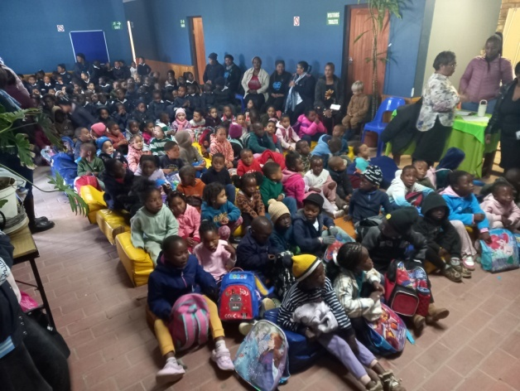
It was Child Protection Week from Thursday,
29 May till Thursday, 5 June. This year the
spotlight was on Education Access for Child-
ren with Special Needs. Although we do not
have children with special needs, I still think
access to education for preschool children is
just as important.

The biggest challenge in our community is
unemployment, thus the struggle to pay
school fees. Sadly we have to ask school fees to keep our doors open. We do not want to turn any child away, because all children have the right to education. This is where our donors come in. Because of all the sponsorships through the years, we could give a lot of children the opportunity to be in school. We want to thank all our sponsors for making a difference in so many children’s lives.

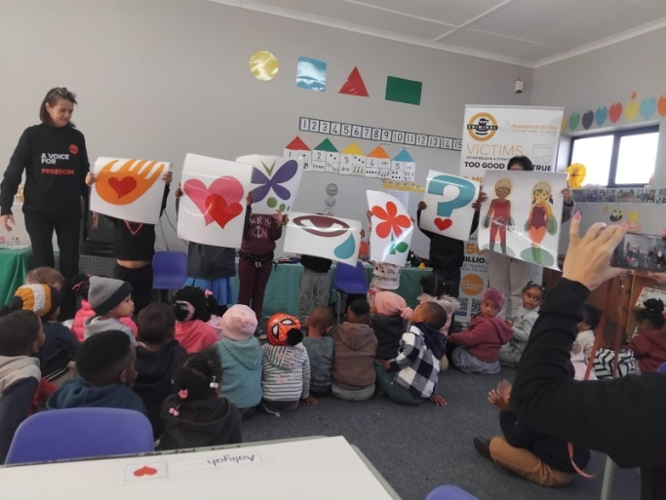
The last group of people who came to visit
us were “A voice for freedom”. They raise
awareness about human trafficking.
South Africa is grappling with a sharp rise
in missing children, with police statistics re-
ling that a child goes missing ever five
hours.

These are alarming statistics and a very im-
portant subject we cannot ignore anymore.
We should all stand together to protect our
children and empower our community.
Let’s ensure that no child is left behind.
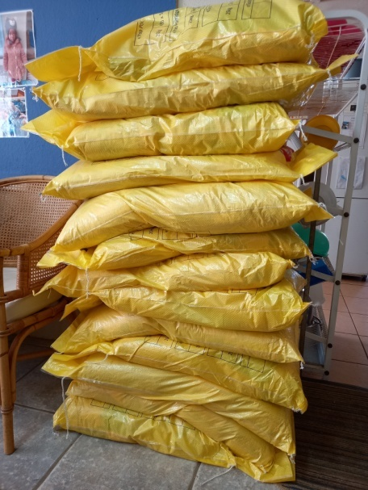
What a lot of e’Pap! After Patrick’s last visit to our school
he asked that we shouldn’t hold back on the e’Pap and
give it to our children every day. The amount of e’Pap
we order have doubled. The e’Pap goes out to three
projects in Kleinmond; Bambanani Baby Crèche, Smart
Kids and Siyabulela Pre-Primary. That covers around
230 children.

The e’Pap is very beneficial to our children. It is very
nutritious and helps build our children’s immune system
and keeps them healthy. Having a nutritious breakfast
also provide children with energy and nutrients they
need to start the day and improve overall well-being.
It helps with focus, concentration, performance and
can also help in maintaining a healthy weight.

They enjoy their e’Pap milkshakes and porridge!

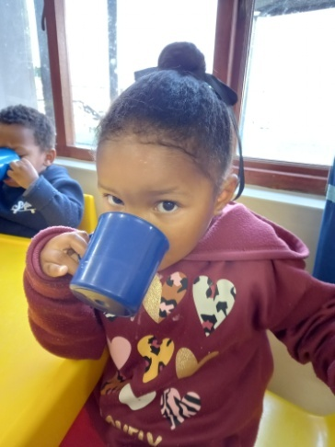
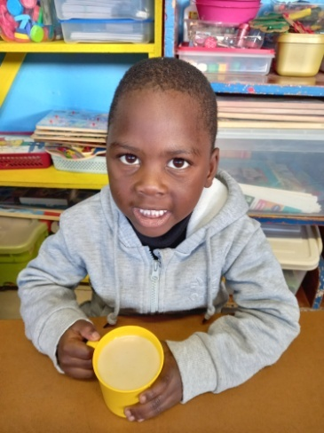
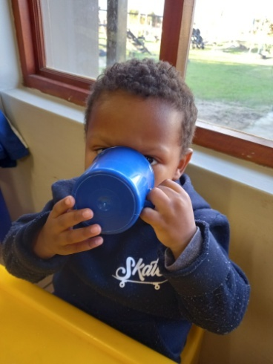
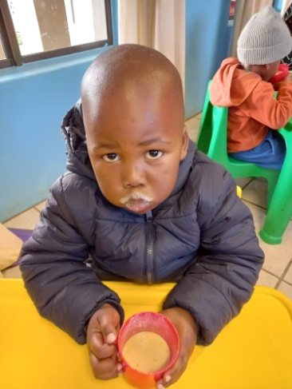

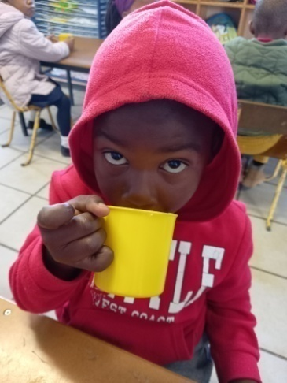
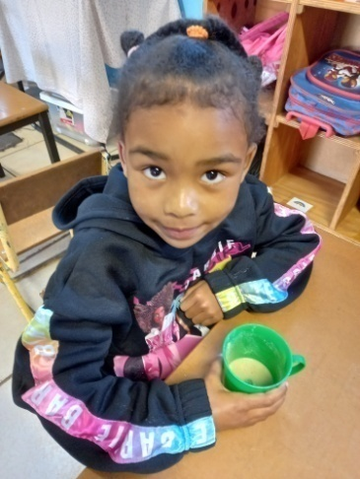
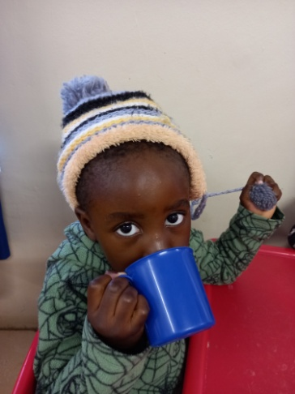
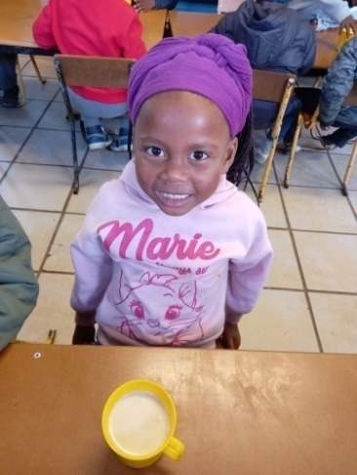

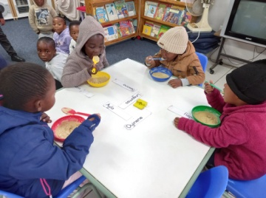
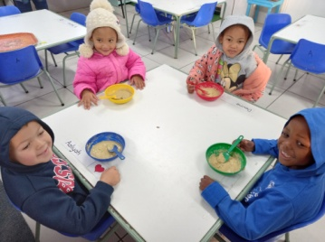
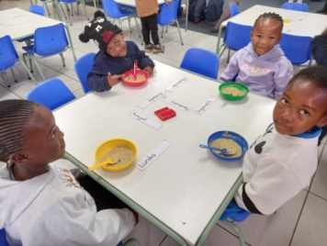
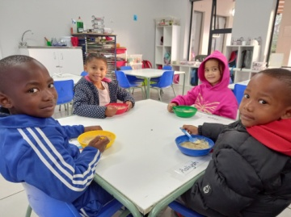

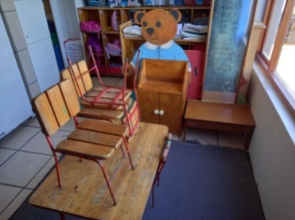
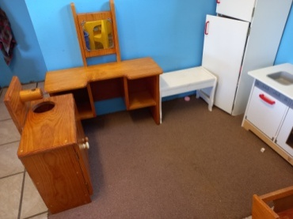
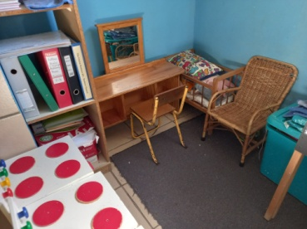
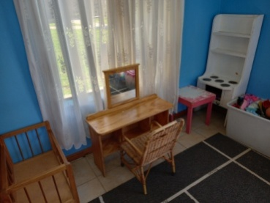

When the playground and fencing are done, then most of our big projects will be finished (except shading and paving for our outside classroom), but then I would like to start focussing on the classrooms again. Equipment, apparatus, educational toys etc.

I would love all our classrooms to have beautiful house corner furniture like our Grade R classes. I want our younger children to enjoy playing there just as much as our Grade R children. Below is their house corners: Much prettier en more durable.

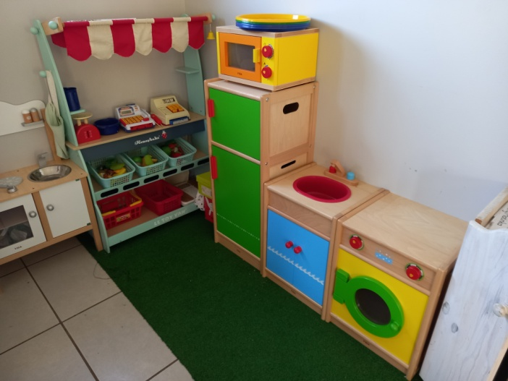
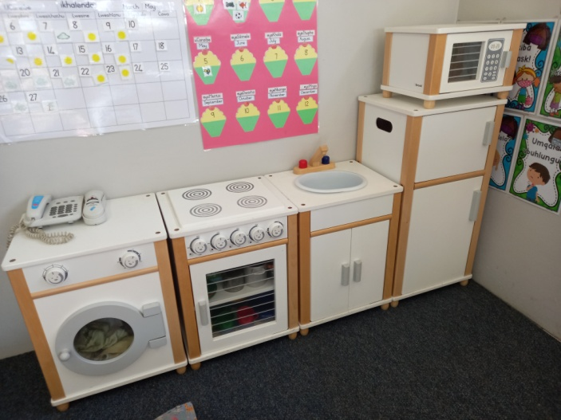

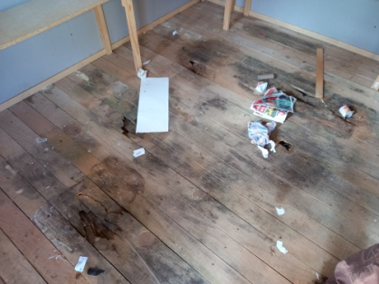
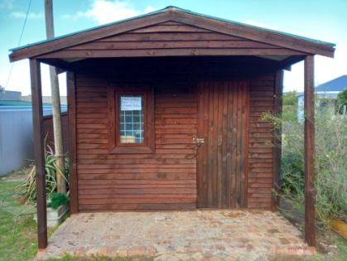
Maintenance work we have to look
at are the floor of our shop and the
decks of our boats. The shops
floor has rotten and there are big
holes in the boat decks.

It will cost ±R10 000 for repairs.
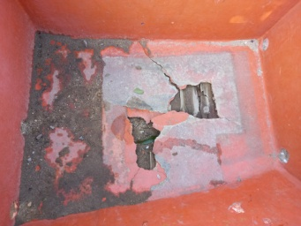
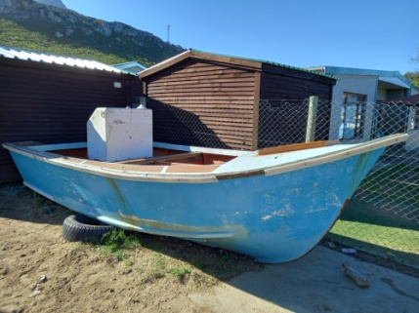
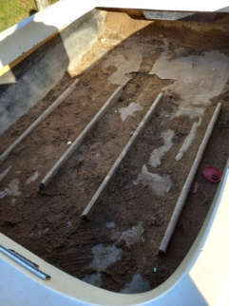
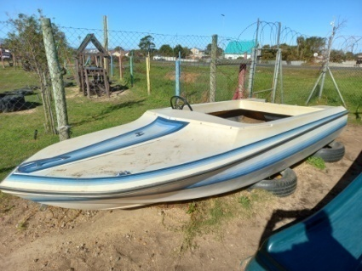

The floor and deck’s
damage.
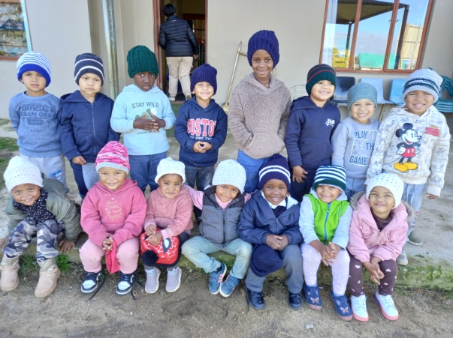
We received a donation of warm beanies for
some of our children. Tannie Evelyn Hendricks
knitted 40 beanies so long and are busy knitting
for the rest of our children. During the cold
winter months it’s always nice when they can put
something warm on their heads.

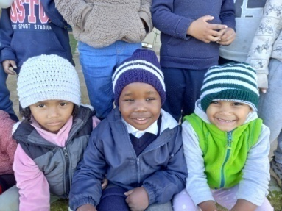
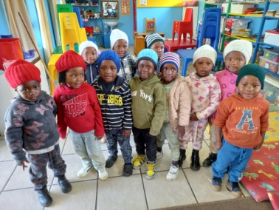

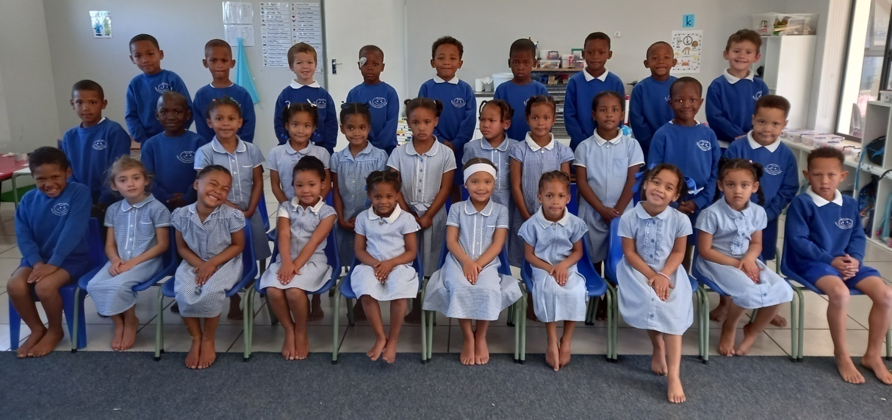

The Grade R Afrikaans class group photo.

Our wish list:
- Maintenance work on shop’s floor and boat decks (R10 000).
- Puzzles and house corner furniture for our 3-5 year classes.
- Carpets for some classrooms.
- Paving and shading for our ‘outside’ classroom.
- Compost for our grass (R5 000).
- Small toilet for 3-4 year class.
- Second hand items for our shop (old bedding, towels, kitchenware,
clothes etc.)
- Mural for Grade R classrooms’ wall (still need R10 0000).
- Mud kitchen for outside play area (still need around R5 000).

