NEWSLETTER 3/2023

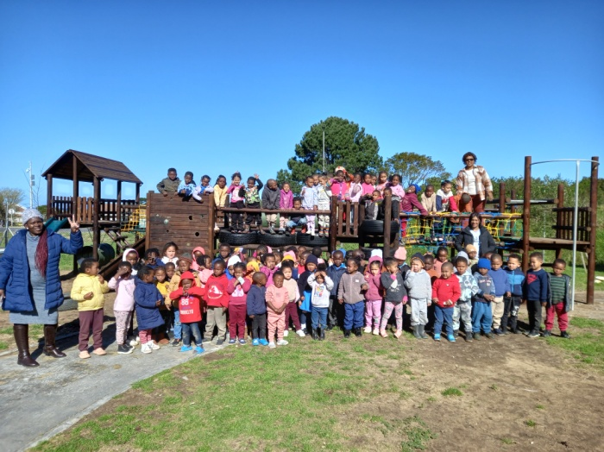
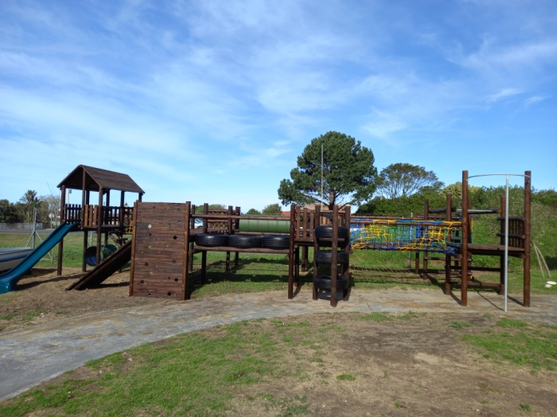

We have done it! Our jungle gym is here and it is everything we wanted for our children. It is the biggest, prettiest jungle gym in Kleinmond! It has taken almost three years to raise money for the jungle gym, so we have been dreaming about this for a long time.
It has been a huge team effort to make this dream a reality. We want to thank everyone who made a contribution towards this project. We will have the grand opening in October, because this is something we need to celebrate!

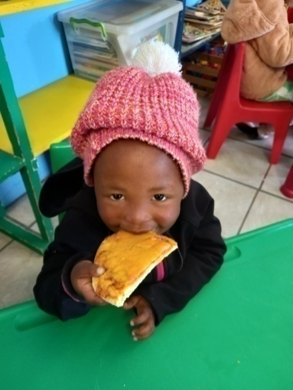
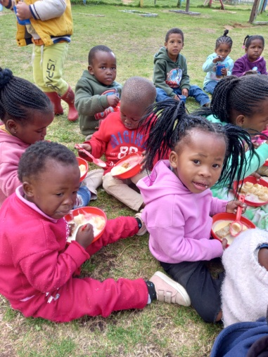
We are receiving a monthly donation
of non-perishable food. Our children’s
nutrition is very important to us, so we
are very grateful for this donation.

This makes it possible to treat our
children once in a while with some-
thing nice for lunch or dessert.

Here they are enjoying some bananas and
custard and pizza!

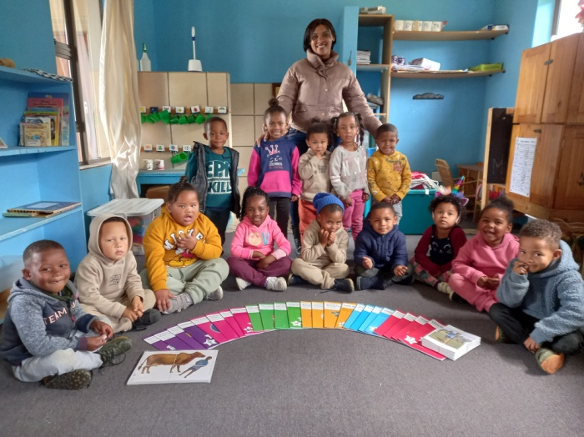
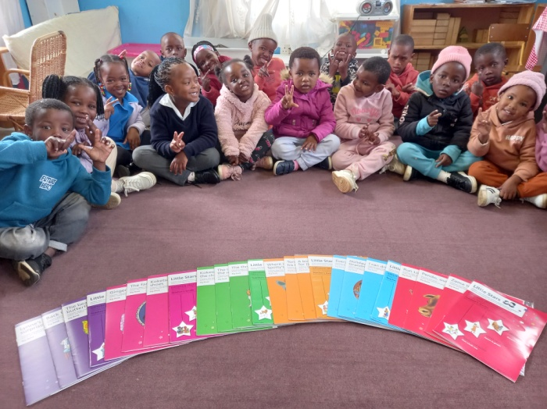

We also received a donation that had to go specifically towards a reading project for the school. I decided to buy the Little Star Language Programme. The Little Star Programme is for the pre-Grade R teachers working with the 4-5 year old children.

The programme addresses the literacy crisis in South Africa by providing children with learning experiences that build language and early literacy. It ensures children experience well-balanced, active, creative and effective language lessons centred around a story. It also strengthens children’s oral language, listening skills, phonological awareness and emergent reading and writing skills.

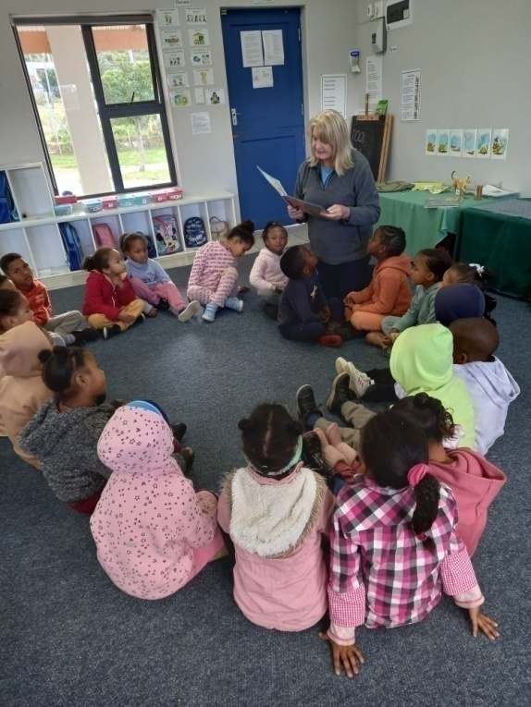
We are part of the ‘Kleinmond Vriende van
Afrikaans’ reading programme. There is
someone who comes every Monday to read
stories to our Grade R children.

Reading out loud isn’t just magical to our
children, it also builds important skills. Reading
aloud build vocabulary and strengthen cognitive
abilities. It improves comprehension, attention
span and active listening. It has benefits for our
mental and emotional health, because it provides
enjoyment. It strengthens fluency; reading
effortlessly, at the proper rate, accurately, and
with appropriate rhythm and expression. It
improves working memory.

We are so happy to be part of this project!

In our previous newsletter I shared with you what is happening in the classrooms.
This time I want to share with you a bit more about what is going on in the Grade R classrooms. They have a different program than the 2-5 year olds.

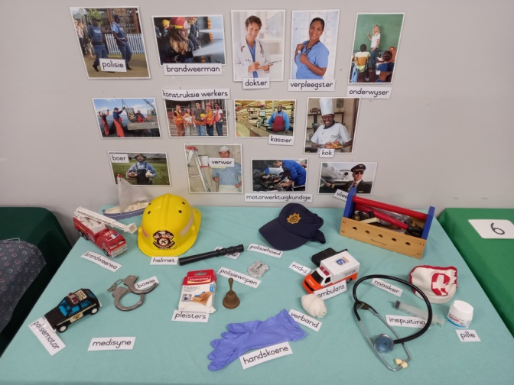
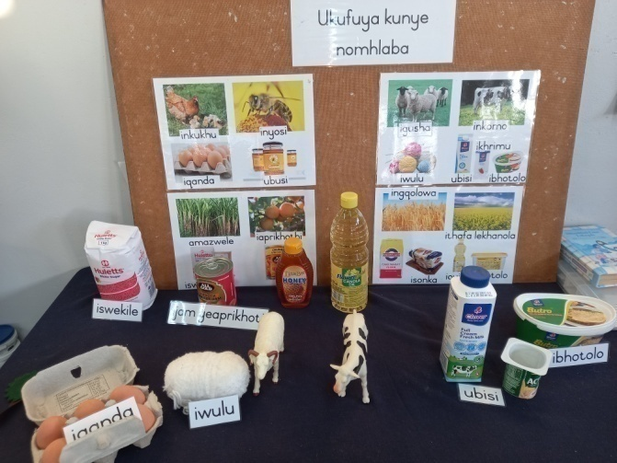

They start at eight in the morning with their morning ring. They go into much more detail when it comes to their themes. For example the little ones do People who help us, the Grade Rs will look at Jobs people do. Also with farm animals and products, they will discuss where honey, jam, sugar flour, oil and margarine come from.

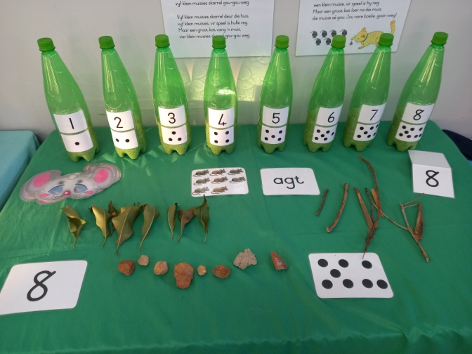
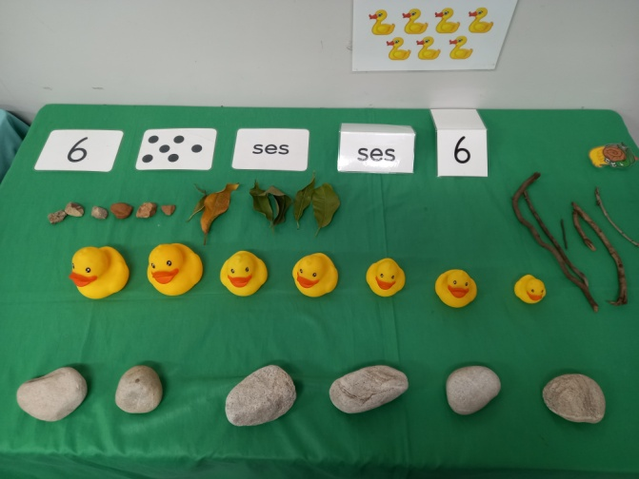

Then it is Mathematics time, while their brains are still fresh. They start with a whole class session where they work on a specific concept and then there are the small focus group and the small groups at the table. They also have a Math table in the classroom.
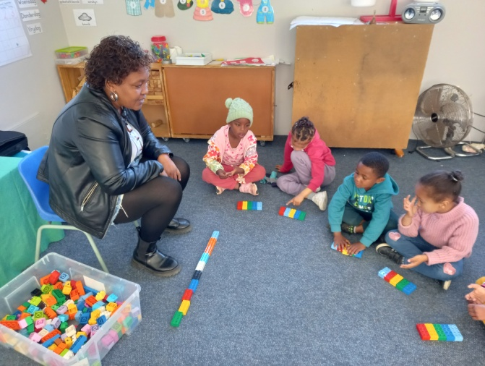
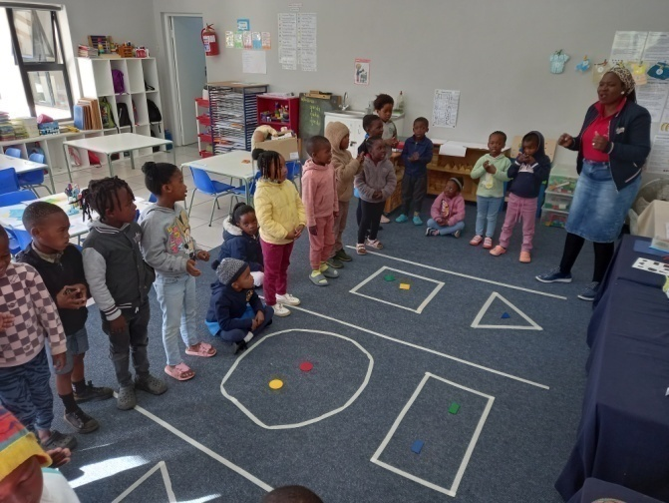

At the table groups, activities are put out which reinforce what they have learned in the whole class and focus groups.

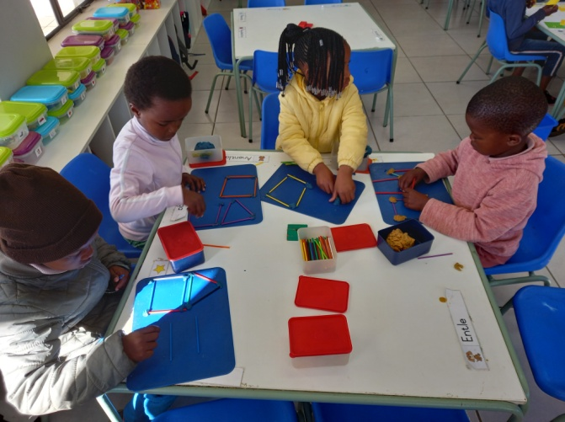
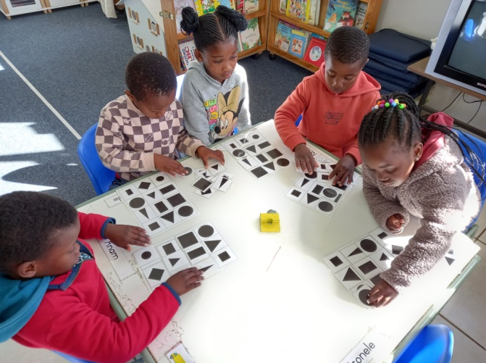

They have a fifteen minute break before Home Language time. During the Home Language time they do shared reading, guided reading and their five group sessions at their table. After each session the children have independent play where side stations like perceptual games, modelling, block play, fantasy, reading, etc. are done. They also have their Home Language table where the story characters, props, letter, song, rhyme and pictures are displayed.
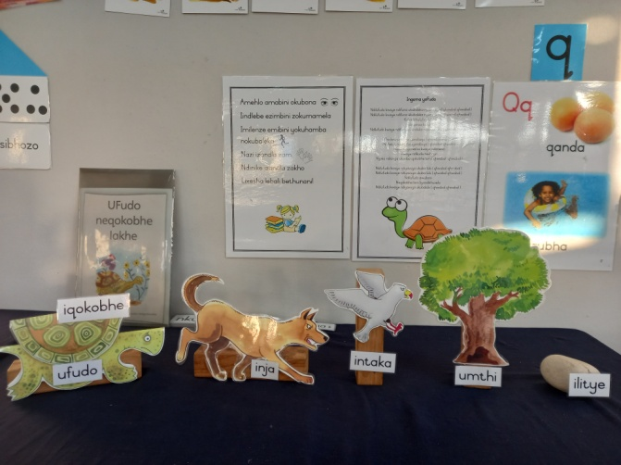
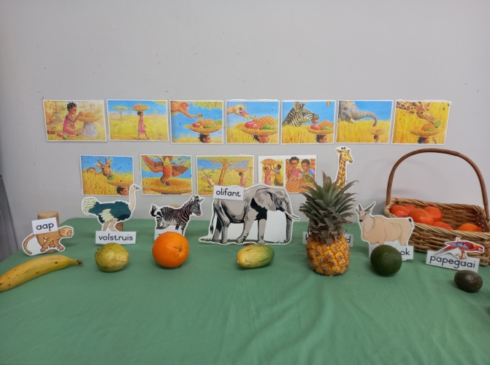

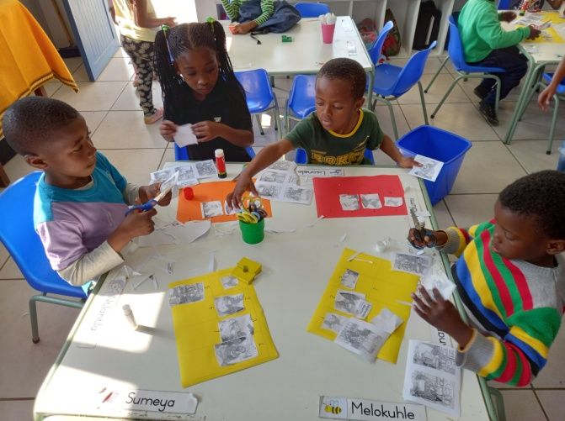
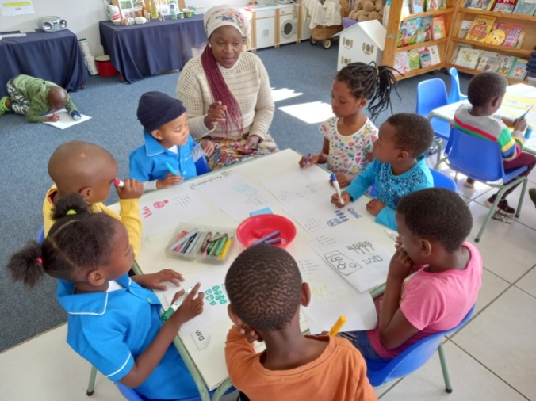

After Home Language it’s their break time and they play for half an hour. Then it is Life Skills (Music and Movement) where they do performing arts, visual arts and physical education. They have lunch and then it is rest time. From the small classes, a lot of progression has happened. You can see they have a packed programme and work very hard to prepare and be ready for Grade 1

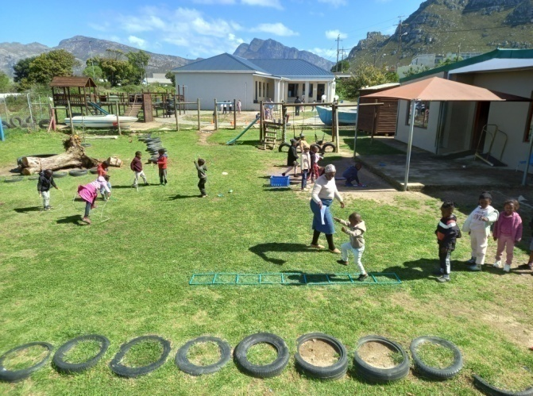
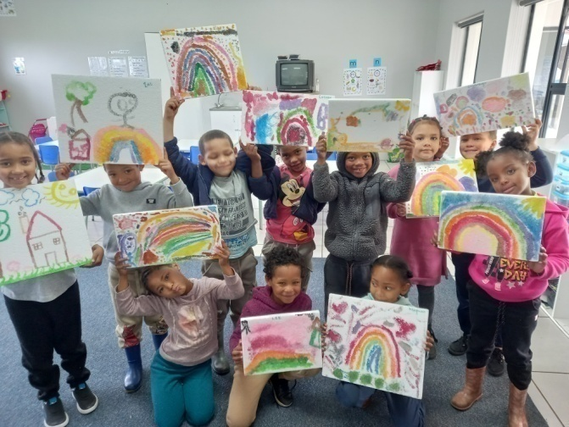

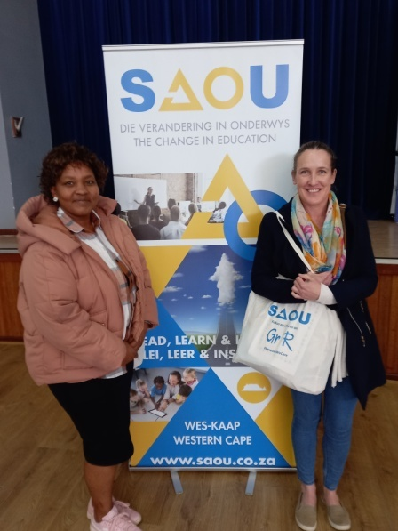
We did some more training this term. The first one was a
Grade R empowerment session that was held by the
SAOU. The programme consisted of the following:
Grade R methodology, transition from Grade R to Grade
1, integrating Home Language, Mathematics, and Life
Skills, coding and robotics, Grade R curriculum and time
allocation.

The second training was the Lego level 2 training. It was
done by Care for Education in cooperation with the
Rooiels Outreach Programme. It was a very practical, fun
interactive training. We look forward to continue to use
the Duplo Lego in our classrooms to develop all the early
child development skills our children need.

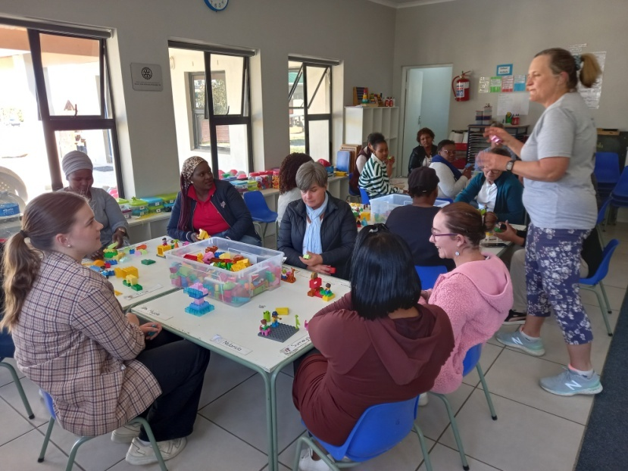
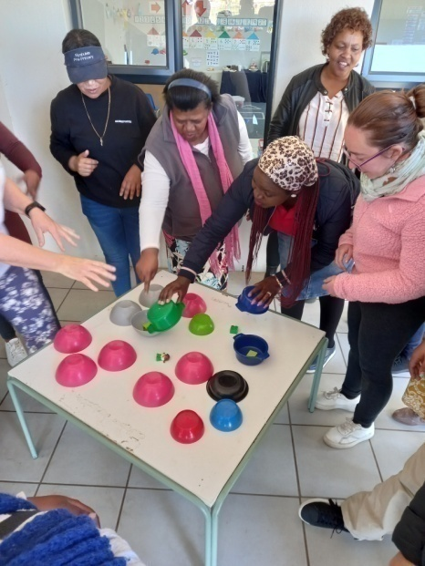

Now for the fun part!
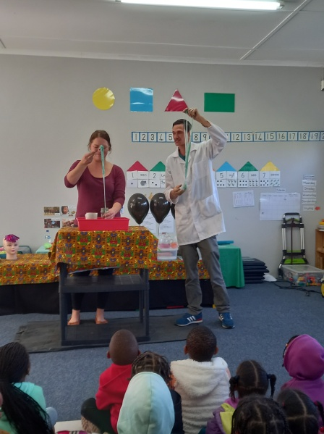
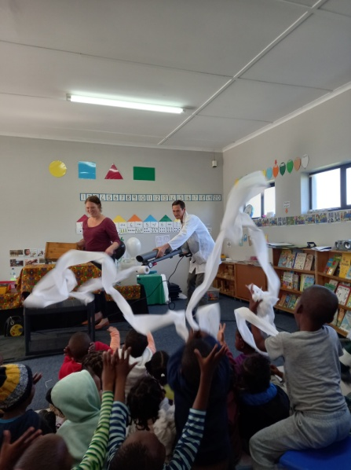
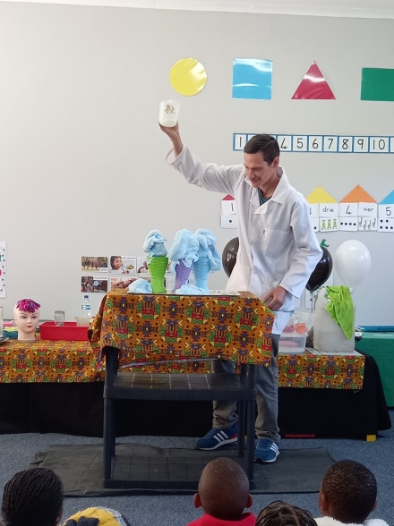

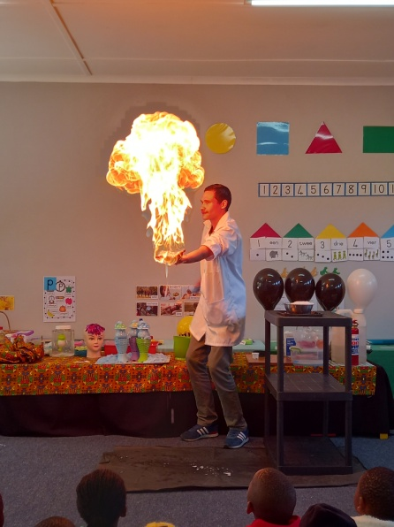

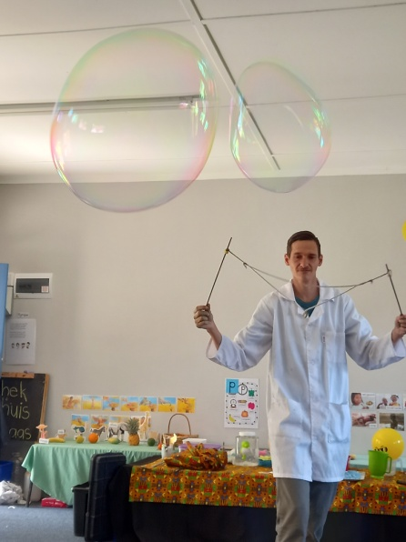
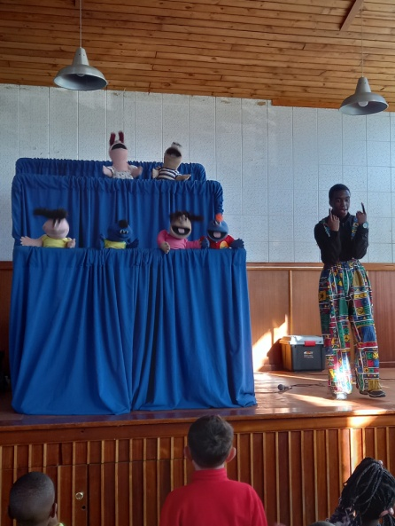
We had a science show
for our children.
The people from the Mini
Science Lab did a lot of
interesting, fun science
experiments. The show
was almost an hour long,
but kept our children’s
attention throughout!
The children really enjoy-
ed every minute of it and
we will definitely make this
a yearly event.

We were invited by Magnificent Kids to a puppet show in
town. The puppet show was done by Abundant Life.
The subject of the show was “Not Fearing” God is with
you. It is a great way to share a beautiful message
through a puppet show, for children to relate and under-
stand the message.

I took a group of children down town. They enjoyed it
very much and enthusiastically took part in the songs
and actions during the show. They each received a
goody bag.

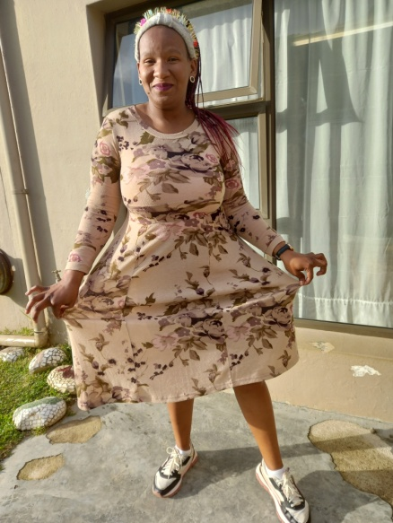
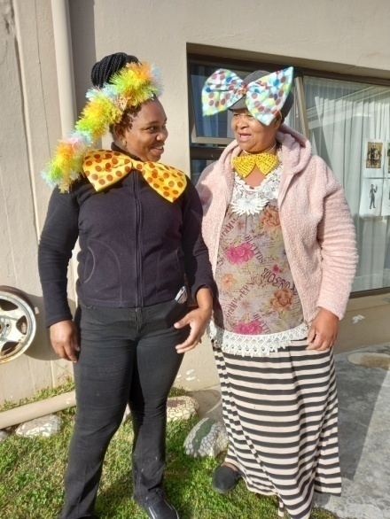
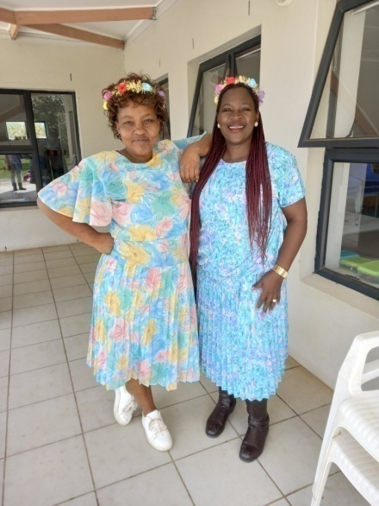

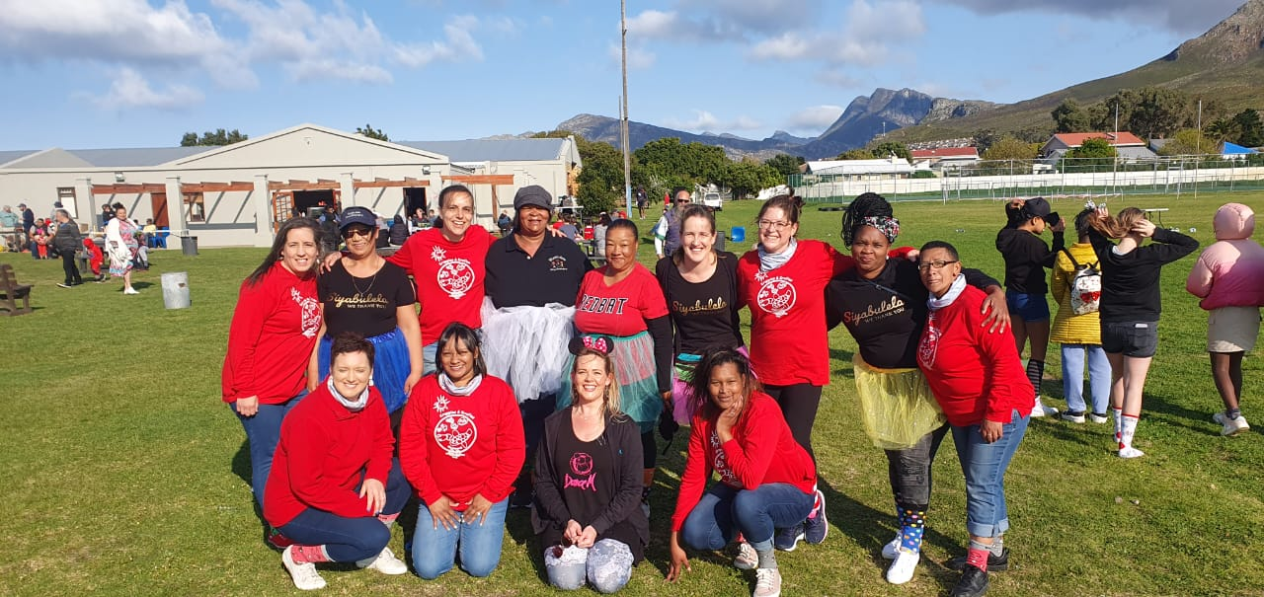
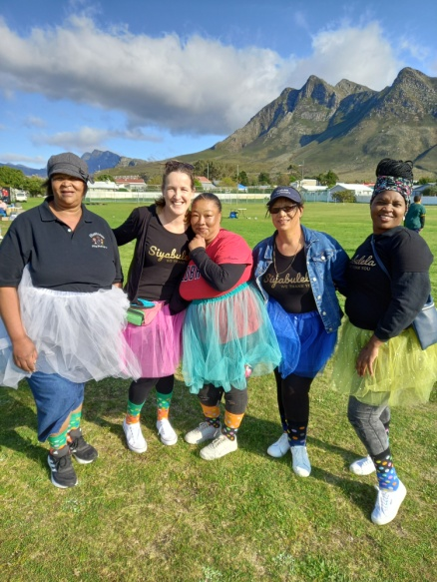

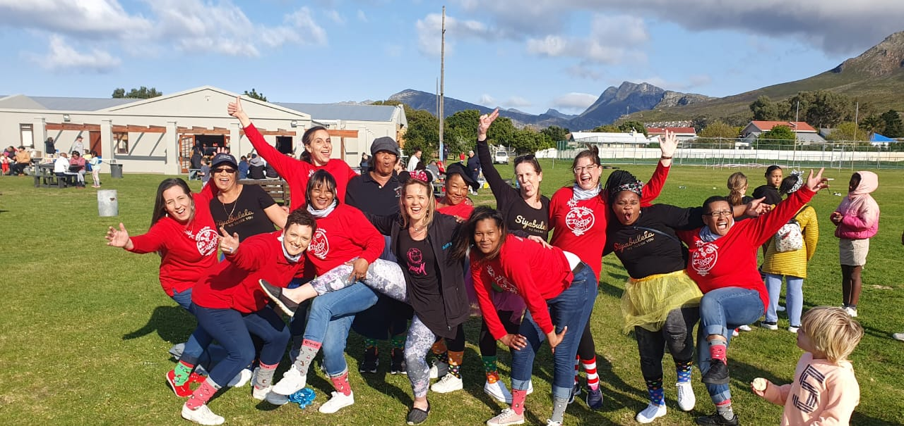

A picture is worth a thousand
words...

We celebrated a cold spring day on the first of September. Our staff brought some sunshine to the day by dressing up and making the most of it. Some of the staff also participated in Krappies en Krefies Funky Sock Day. It was another cold spring day, but we dressed up and brought the energy!

We enjoy supporting the other schools in town. I think it is important to work together, because we are all working towards the same goal at the end of the day.
We are finally back to our wish list. There is always a list of things we need for our school and our children. There is always room for improvement and I think it is good to have goals to strive towards.

Thank you for making a difference.

Alta, the staff and children of Siyabulela Pre-Primary

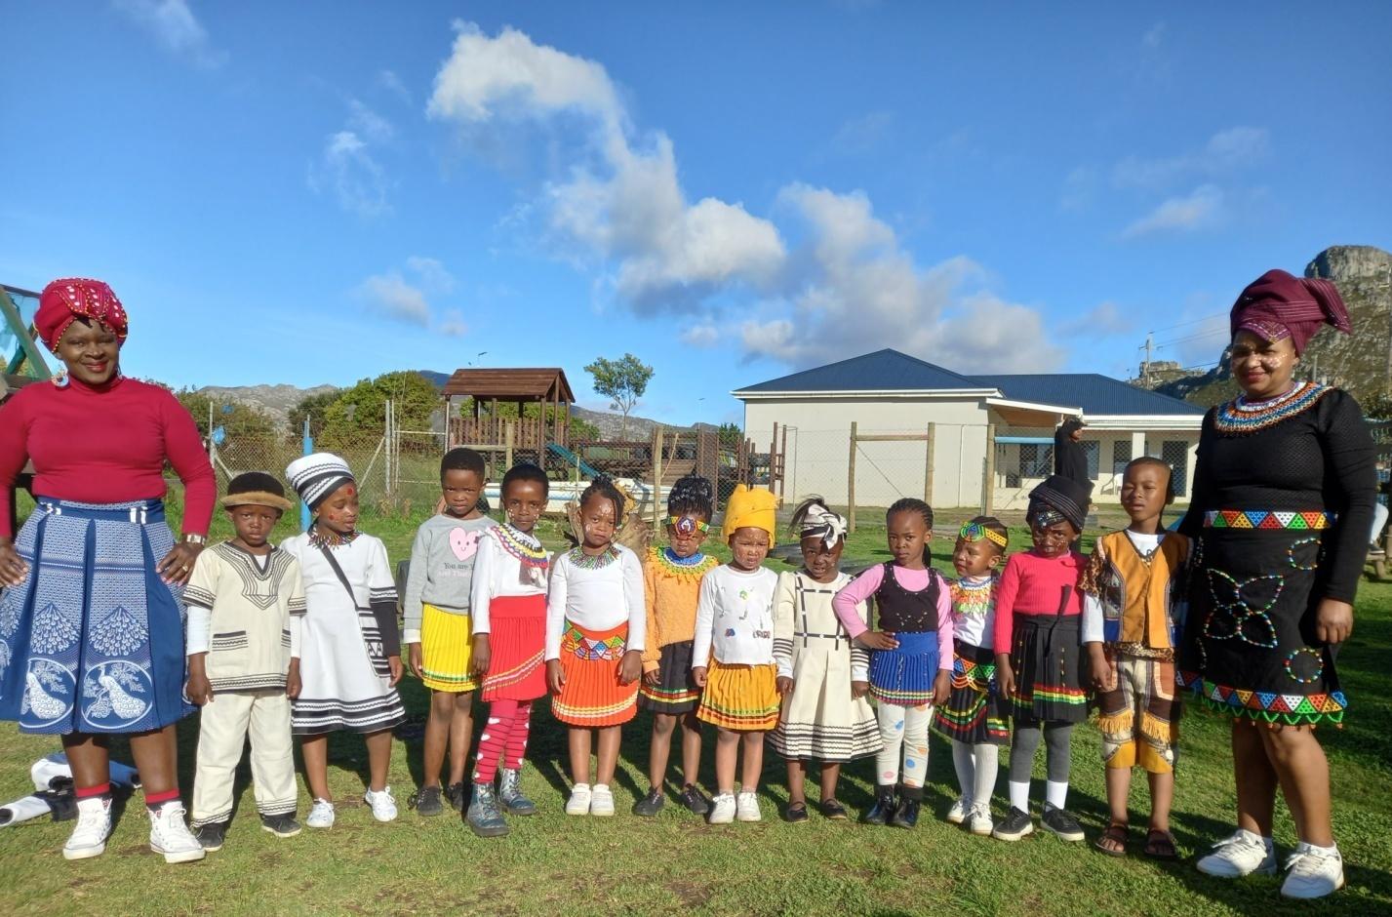
Heritage Day on 24 September recognises and celebrates the cultural wealth of our nation. South Africans celebrate the day by remembering the cultural heritage of the many cultures that make up the population of South Africa.

Siyabulela is rich in different cultures...

Our wish list:
- Mural for Grade R classrooms’ wall (R20 0000).
- Mud kitchen for outside play area (R15 000).
- Fixing cracks in wall in classroom (R2 350).
- Lifting ground level where water is coming through wall (R4 980).
- Building cement box for corrugation taps (R950).
- Small toilet for 3-4 year class.
- Carpets for some classrooms (R6 730).
- Paving and shading for our ‘outside’ classroom.
- Natty Rubberising bicycle track: R300 per square meter.
- Higher fencing around our school to prevent breakings.
- Second hand items for our shop (old bedding, towels, kitchenware,
clothes etc.).

