NEWSLETTER 3/2024

I was evaluating the teachers as I do every year and every year it is my highlight to spend some time in the classrooms and see what is being done there. This year was no exception. I am in awe of what the teachers are doing, how hard they are working with our children and how well our children are doing!

I told you in the last newsletter about how we are focussing on number concepts, because the children struggle with number sense. This term I visited the Grade R classes and was amazed at the progress that was made during the year.

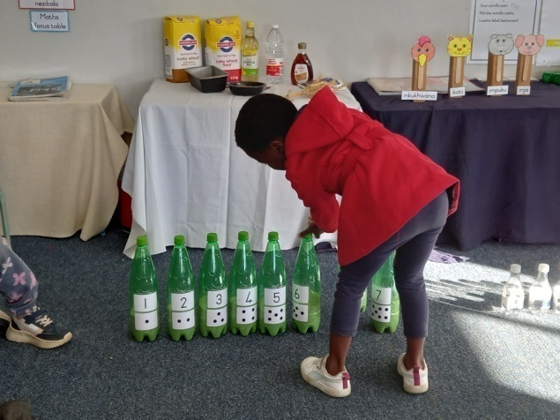
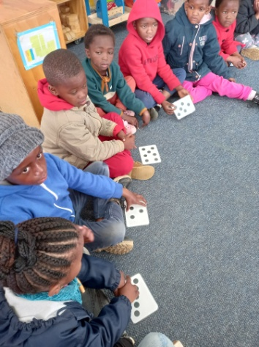
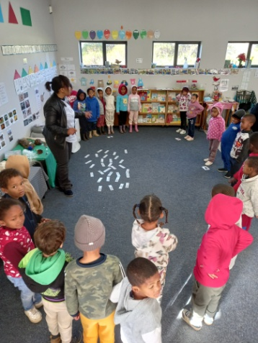

The Grade R’s starts early in the day with Mathematics. First it’s the whole class session during which they do rhymes, songs, oral counting, counting objects and then their math concept for the day. The days I was there, the isiXhosa class did dot cards and ordering. They placed 8 numbered bottles in the correct order. Then they said what dot card they have and matched these to the bottles.

The Afrikaans class were discussing and reporting on collection, sorting and organising data.

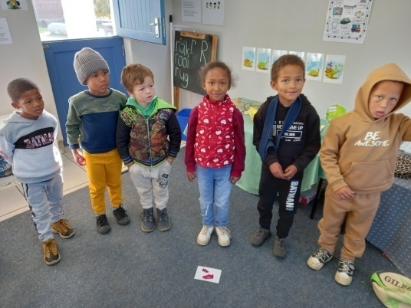
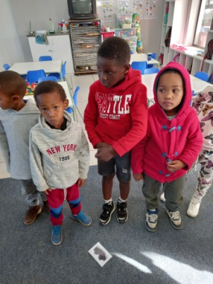
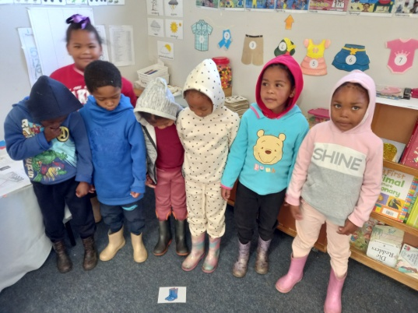

I found the sorting and organising data lesson very interesting and practical. The learners had to arrange themselves into groups according to their shoe type (shoes with Velcro, laces, Velcro and laces, buckles and water boots). Then they counted the learners in each group and had to compare the data they collected; most, more, least, fewer, equal.
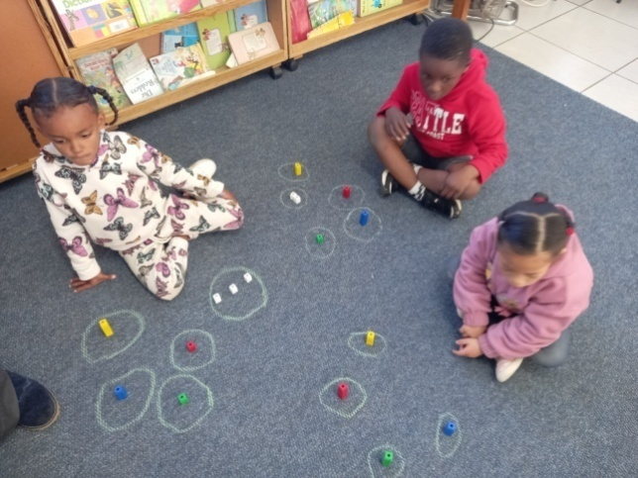
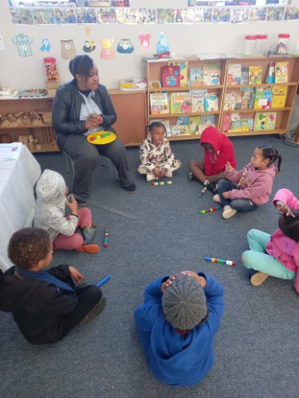
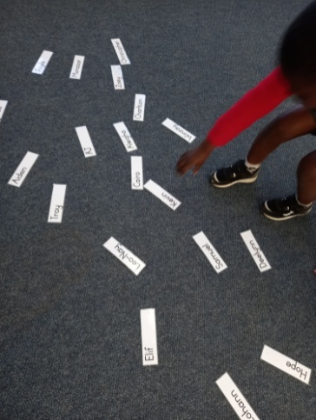

This was followed up by representing data; where they choose their favourite colour hat, then they have to recognise their name among other names and place it on a pictogram. They compare the data again. This is again reinforced during the small group session. Where they had to count out 10 counters, compare counters to the other children’s and then sort their counters into colour groups and compare.

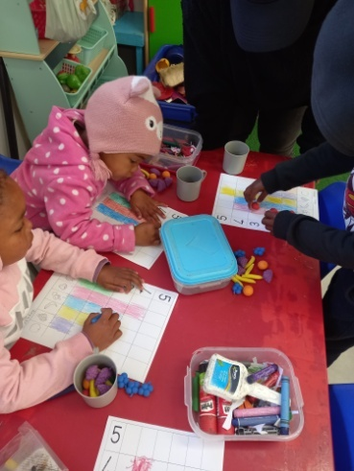
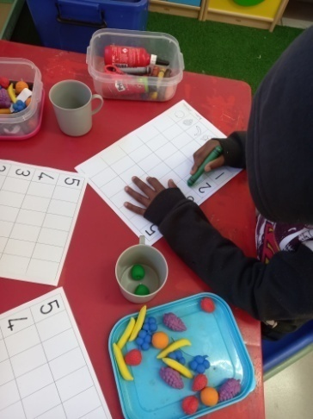
At the workstations at their tables
they also did data by counting the
different fruit they have and colour-
ing in the graph.

What was interesting to see was how
they checked afterwards if they were
correct by putting the plastic fruit on
each block they coloured in.

All in a days (morning) work!

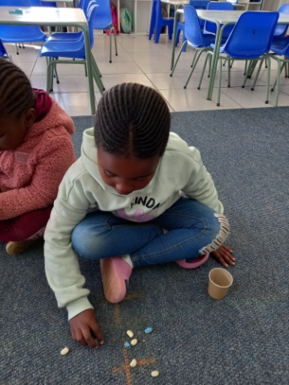
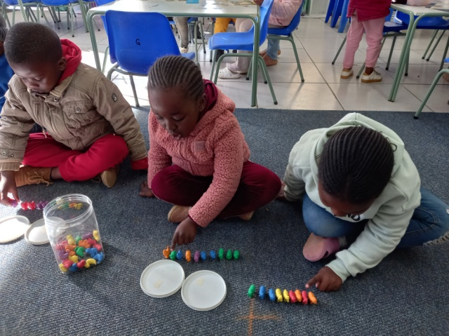
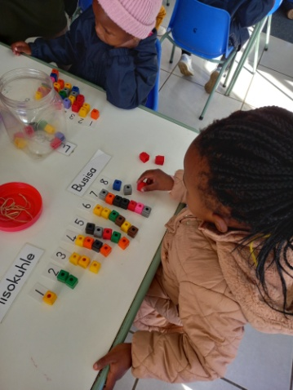

The other class did word problems, practising 1–8, more/fewer/equal, shake and spill the beans game and ordinal numbers 1-5. This might be too much Math for you, but as a pre-school teacher I find it fascinating. So this is for all the Math teachers out there.

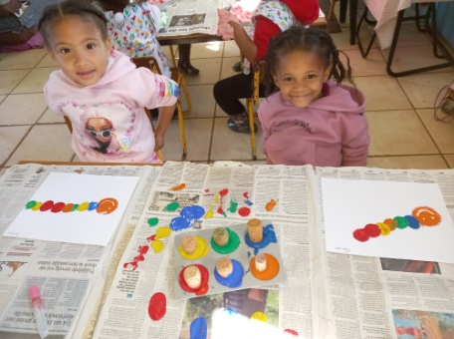
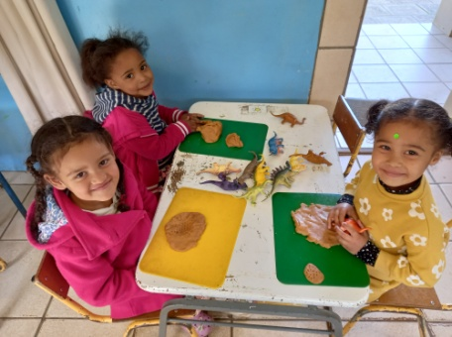
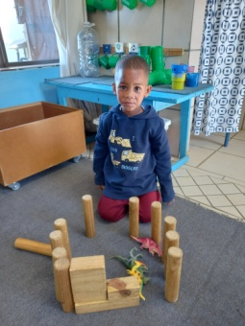
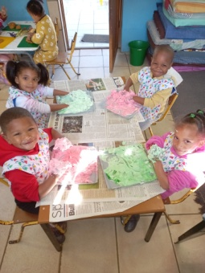

Then off course, all the fun and learning continued in the other classes. There were sensory play, painting, play dough activities, construction, time for “reading” in the book corner, playing in the house corner, doing music and lots more! During their time in the reading corner they look at the pictures and make up their own stories.

The house corner is also very important for their social development and communica-tion skills. They learn critical thinking skills, how to follow simple directions, build expressive and receptive language, increase social skills and learn how to manage their emotions. Role play enhances self-confidence, intellectual growth and language skills. It allows children to experiment with real-life situations, preparing them for future roles and responsibilities.

And here we all thought they were just playing...

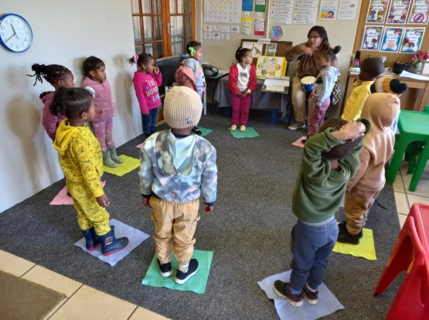
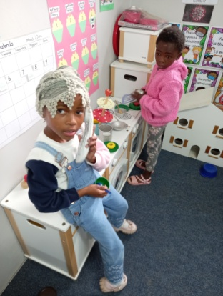
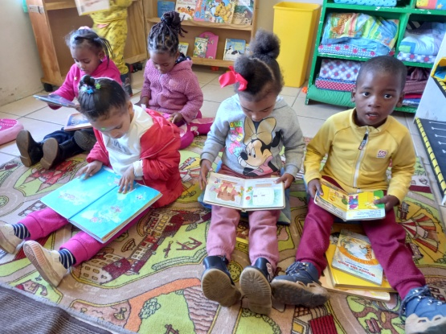

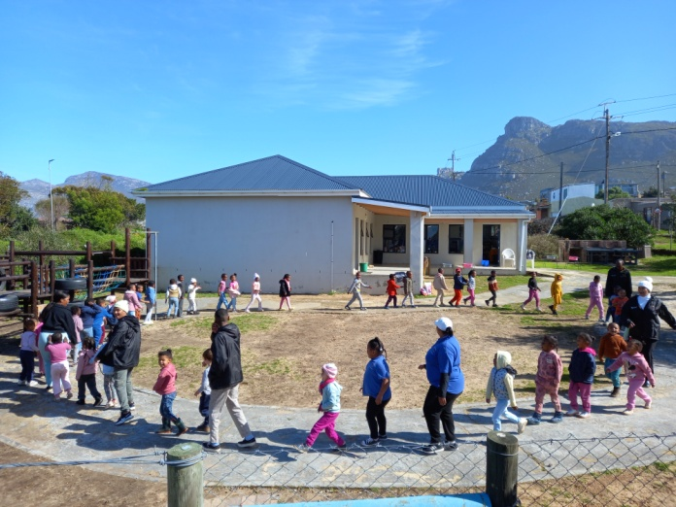
We are part of the Yeboneers project this
year. They are a group of young people
who serve their communities and learners
in different ways. At Siyabulela they read
stories and play games with our children.

It is an initiative between the Western
Cape Government, Community Chest
and numerous NGOs. The aim of the pro-
gramme is to develop, grow and support
children in their educational development
and holistic development.

Another initiative we have at the school to give young people opportunities in life, is our Boland College students who do their practical’s at the school. They are here for four days of the week and go to class the other day. By doing this they get a lot of practical experience and are ready to be an ECD teacher once they are finished.
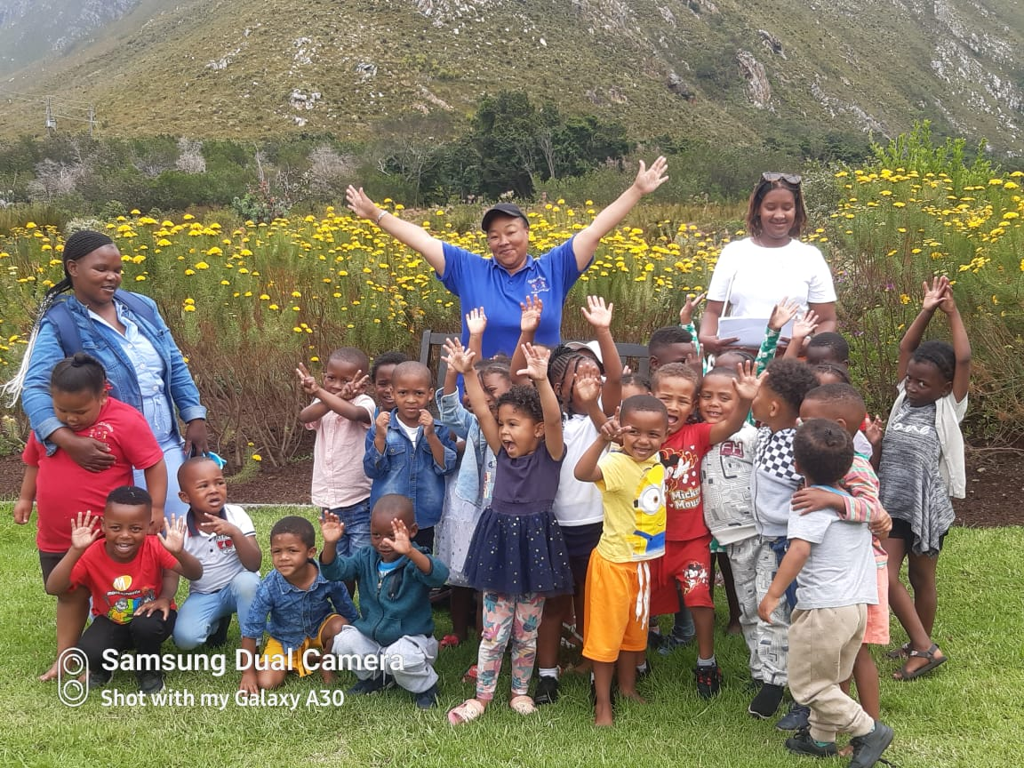
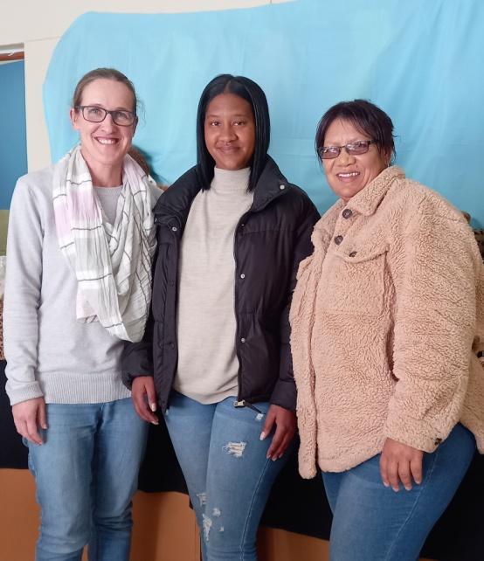

r

Then off coarse our Grade R classroom assistant, made possible by the Narollah Trust.
I just saw once again, when visiting the Grade R classes, what important role they play and how beneficial it is for the Grade R teachers and children to have assistance.

Their roles and responsibilities: getting the classroom ready, supporting teacher in managing class behaviour, supervising group activities, giving individual support to children who need it, reading to children, clearing away materials and equipment after lessons, helping with outings, taking part in trainings, carrying out administrative task.

To support children with particular individual needs, they work one-to-one or in small groups. They can also take the class when a teacher is of sick or on training.
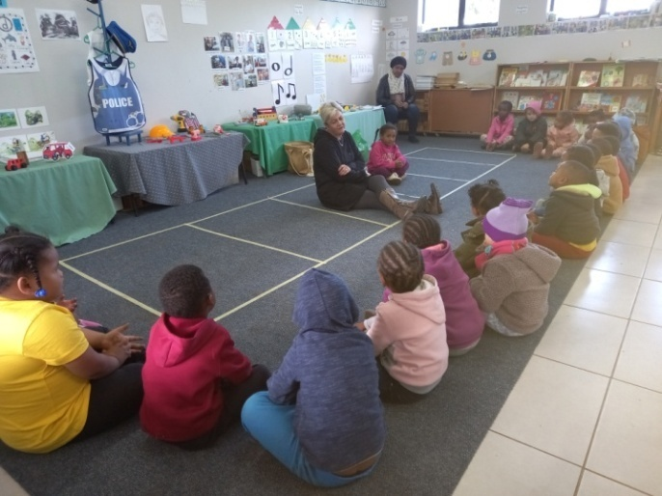
Then we are very lucky to have tannie
Adalene doing the KEE (Kids Emotional
Empowerment) programme at our school.
She and her daughter are the founders
of KEE.

The goals are to address the social- and
emotional development of the child. It is
also focused on empowering the children
on their own journey to a better sense of
identity.

Topics include, but are not limited to:
identity, boundaries, emotions, social skills. We are very happy to be part of this programme and feel that our children will definitely benefit from it. Social and emotional development, which is very important, are sometimes pushed aside, because the focus falls on cognitive development in schools.

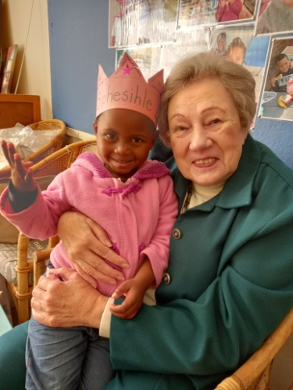
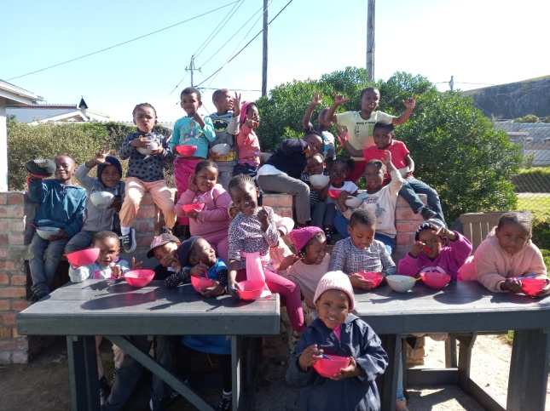
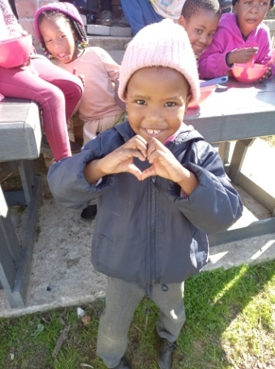

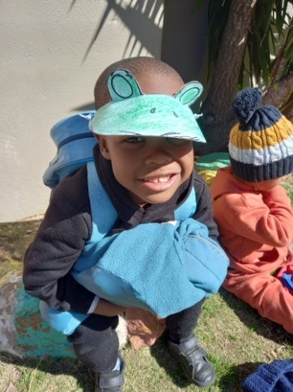
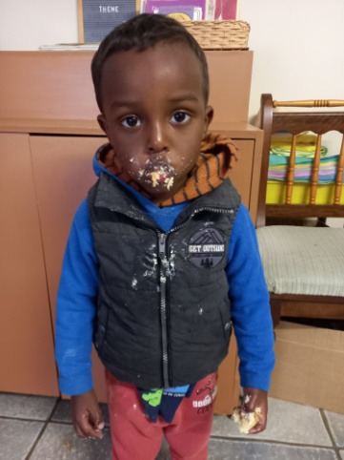
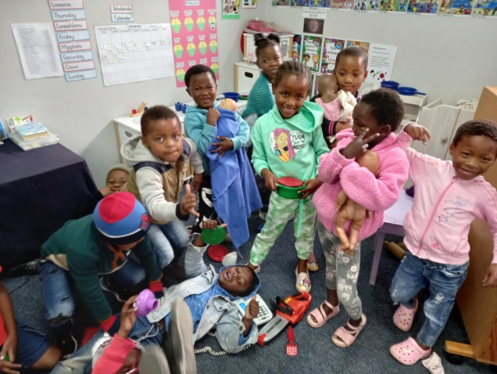

I am ending of with a few fun photos! Grade R children having lunch outside in the sunshine, birthday celebrations with our ever so lovely tannie Corrie, being frogs for the day, more birthday celebrations (stuffing your mouth with cake) and happiness in the house corner. In all this world there is nothing so beautiful as a happy child.
We had a very cold, wet winter and look forward to some Spring weather. As always we have a list of things needed to be done at our school of which our last leaking roof is the most important.

I was once again in awe of how amazing people are when I wrote an article for the local newspaper asking for donations towards geysers for two of the other pre-schools in the community. We were able to raise enough money to make this happen.

Thank you all for being amazing! Happy Spring!
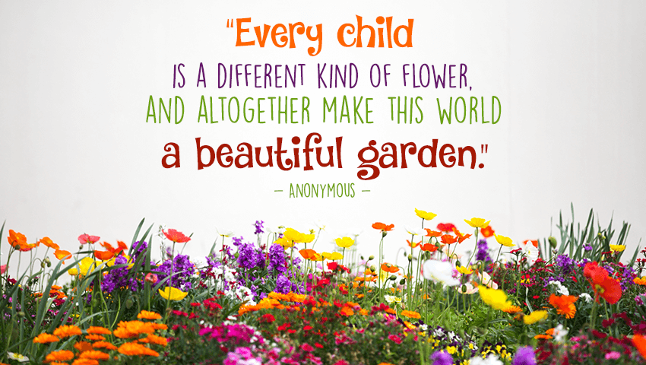

Our wish list:
- New roof for my office/staff room, kitchen and store room (R70 000).
- Varnish for our Wendy houses (R10 310).
- New roofs for our Wendy houses (they are all rusted) (R25 000).
- Compost for our grass (R5 000).
- Puzzles and house corner furniture for our 3-5 year classes.
- Small toilet for 3-4 year class.
- Carpets for some classrooms.
- Paving and shading for our ‘outside’ classroom.
- Natty Rubberising bicycle track: R300 per square meter.
- Higher fencing around our school to prevent breakings.
- Second hand items for our shop (old bedding, towels, kitchenware,
clothes etc.)
- Mural for Grade R classrooms’ wall (still need R10 0000).
- Mud kitchen for outside play area (still need around R5 000).

