NEWSLETTER 3/2025

Looks like our theme for this newsletter is dress up! But first things first. Our new fences and gates are up! We are happy to share with you that after years of waiting and having it on our wish list for a very long time; we have beautiful, durable fencing. We are so grateful to the sponsors for this project: the two UK churches, Holy Trinity in Prestwood and St Mary Magdalen in Great Hampden, the Fraser Family Trust and another family trust.
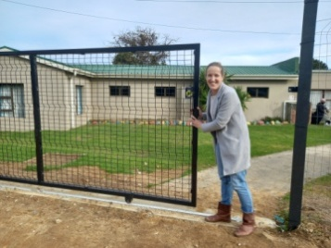
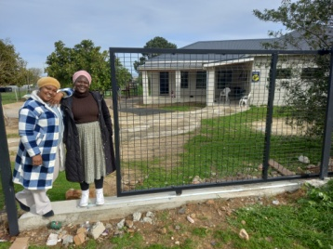
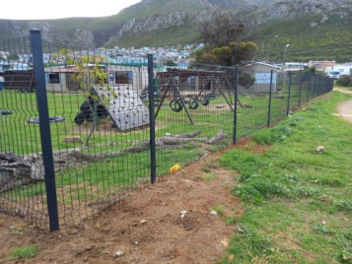
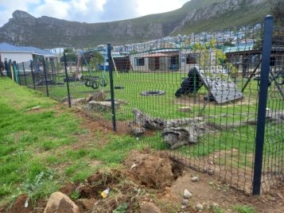

I am also happy to share with you that our shop floor and our boat decks have been fixed. We don’t have to worry about broken planks anymore and the boats are safe for our children to play on. Thank you Michael, you have been instrumental in helping us to get our maintenance done.

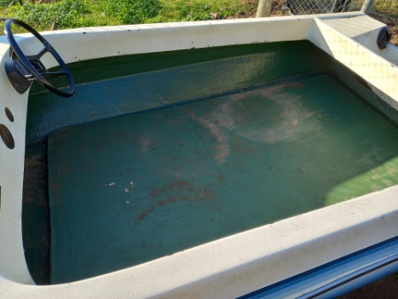
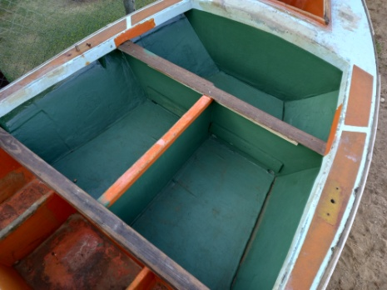
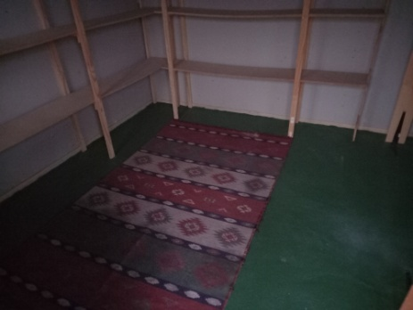

They are still busy upgrading our Grade R playground. Our last two projects for the school’s playgrounds are phase two of our Grade R playground and then we want to put in two sandpits for our Grade R playground and new swings and see-saws for our other playground.
So, as I mentioned before. We have been dressing up and having fun here at Siyabulela! We did a ‘What I want to be one day’ dress up day end of last term. It was a bit late for the newsletter, so I’m sharing it now. The children (parents) went all out. There were doctors, police men, army men, fire fighters, teachers and even princesses and super heroes!

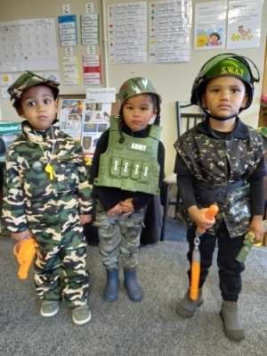
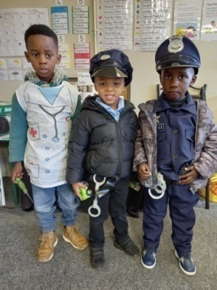
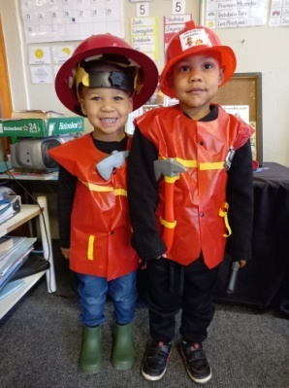
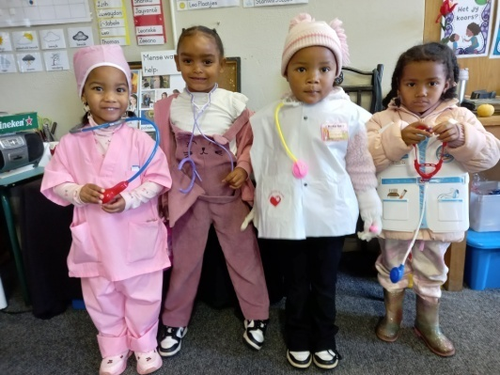

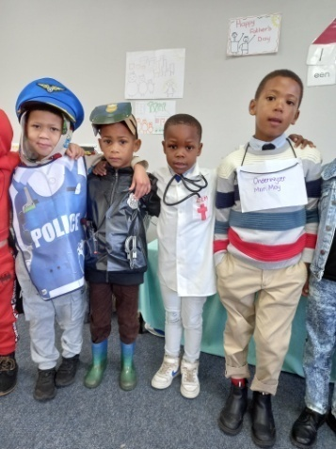
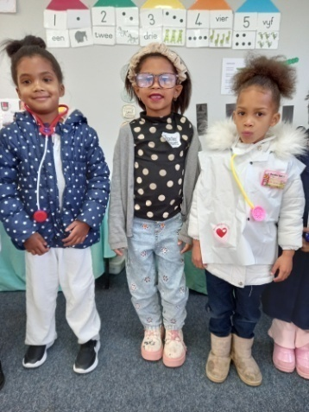
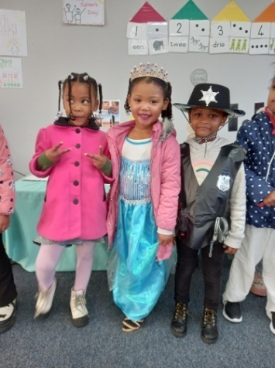
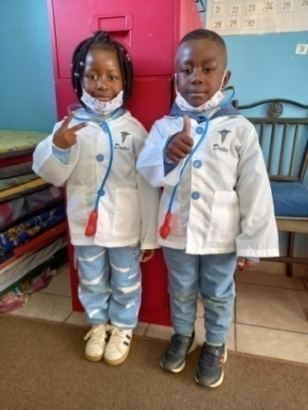

We gave no set ideas as to what they could wear, because we want our children to dream big and believe they can be anything they want to be one day.
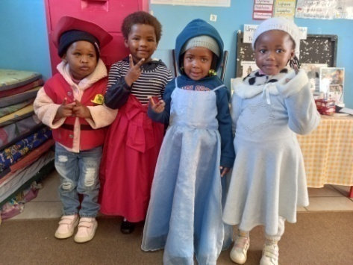
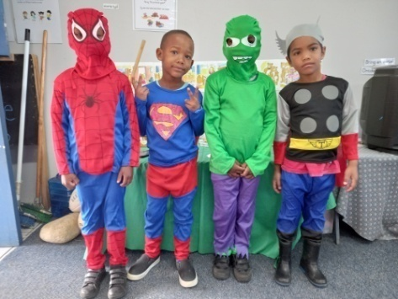
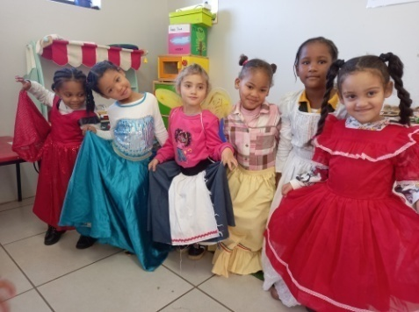

We had some more dress up fun in the house corners. This is where their imagination runs free. Imaginative play offers numerous benefits, including cognitive skills like problem-solving and critical thinking, enhancing social-emotional growth through empathy and cooperation, and developing strong language and communication skills by fostering self-confidence, promoting independence, and building a deeper understanding of the world.
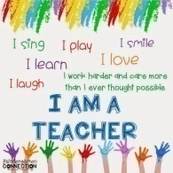
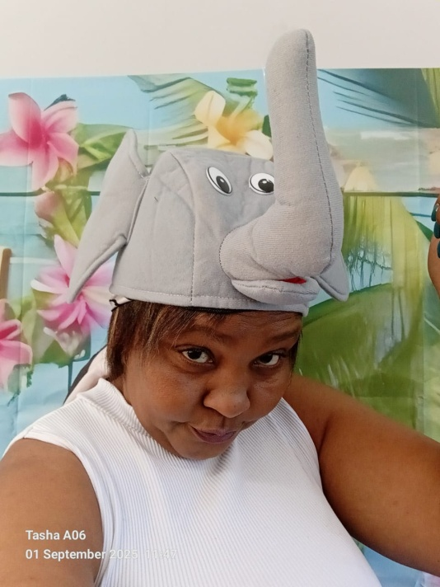
And it’s not just our children who like to dress up,
our teachers also enjoy it! It is very important that a
M preschool teacher can enjoy themselves with the
children in their class. If they make it fun for them-
self, it will be fun for their children.

I was very proud of my staff and the work they do
when one of the Boland College students ask if she
can change her practical school and come to us.
She did her shadowing at different schools and
said she had her best shadowing experience
at Siyabulela and she will learn the most here.

That says a lot.

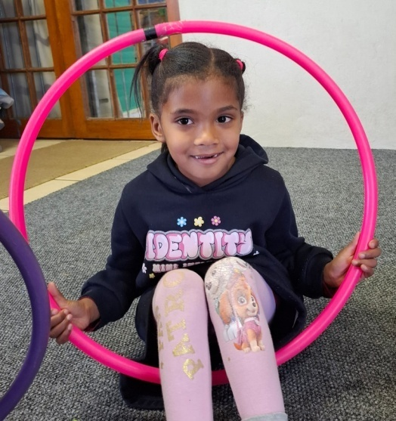
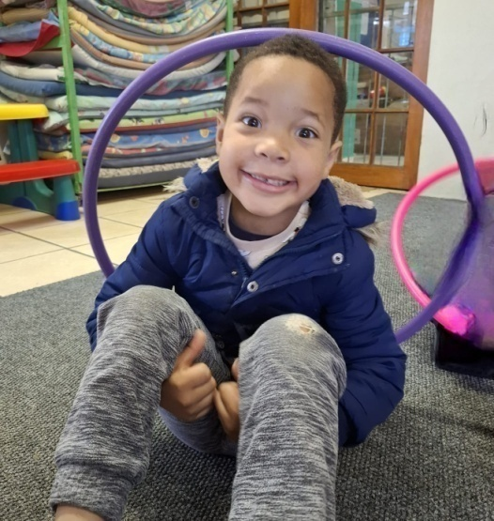
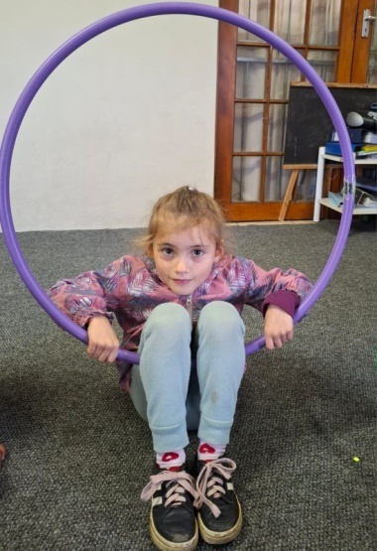

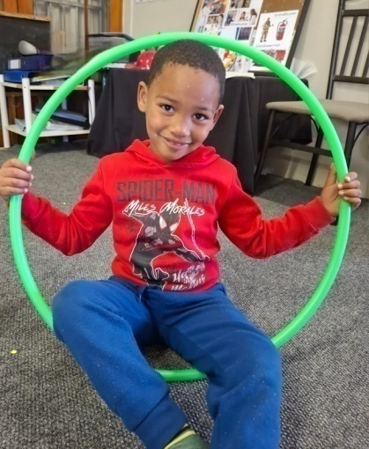
The Dance Mouse children keeps enjoying their dance class-
es. It is amazing to see how much they have grown through
the year and how much confidence they have.

Every class burst with energy, creativity and pure movement
magic. Using fun props like ribbons, scarves, balls, flags,
umbrellas and hula hoops, they make every class an adven-
ture.

Dance Mouse enhances coordination, balance, brain pattern-
ing, team work, flexibility, rhythm and self confidence. It also
supports emotional well-being, fitness and endurance.

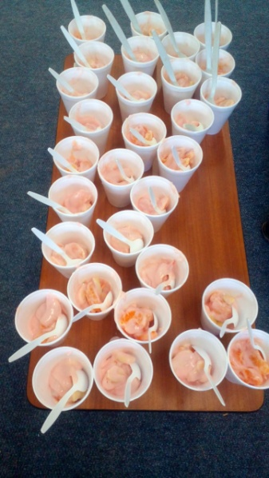
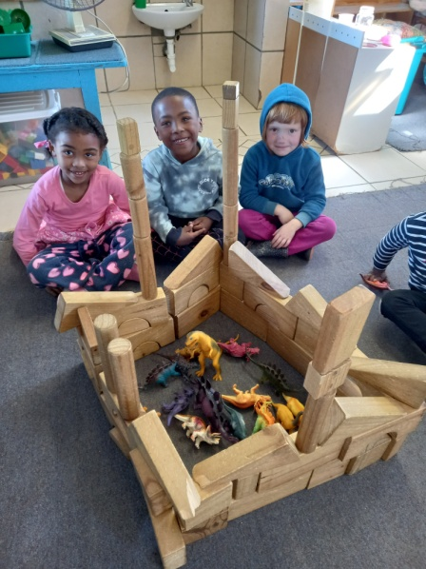
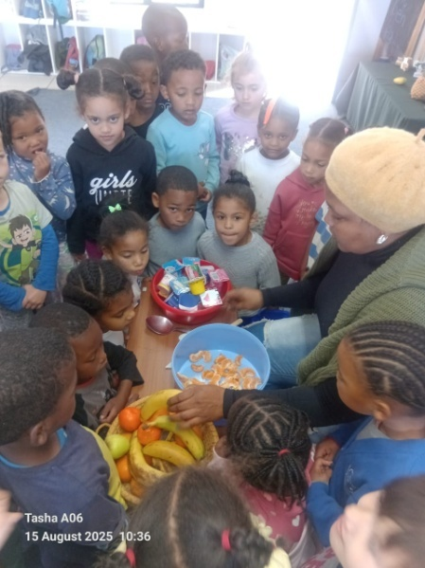

In the classrooms we’ve also been having some fun. The Grade R’s did Healthy Eating and Healthy Living. They always make fruit salad when they do these themes. All the children give their fruit and yoghurt and the teacher makes them a big bowl of fruit salad. They love it!

Construction is always a part of their day (whether it is blocks, Lego or other construction toys). The 2-4 year old children still build on one level, but when they go to the 4-5 year class, they start building more upwards. The children made a “castle” for the dinosaurs.

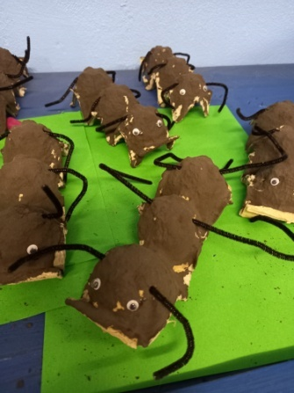
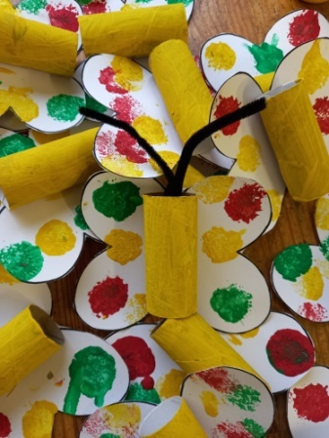
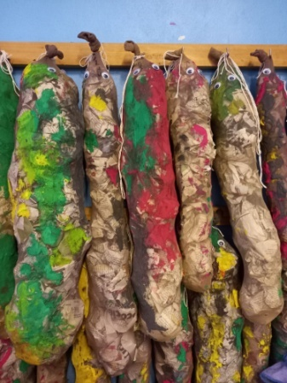
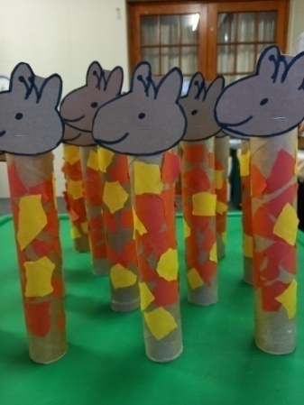

The implementation of the new Maskot program is going well. The teachers are really embracing all the new ideas and activities. There are lots of educational activity ideas for the morning and then they have been making beautiful arts and crafts.

The Maskot program is big on using recycle materials for art work, so here you can see giraffes, snakes, butterflies and ants made out of kitchen and toilet rolls, stockings, newspapers and egg cartons.

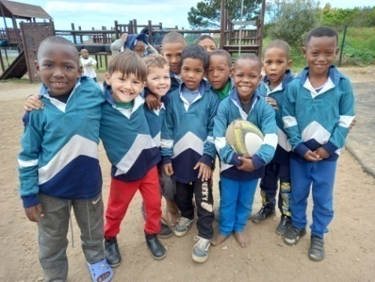
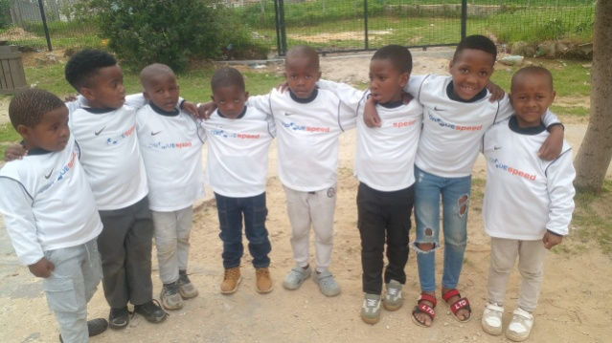
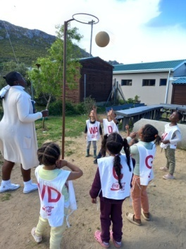

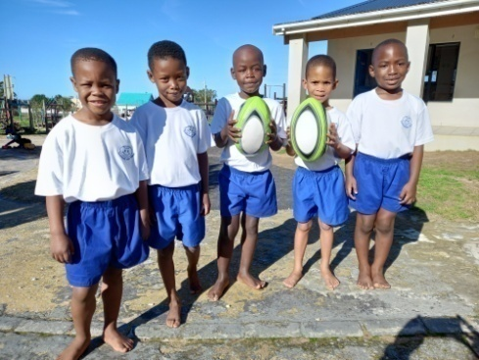
Outside the classrooms we’ve been having just as
much fun. We’ve been putting on the rugby, soccer and
netball kits and our children are doing “sport” Friday
afternoons. They love it!

Team sports are not just good for their gross motor
skills, it’s good for their hand-eye coordination, teach
them to share and play as a team. These sports foster
a sense of belonging and purpose, build relationships, teach resilience, and improve executive functions like focus and memory.

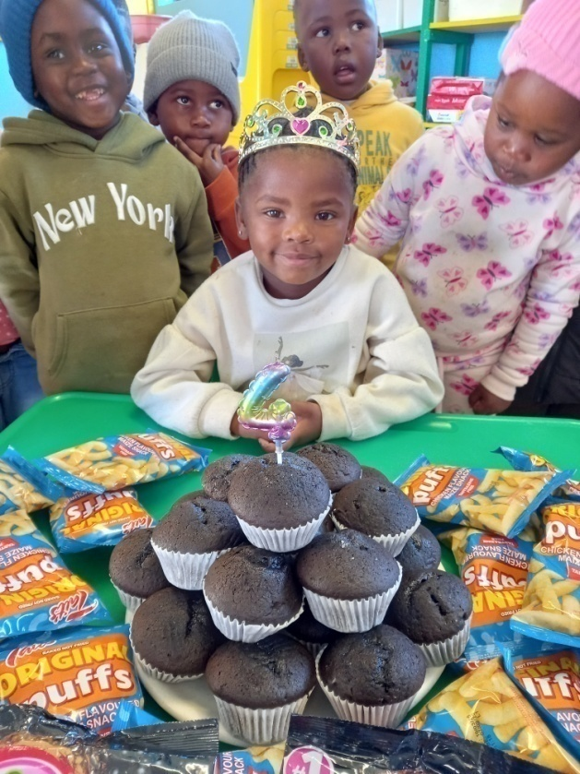
We like to make birthdays special for our
children. It’s the one day in the year that they
should be spoiled. We make a crown for them,
and we decorate the class.

Some of our sponsors will also send some
cake, sweets and a gift.
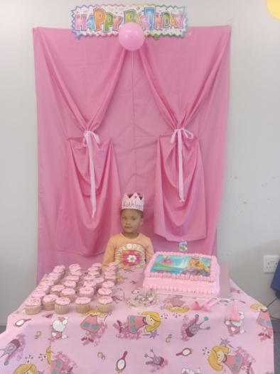
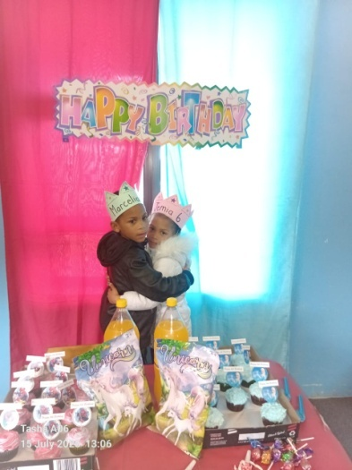

Celebrating birthdays is important because it provides joy, marks a person's unique existence, and reinforces their sense of self-worth and connection to others.

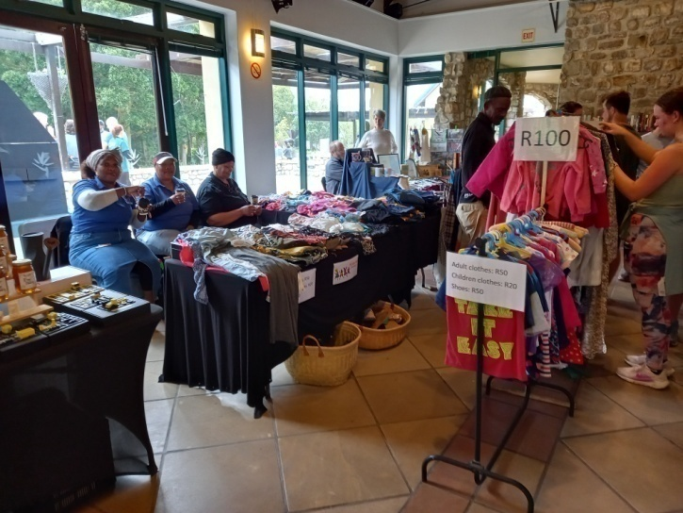
We did our first market this term. There
was a market at Harold Porter Botanical
Garden and we decided to see how it
goes. We sold second hand clothes the
Saturday and Sunday. It was very enjoy-
able.

We raised some funds for the school, but
I said it’s not just about the money. It’s
also raising awareness and letting people
know about Siyabulela.

This way we also build new relationships.

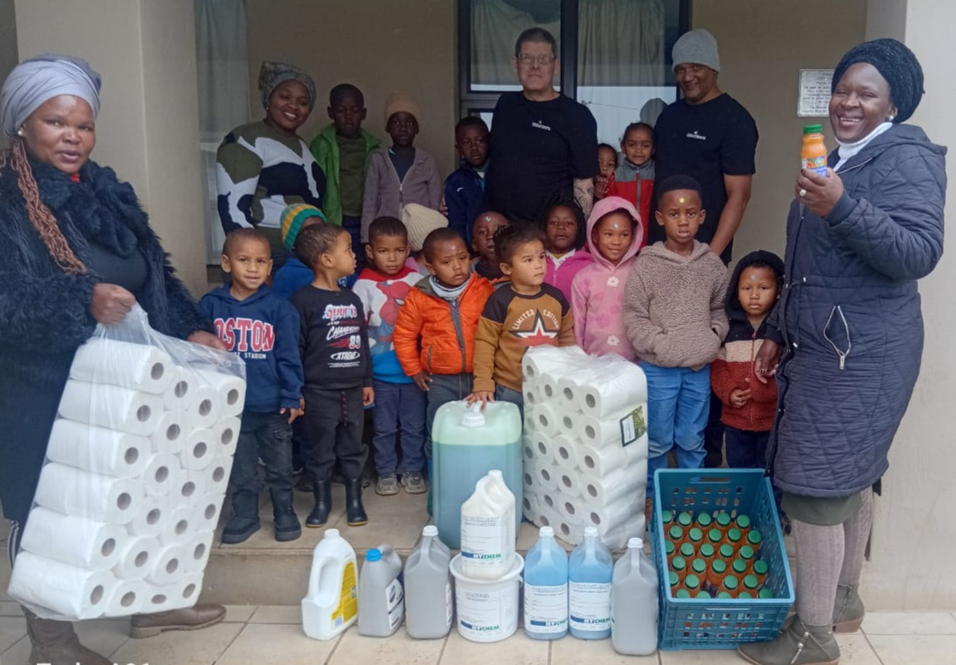

We would like to take this opportunity to say thank you to Arabella County Estate for the donation of soup, bread, juice, cleaning products and toilet paper for Mandela Day.

“It is in your hands to create a better world for all who live in it”; is attributed to Nelson Mandela. (Mandela Day – 18 Julie 2025)

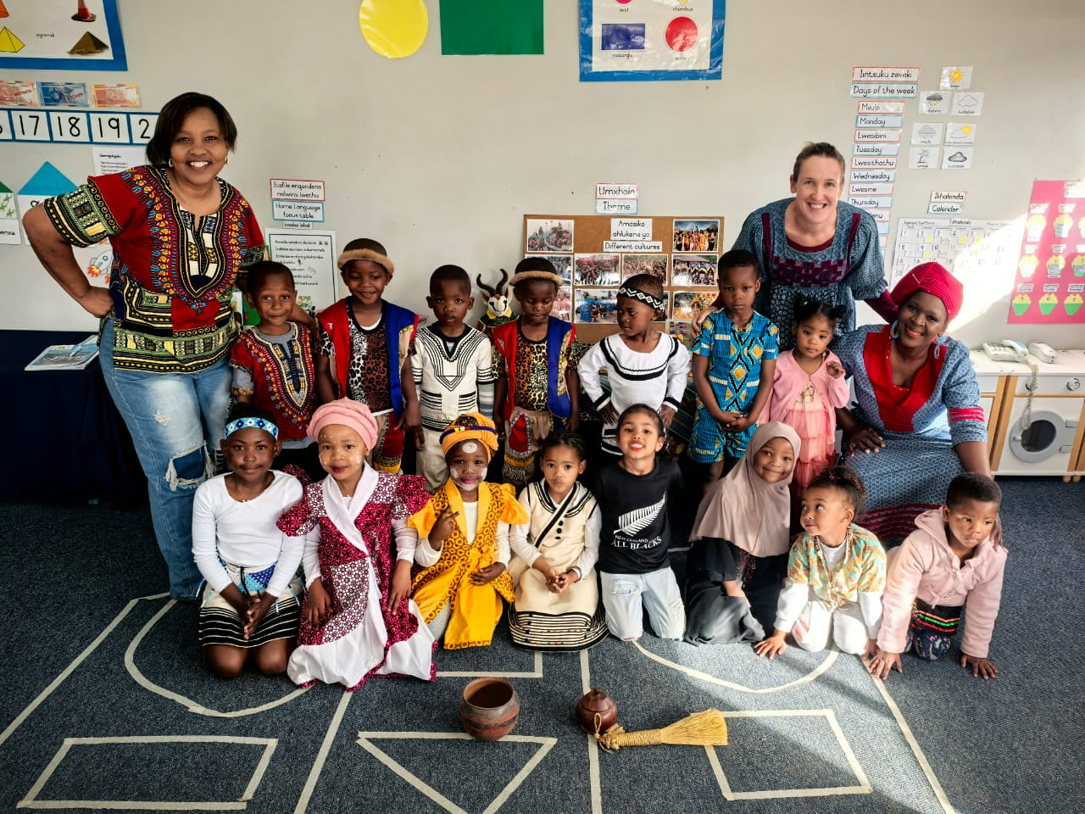

Siyabulela celebrated Heritage Day. We celebrate Heritage Day to honour our country’s rich cultural heritage and diversity, celebrating the many cultures that make up our population. Our children have so many different backgrounds and come from different cultures. It is lovely to see them wearing their traditional clothes.

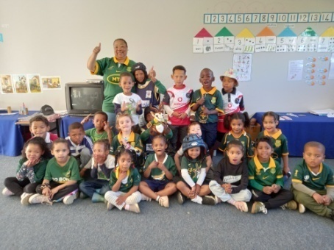
Siyabulela Pre-Primary took part in the Community Sports
Weekend. The Friday we dressed up in different sport
clothes to get into the spirit of the weekend. Saturday we
did different activities with the children and also played
rugby and netball. They have been practising all term, so
were very excited and enjoyed the morning a lot.
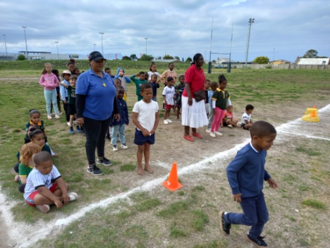
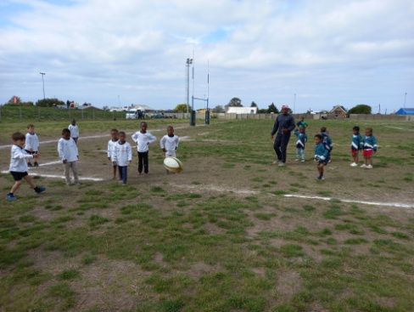
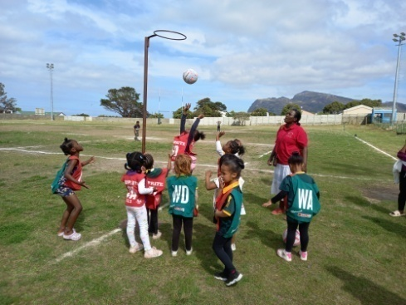

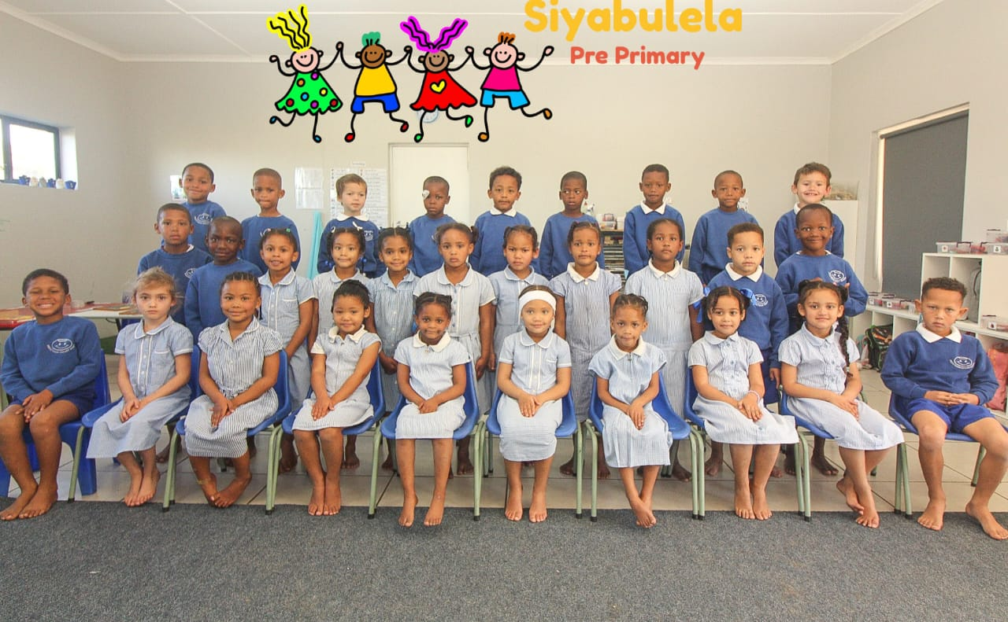

As promised, the professional photos taken of our Grade R children.

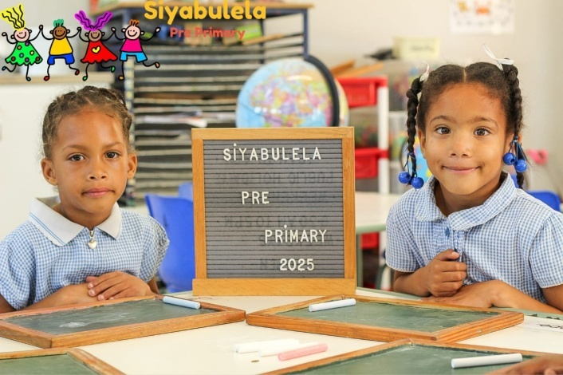
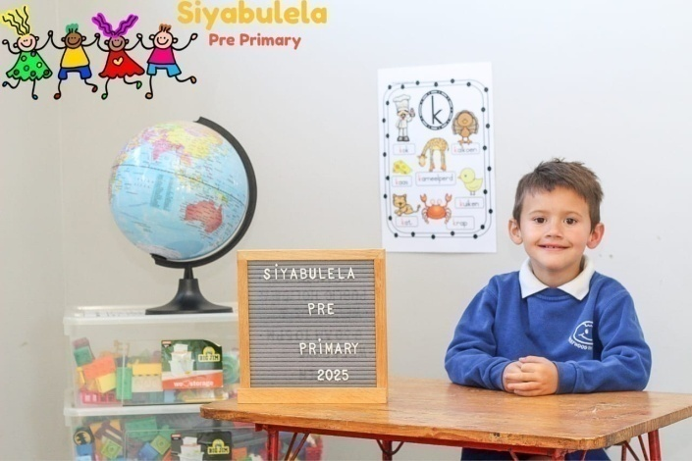

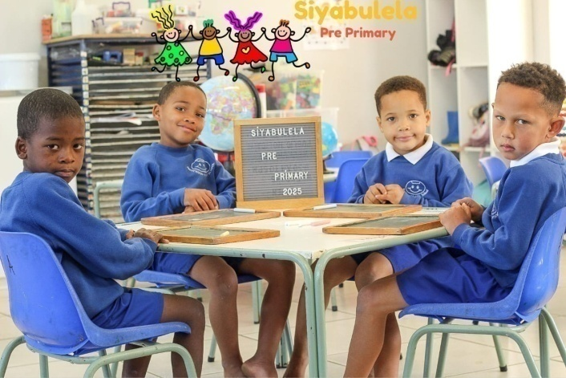
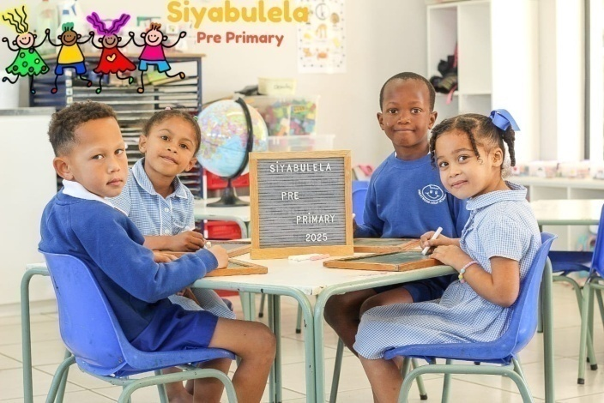

We are so proud of all our children and staff. It takes a lot to keep a preschool going and as I’ve said before it is what happens in the classrooms that is most important.
Our children and teachers work very hard.

I am also grateful for all the rest of our accomplishments. All made possible by people who care and know how important the preschool phase is for our children.

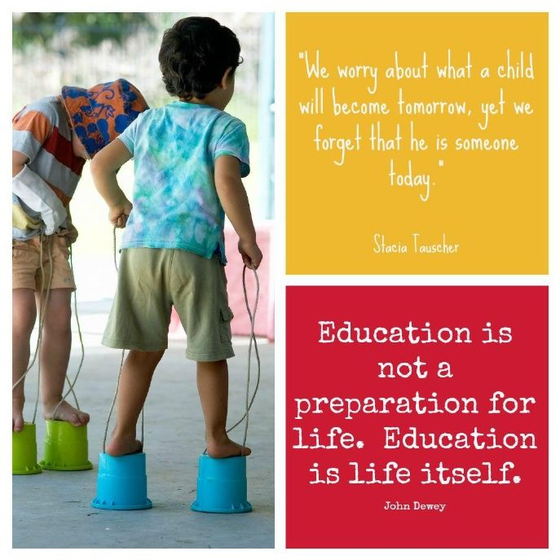

Our wish list:
- Phase 2 of our Grade R playground.
- Sandpits for our Grade R playground (R13 250).
- New see saws and swings for our other playground (R8 600).
- Aluminium window frames to replace the old wooden frames (R37 000).
- Puzzles and house corner furniture for our 3-5 year classes.
- Carpets for some classrooms.
- Shading for our ‘outside’ classroom.
- Compost for our grass (R5 000).
- Small toilet for 3-4 year class.
- Second hand items for our shop (old bedding, towels, kitchenware,
clothes etc.)
- Mural for Grade R classrooms’ wall (still need R10 0000).
- Mud kitchen for outside play area (still need around R5 000).

