NEWSLETTER 4/2023

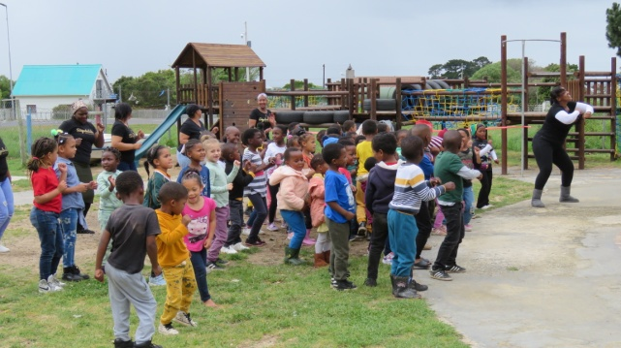
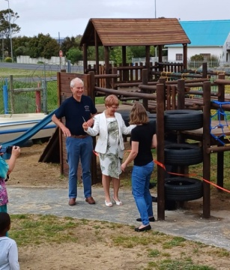
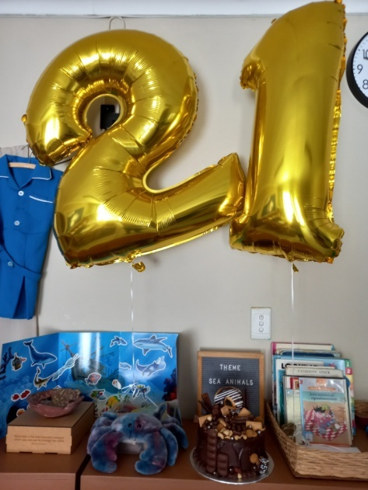

We celebrated our 21st Birthday this year! Siyabulela
Pre Primary was established in 2002 to supply in the
demand for Earley Childhood Development Centres in
Kleinmond.

The school opened it’s doors for 35 children which were accomodated in one classroom with only one teacher. Today, 21 years later, we have 140 learners inrolled between the age of 2 and 6 years.

How far we have come in 21 years! I am so proud of what we have accomplished since the school opened its doors. We are a team of people working together to give the best we can for our children. We work together as a group to change every child at the schools life in a positive way. Our mission is to protect and promote the interest, well-being, safety and development of children within the context of family and community and to safeguard the rights of children.

We cannot continue the work we do here without the support of Child Welfare, our sponsors and the community. We appreciate everyone who is involved at the school and helping us to make this not only a save, but beautiful space, where our children can come to every day to learn, develop and feel loved.

We had a lovely morning with some of the role players and donors of the school to celebrate this big milestone. Along with our 21st birthday celebrations we had the grand opening of the jungle gym. Betsey Joubert shared some history of the school and Robert Fraser his passion for and the importance of ECDs.

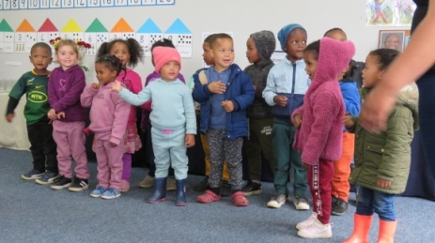
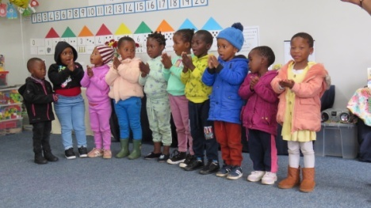
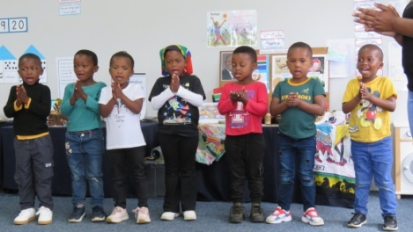

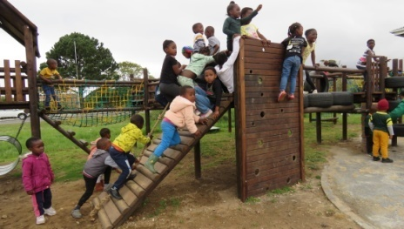
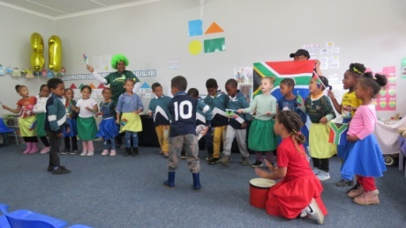
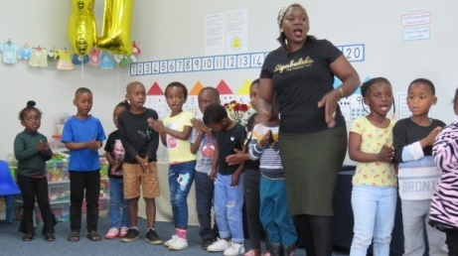

The Grade R classes opened in 2020, so we have raised and saved money from then till know for the jungle gym. The children did a bit of dancing for us and then all our guest got to see how they enjoy playing on the new jungle gym. The plaque with all the names of people who contributed to the jungle gym was also unveiled.

But the celebrations didn’t stop here... We had a big 21st birthday celebration for our children and the community on the first Saturday of December. We started the morning on a high with Dance Mouse, and then there were a magician, balloon artist, face painting, jumping castles and stalls. Everyone who were there had a really good time.

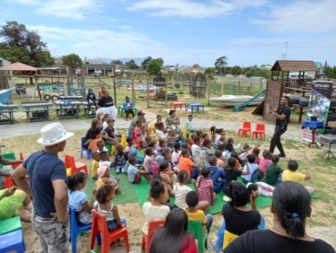
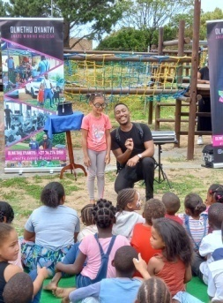
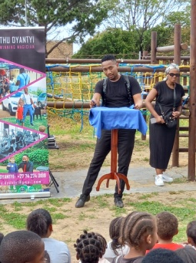
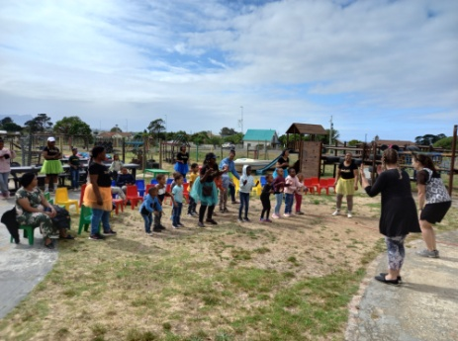

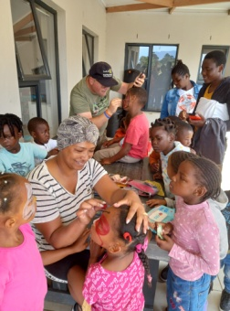
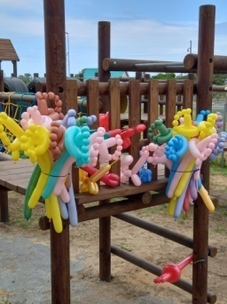
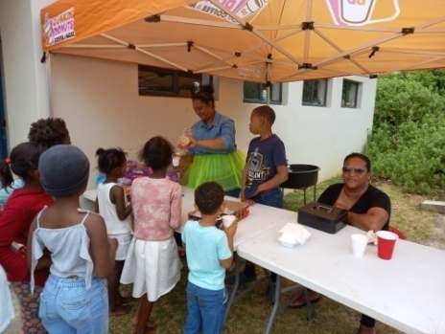
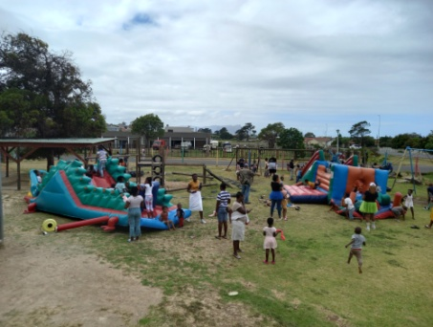

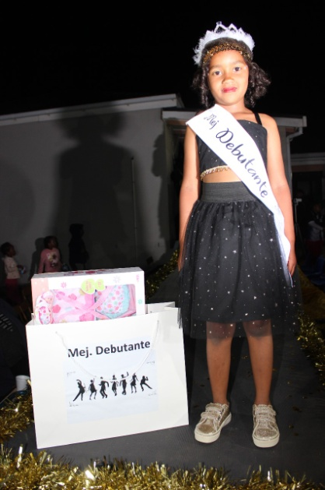
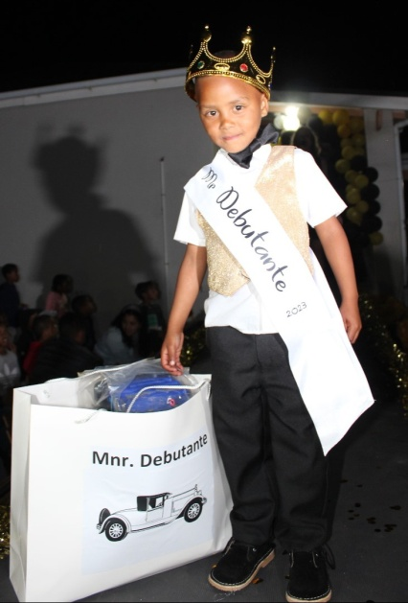
The other big occasion we had
was our Debutante. It is our
biggest school function and this
year was no exception.

Our theme for the evening was
The Great Gatsby and the
children went all out! They
looked beautiful!

There were more than 300
people attending the evening
and it was enjoyed by all.

Mr Debutante 2023 Ms Debutante 2023
Eedon Bosman Marli Dreyer

Our Debutante was followed by our Grade R graduation. This is always a special occasion we share with our Grade R children and their parents to end of their time at Siyabulela. This year there were 31 children who graduated. Our top achievers for 2023 were Shanis Chigudu and Lesley Pretorius.
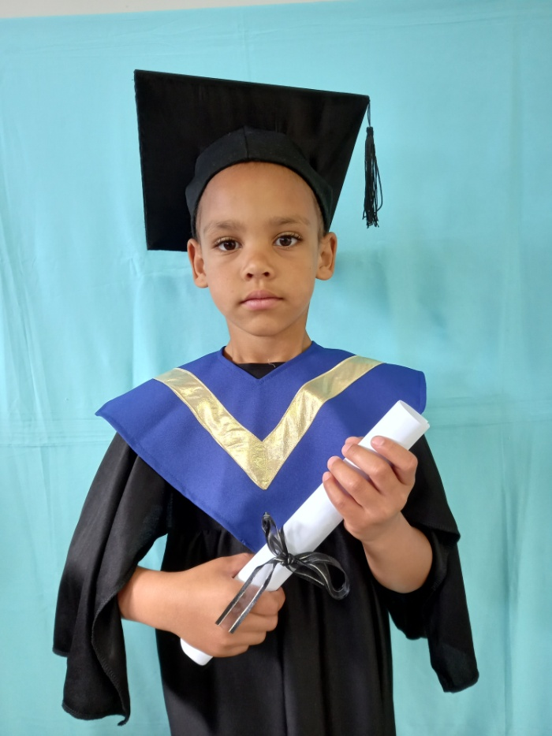
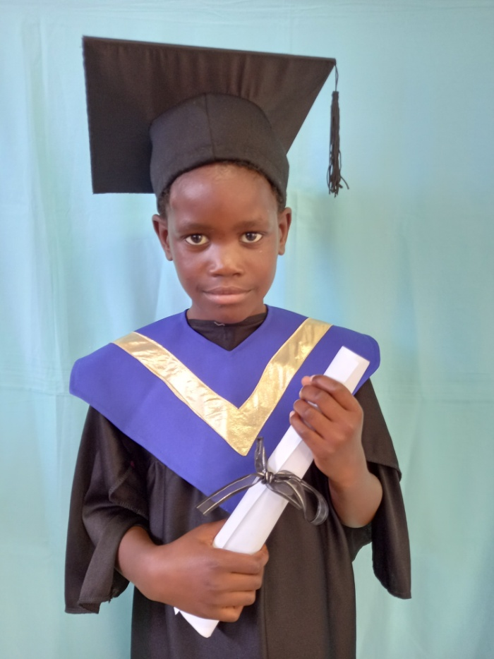

What makes Shanis’s story even more impressive is the fact that her Home Language is Shona and that this was her first year in school! Just shows you what our children can accomplish in one year! I told our parents that we do not have to stand back for any school. On the contrary we follow a high standard at the school and our children get excellent education. They are more than ready for Grade 1 and what lies ahead.

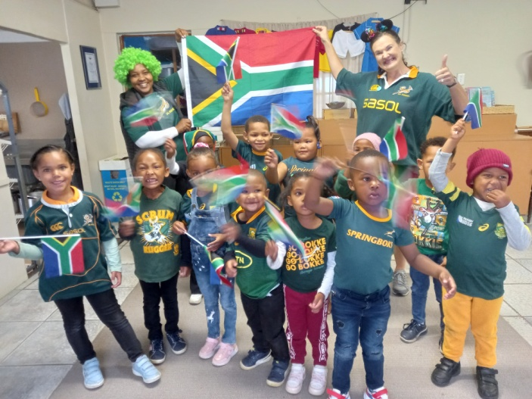
We also celebrated South Africa’s Rugby
World Cup win! Our children dressed up
in the colours of the SA flag. There were
also a few children with Springbok shirts.

The boys played “rugby” all day, some of
them even did the Hakka and they all
sang the national anthem. We had
Mariska from Dance Mouse there who
did some dances with SA flags.

Go Bokke!

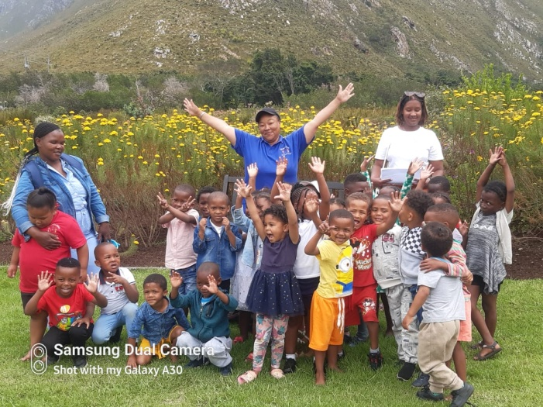
The 4-5 year classes went to Harold Porter
Botanical Gardens for their yearly outing.
This is always a big occasion for our child-
ren because they don’t really get to go
anywhere out of Kleinmond.

We are very grateful for Harold Porter’s
staff who gives our children the opportunity
to be in and learn about nature every year.

It’s always good for the soul to be in nature.

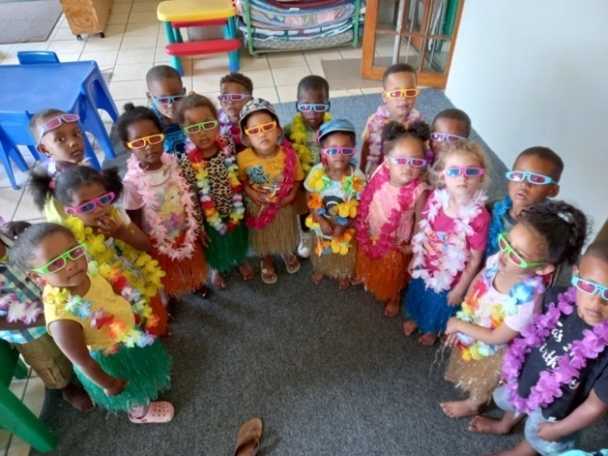
With all the functions and excitement going
on we still have to make time to follow our
daily programme and work with our child-
children.

Education and looking after our children
always stays our first priority. They are at
school to learn and develop.

And then for some more fun and excite-
ment...
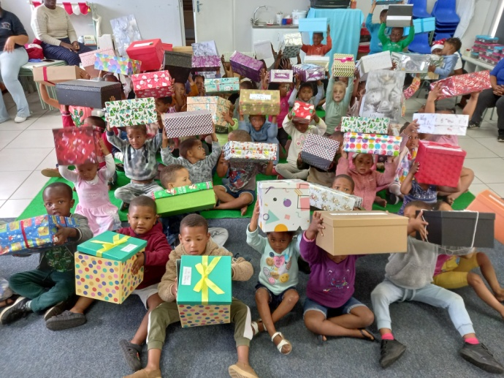
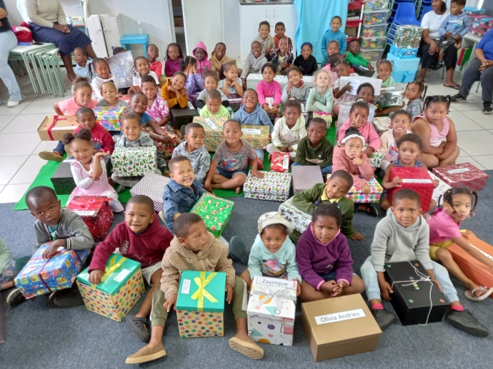

Our Christmas party! Once again Sandra and her team got together 140 Santa shoe boxes to brighten up our children’s Christmas. This is always a highlight for our children and they are very excited to take their boxes home and see what is in it. You will see most of them coming to school the next day with the new clothes they received. A big thank you goes out to all Santa’s (Sandra’s) little helpers.

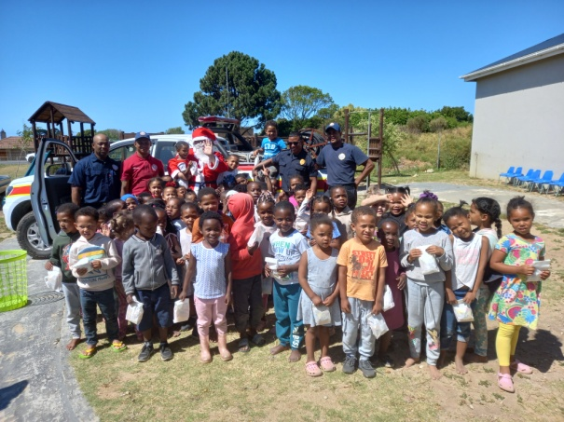
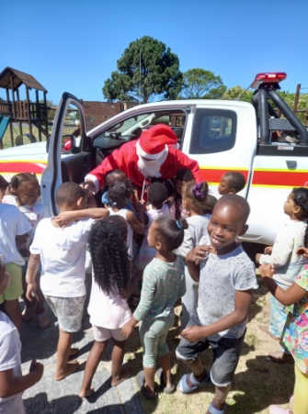
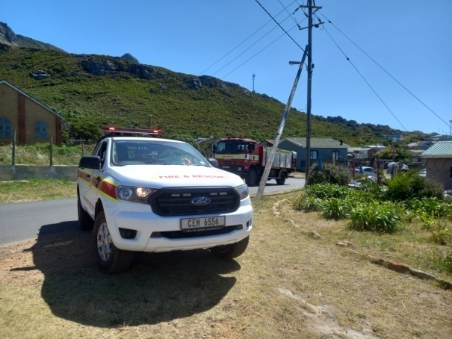

Father Christmas (and the guys from Overstrand Fire & Rescue) also came to surprise our children. They came with a fire truck, sirens ringing and lots of sweet packets. The excitement was big and it made their day to see Father Christmas.

I want to end off this year’s last newsletter with our staff. This is our staff...
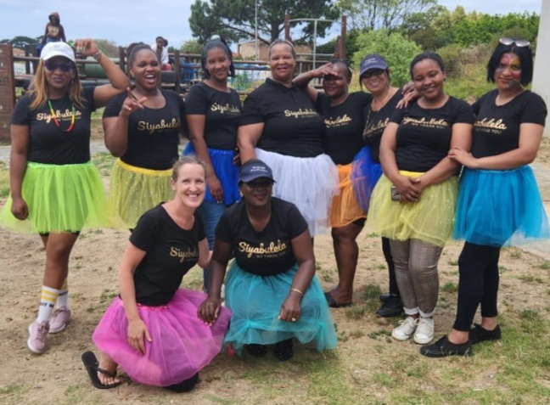
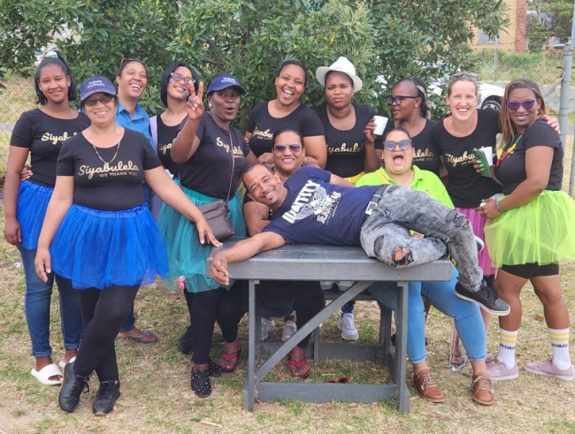

We did not have time to take a formal photo at the Debutante, but these pictures shows us much better anyway. We’re not fancy; we’re not prim and proper, a bit silly sometimes and a lot of different personalities.

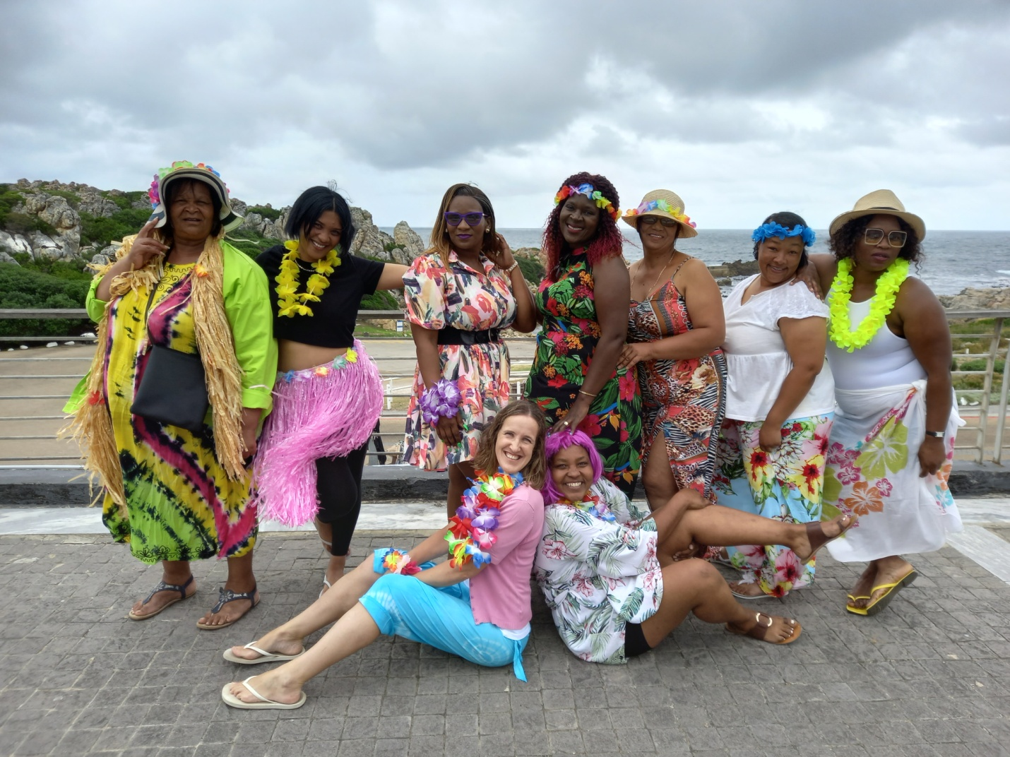

Let me introduce you. On the left we have (mama) Jeanette. She is our cook and the one responsible for filling our children’s tummies. She is our mom at school and always ready to listen and give advice.

Next to her is Logan Bailey, our 4-5 year Afrikaans teacher. She is a born teacher and has a passion for working with children. The children in her class loves her.

Then it’s Sibongile Mtshizana, our 3-4 year isiXhosa teacher. Teaching the 3-4 year olds is not easy. She works very well with them and teaches them from early in the year to be independent.

Glenda Mojaki is our Grade R isiXhosa teacher. She is a very dedicated teacher and always with her children working hard to get them ready for Grade 1.

Juanita Galant, the 3-4 year Afrikaans teacher. She knows how to work with this age group and she is reliable and very capable.

Reese Andoons is our Grade R assistant and the sunshine at our school. She is always happy and willing to walk the extra mile and take on extra responsibilities.

At the end on the right is Eunice Mfanta, our cleaner. She is very good at cleaning and not afraid to work hard. This is a good thing, because we have two big buildings to keep clean.

Natashia Robite, our Afrikaans Grade R teacher, sitting next to me is the spirit of the school. She is the one who talks at our functions and takes on all the responsibilities when I’m not there. She is a great teacher as well.

And then Bongi (who couldn’t be at the yearend function, but is on the other photos) is our 4-5 year isiXhosa teacher. She has been here the longest of everyone and is like a mother to the children in her class.

I always say we are a team of people working together to make Siyabuela what it is and the teachers are a big part of the team.

Thank you the rest of our team; our sponsors/donors, our children, our parents, the community and everyone involved in the school no matter how big or small.

Have a blessed Christmas time with family and friends.

We love you.

Alta, the staff and children of Siyabulela Pre-Primary



Our wish list:
- Mural for Grade R classrooms’ wall (R20 0000).
- Mud kitchen for outside play area (R15 000).
- Building cement box for corrugation taps (R950).
- Small toilet for 3-4 year class.
- Carpets for some classrooms (R6 730).
- Paving and shading for our ‘outside’ classroom.
- Natty Rubberising bicycle track: R300 per square meter.
- Higher fencing around our school to prevent breakings.
- A big tree for our playground.
- Second hand items for our shop (old bedding, towels, kitchenware,
clothes etc.).

We could make our wish list a bit shorter, because we got a donation for the fixing of the cracks in the wall and the lifting of ground level where water was coming through. Thanks to the Narollah Trust for this donation.

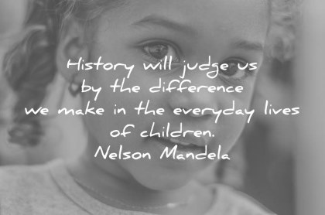

In 21 years we have come so far, because of each person who is part of Siyabulela’s story. When you look at our school you can see where people invested and all the things that have been sponsored over the years:

Classrooms, kitchen equipment, grass, trees, paint inside and outside, a new roof, chairs and carpets, wendy houses, maintenance, educational toys, equipment, books,
a jungle gym and the list goes on.

Siyabulela ‘We thank you’

