NEWSLETTER 4/2024

I am starting this term’s newsletter with some news from last term. We still did a few things after I sent out the last newsletter.

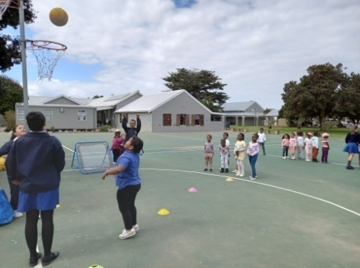
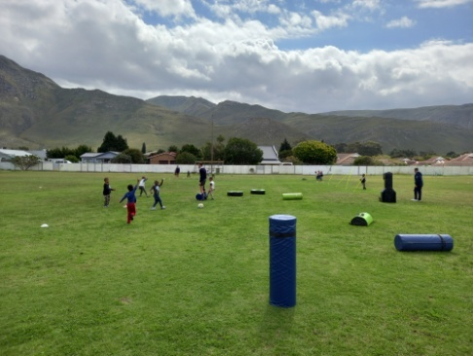
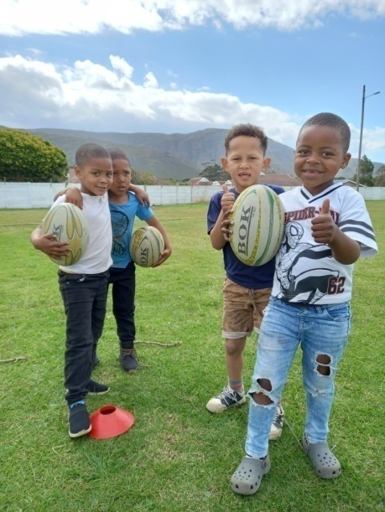

Our Grade R classes were invited by Laerskool Kleinmond
to a sports development day. When we arrived they had
stations put out on the rugby and netball fields. The learners
of the school did the development sessions themselves.

Our children enjoy anything to do with sport, so they had a great time. Afterwards they were treated with snack packs and we got to take a few rugby and netball balls back to school. We want to thank the Laerskool for this infinitive and hope this will be an annual event.

We also had our own Youth Sports Day in the beginning of the term.
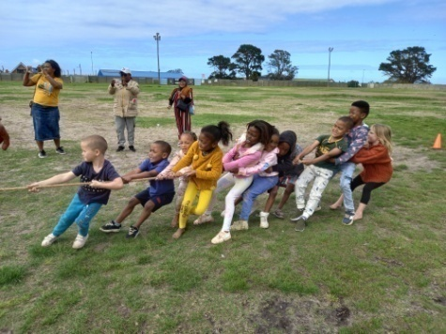
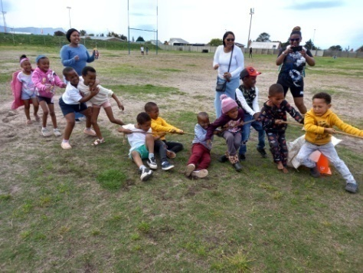
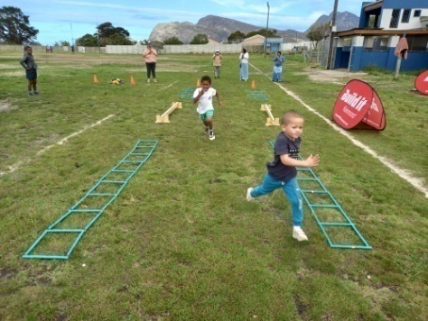

This was held in conjunction with the municipality. We started the morning with fun activities for the younger children. There were also a magician, balloon artist and face painting. The bigger children participated in street soccer and a netball shoot out. It was enjoyed by everyone who attended and we will definitely make this a yearly event.

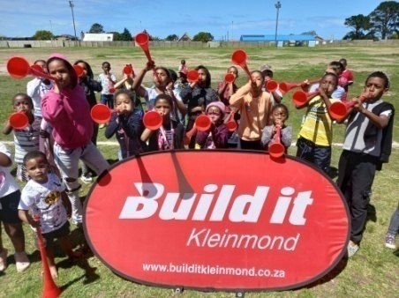
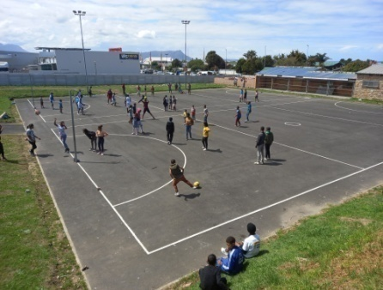
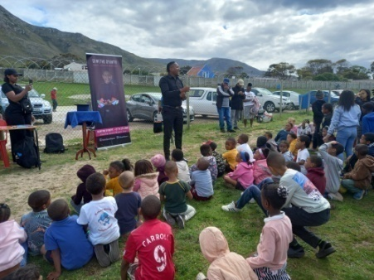

Our biggest and only sponsor for the day, Build It, made a huge contribution towards this day. All the prizes and hand outs contributed to the success of the day. They are definitely passionate about sports development for our communities children.

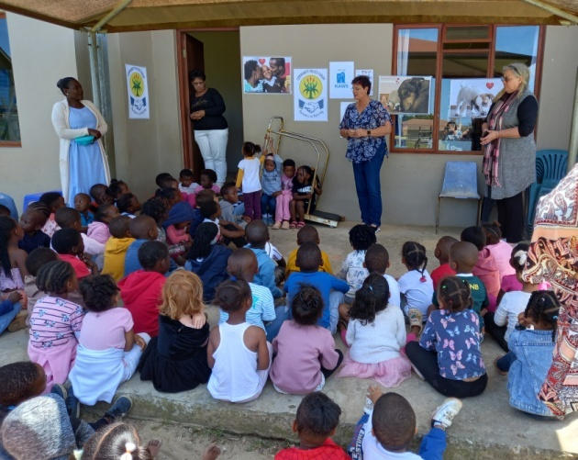
We had a visit from the Community Police
Forum, who came to talk to our children
about taking care of their pets. There are a lot of neglected dogs in the com- munity, so it is a very important subject to discuss with our children.

They were told to make sure their pets have
food and water all the time. They each got
a small bag of dog/cat food to take home.

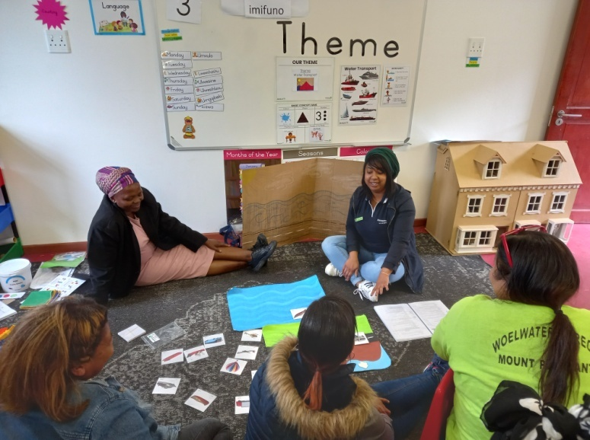
I attended training at Enlighten Trust.
We are implementing a new program,
the Maskot Early Learning Program.
It was developed by Masikhule. They
are dedicated to quality early learning
development for every child.

It was developed over many years to
offer holistic, practical and stimulating
content. I found the program very prac-
tical and next year we will start to
phase it in. We will keep the content
we have and just add to it.

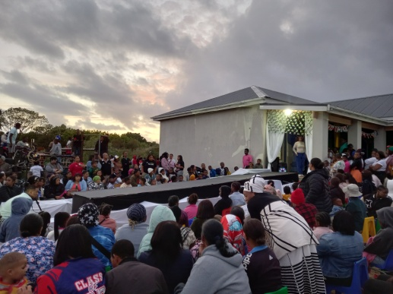
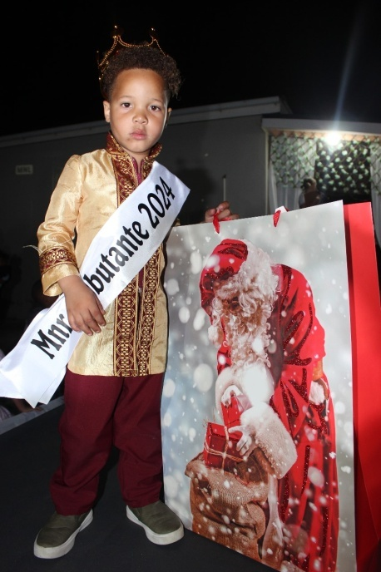
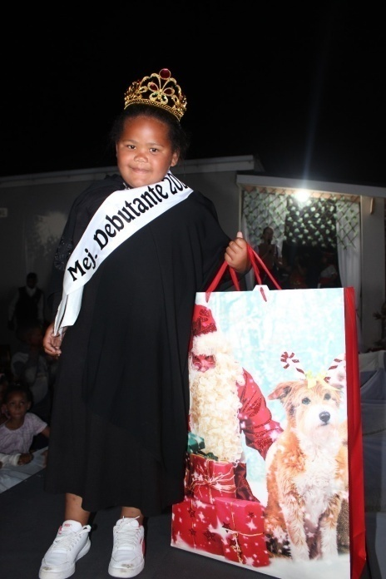

Above: More than 400 attendees.

Miss Debutante 2024:
Leo-Nay Diedericks

Mr Debutante 2024:
Kiro Adam October

Our Debutante, our biggest event of the year, was a huge success again. Our theme this year was Around the world and the children and staff dressed as different countries around the world. The children all looked beautiful and you could see the parents put in a lot of effort.

This year was our longest, but best Debutante we had so far. There were more than 400 people who attended and I think this is the biggest event in our community. It is always an evening enjoyed by all who attended.

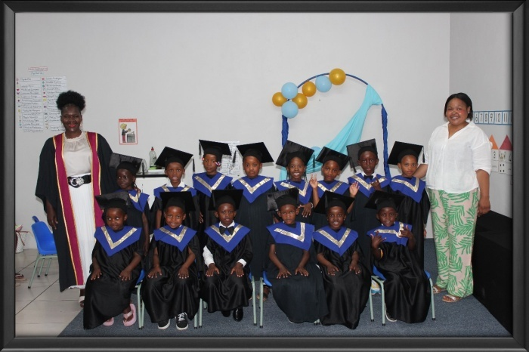
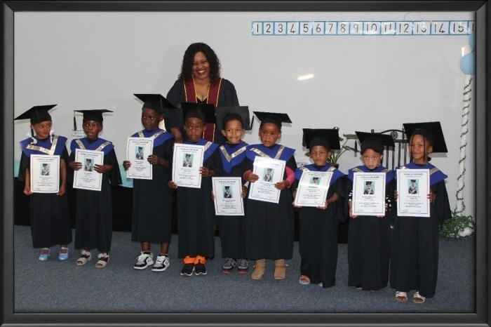

Our Grade R Graduation ceremony is always a special occasion we shared with the children and their families to end of their time at the school. This year there were 30 Grade R learners who graduated. Each child received a certificate, a book and stationary for Grade 1. There were also some special awards handed out; for best attendance, excellence in Life Skills, Home Language and Mathematics and top achiever. We wish them all the best for the future and hope they will shine just as bright as they did here at Siyabulela Pre Primary!
We also had a concert this year. We had two amazing evenings of dancing and singing.
This year was a variety concert and each class did a rhyme and/or song of their choice and then we ended off with the children’s favourite Dance Mouse dances.

The children were frogs, ducks, dragon flies, dinosaurs and lots more. For us the concert is about enjoyment and we want the children, teachers and parents to have fun!
The community came out in numbers and everyone attending enjoyed watching the children perform and had an incredible night.

Unfortunate we did not take any pictures, so these are the pictures from the donors’ tea.

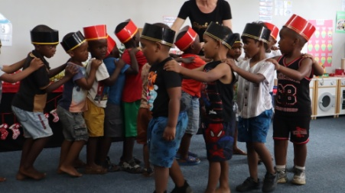
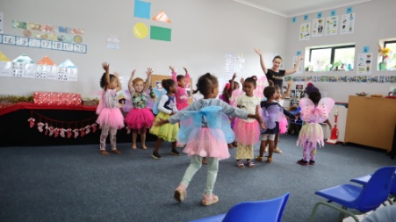
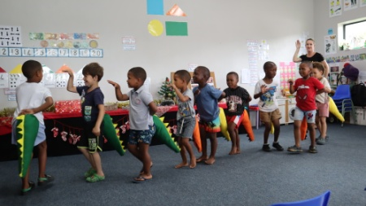

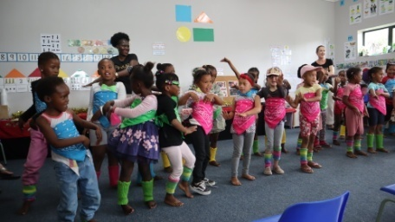
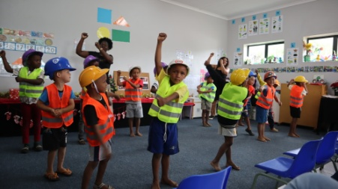
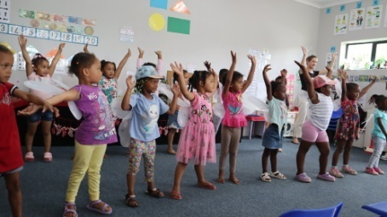

The donors’ tea we do every year to say thank you to everyone who is involved at our school; whether it is by sponsoring a child, giving your time, reading for them, dancing with them, making any kind of contribution or donation or even just writing an article in the local newspaper. We want to show our appreciation during this day.

All of the people involved at Siyabulela decided to be part of our children’s lives. We are proud of what we have accomplished over the years and we hear a lot of good things about our children when they go to the primary school. All the people involved help to make it all possible.

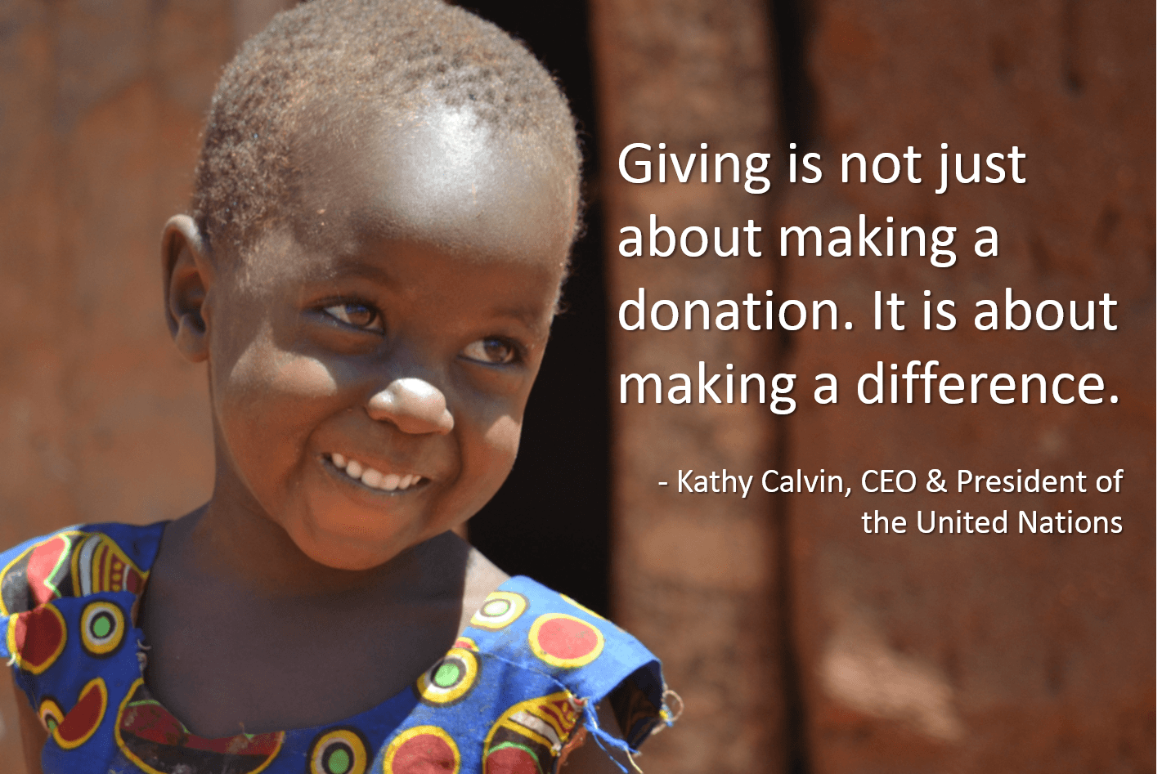

THANK YOU FOR MAKING
A DIFFERENCE

We celebrated another milestone at the tea. We have been getting Santa shoe boxes for 10 years! So we are looking back at 10 years of happiness over Christmas...

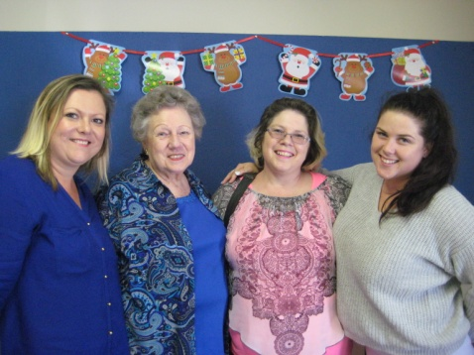
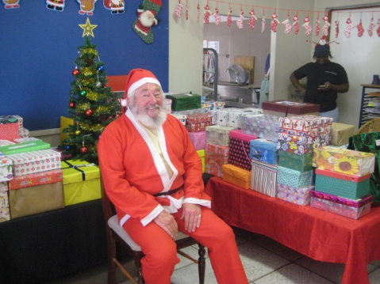
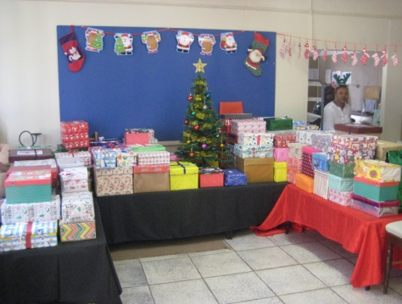

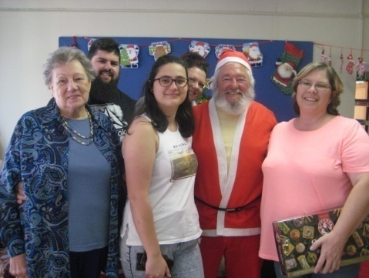
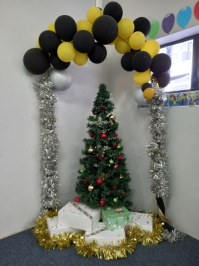
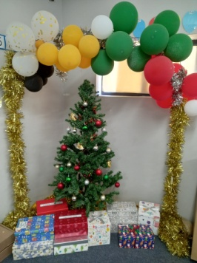
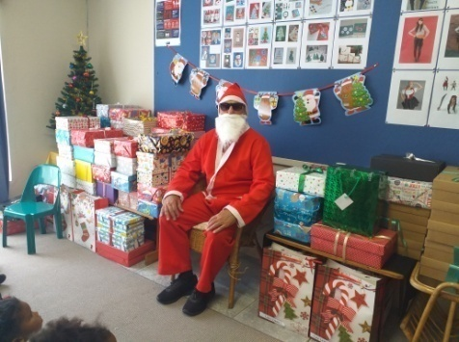

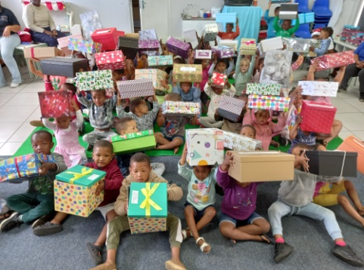
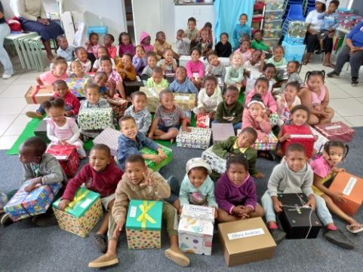
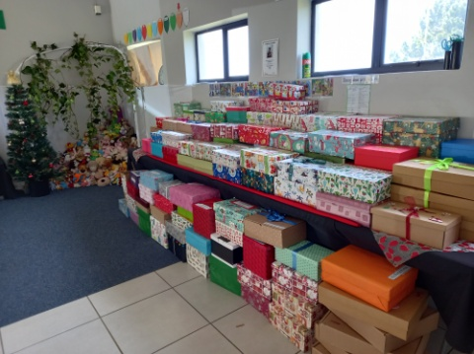

Sandra Smit started this initiative 10 years ago, not knowing that 10 years later she will still be busy collecting 140 Santa shoe boxes every year. This is always the highlight of our children’s year and that is what makes these boxes so special. For some of our children this is the only Christmas gift they will get for Christmas.

Wow! What can we say: To all the people involved in this amazing project, thank you, you are our Christmas angels.

So with this, I end of the year. A Merry Christmas and a Happy New Year!

All our love,

Alta, the staff and children of Siyabulela Pre-Primary

Very excited to share one last bit of news with you; we got a donation for R70 000 for a new roof! They are busy putting it up as you are reading this. Michael Merkel, this is our Christmas miracle this year. Thank you.

Our wish list:
- Higher fencing around our school to prevent breakings (R234 900).
- Varnish for our Wendy houses (R10 310).
- New roofs for our Wendy houses (they are all rusted) (R20 000).
- Compost for our grass (R5 000).
- Puzzles and house corner furniture for our 3-5 year classes.
- Small toilet for 3-4 year class.
- Carpets for some classrooms.
- Paving and shading for our ‘outside’ classroom.
- Natty Rubberising bicycle track: R300 per square meter.
- Second hand items for our shop (old bedding, towels, kitchenware,
clothes etc.)
- Mural for Grade R classrooms’ wall (still need R10 0000).
- Mud kitchen for outside play area (still need around R5 000).

