NEWSLETTER 4/2025

Our highlights this year were definitely our new fences, upgraded playground, new roofs for our Wendy houses and our successful Golf Day and Debutante. Yes, we have started with the upgrading our Grade R playground and what a difference it is making to playtime.
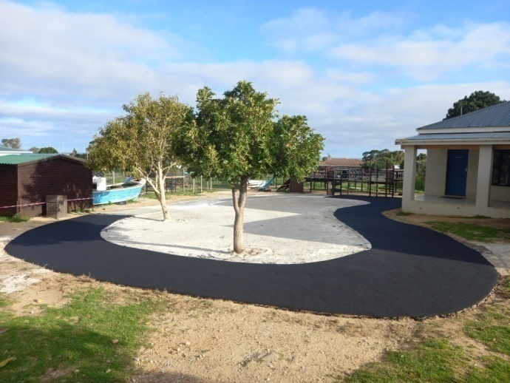
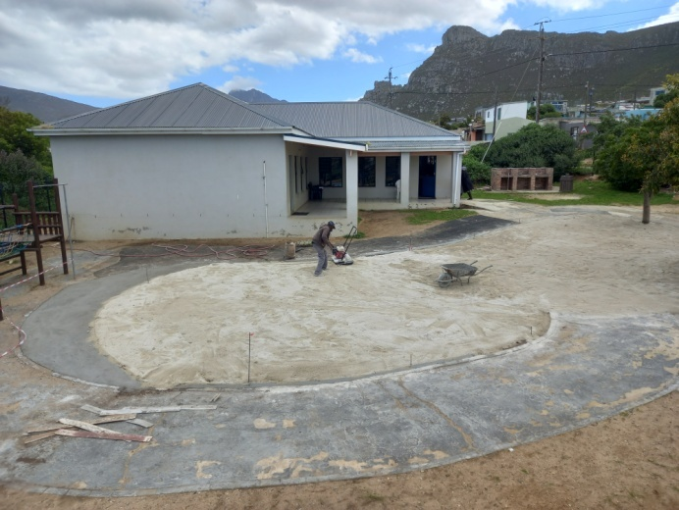

Preparing the services

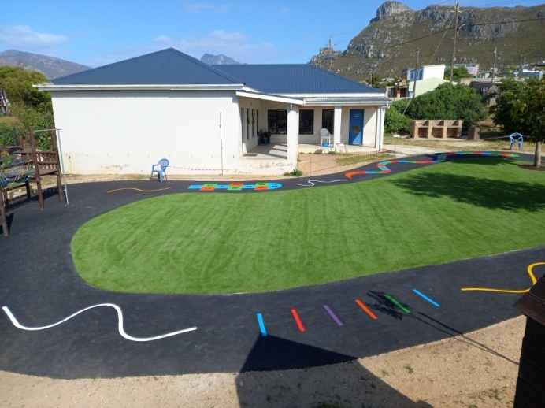
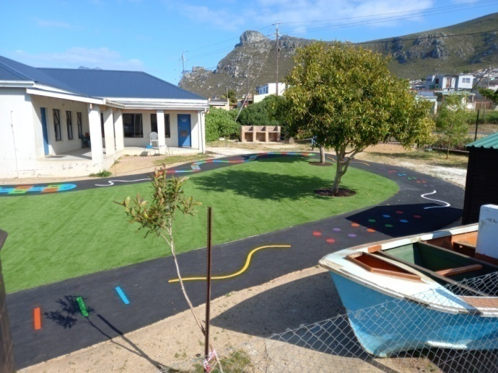

Our beautiful new playground!
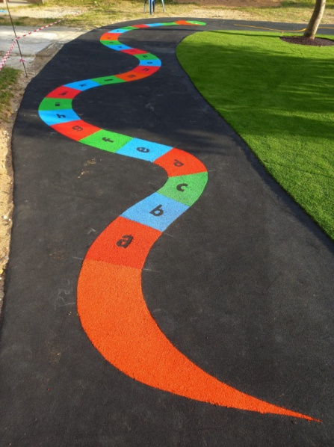
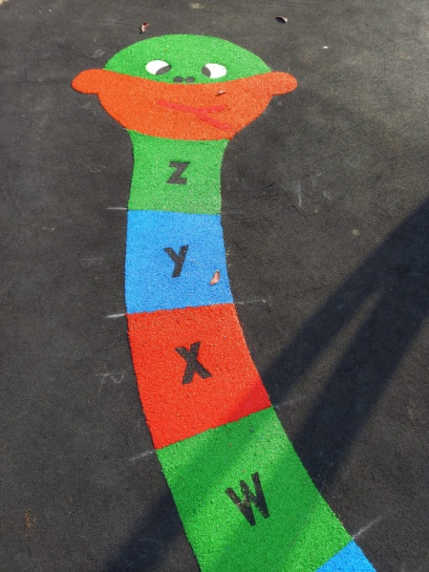
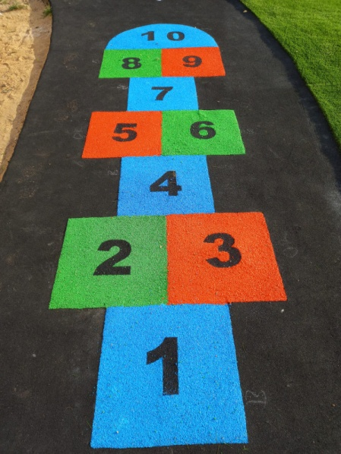
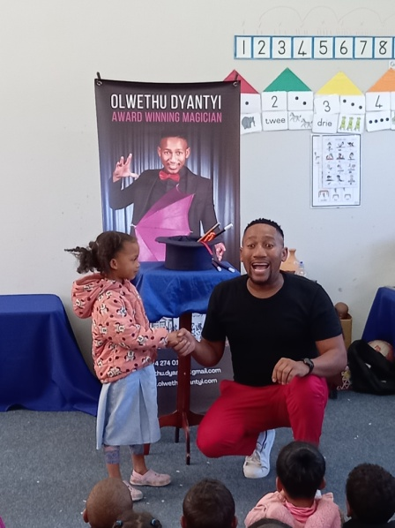

The new playground isn’t just for playing. The rubberising impact absorbing surfacing is designed to offer maximum safety performance with high durability. The colour and design that was added makes it an educational playground where the children jump, balance, learns numbers and letters.
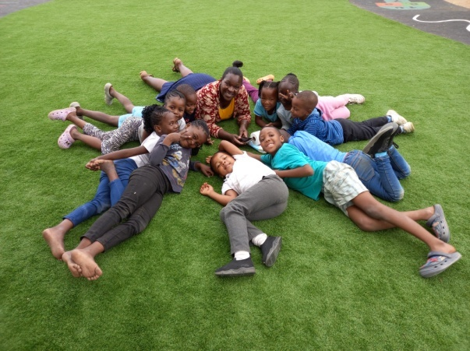
The children are also able to roll around on the
grass. They can sit down in the shade and have
their fruit and yoghurt and sometimes they just
like lying down and resting a bit.

Thank you to the Fraser Family Trust for helping
us to create this space where our children can
play, learn and grow. It has been life changing
and satisfying to see how they are enjoying
themselves.

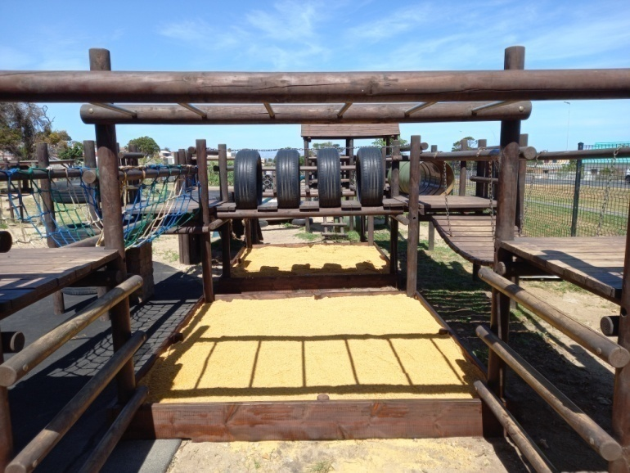
Another much needed structure on
our Grade R playground was sand-
pits. We were lucky enough to add
not one, but two sandpits.

Sand play helps children develop
language and motor skills, encoura-
ges experimentation and problem
solving and improves social interact-
tions.

Playing with sand benefits children
by encouraging exploration, curiosity
and experimentation with different
THANK YOU MICHAEL! textures and materials.
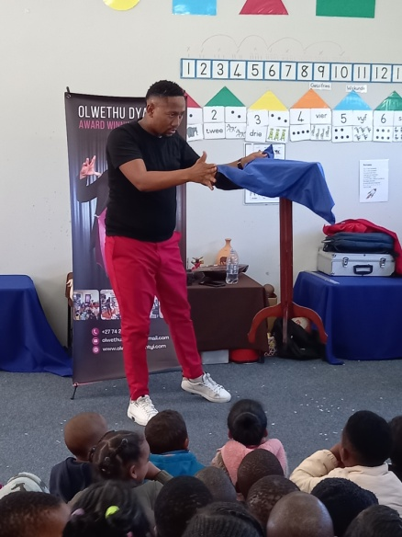
Our Favourite magician came to visit us the end of last
term. Olwethu Dyantyi is one of South Africa’s foremost
entertainers. Having made the finals of SA’s Got Talent,
his incredible talent have taken him around the world.

Incredible magic combines with mind boggling illusions,
the result, spellbinding entertainment. He is not just
good in magic, he is funny as well and always makes
our children laugh out loud.
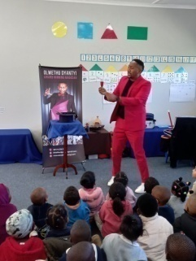
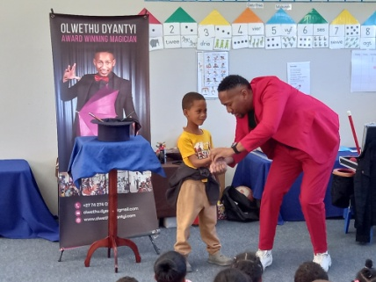
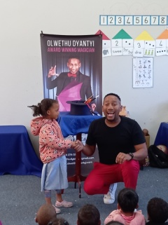

Olwethu (Ollie) in action.
Making a table go up in the air.

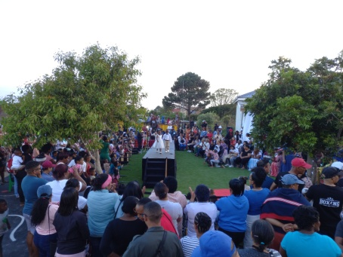
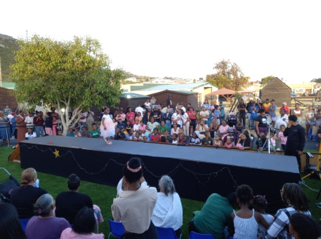
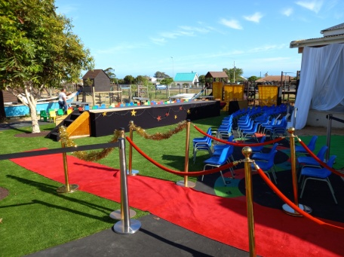

Our Debutante evening was a magical evening. The theme this year was mini-mini matric and the parents went all out. The children looked beautiful in their evening dresses and tuxedo’s. For the first time ever we had two misses Debutante, Melikah Makka and Meleesha Carelse and our Mr Debutante was Stanwill Jacobs. It was a very successful evening and enjoyed by all who attended.
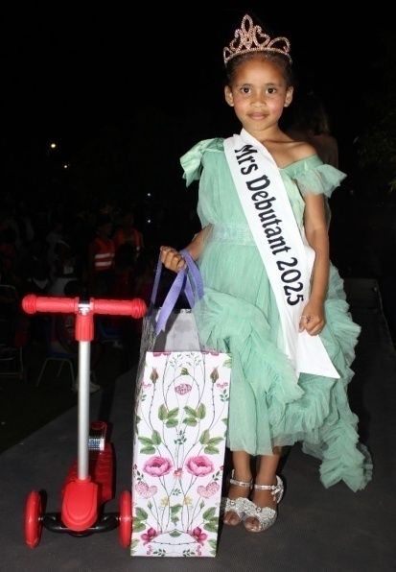
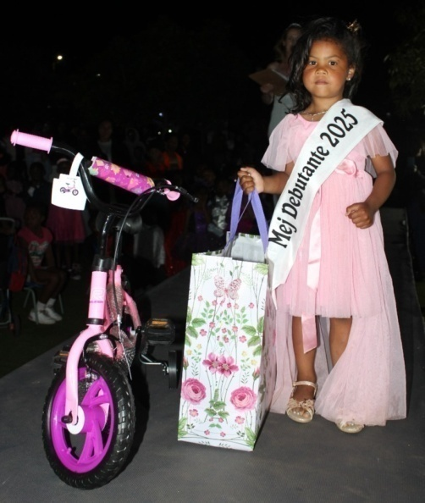
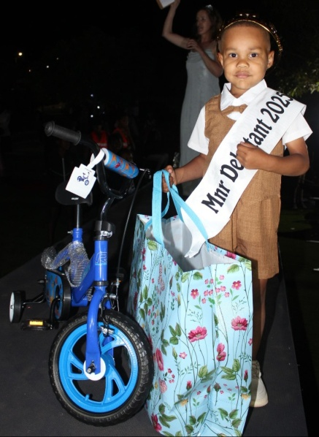

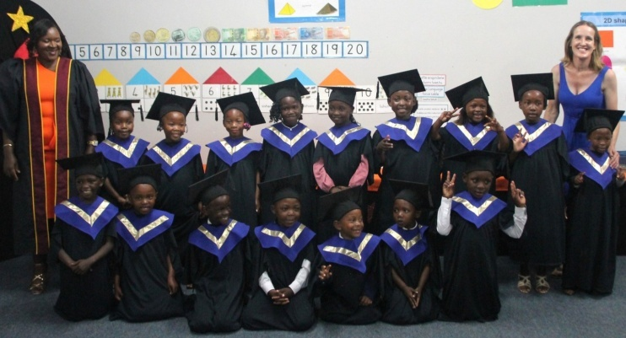
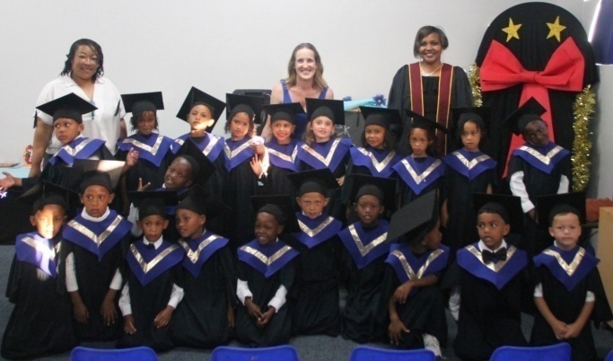

Our Graduation evening is always one of our last events for the year and a very special occasion we share with the children and their families to end of their time at the school. This year there were 40 Grade R learners who graduated. Each child received a certificate, a book and stationary for Grade 1.
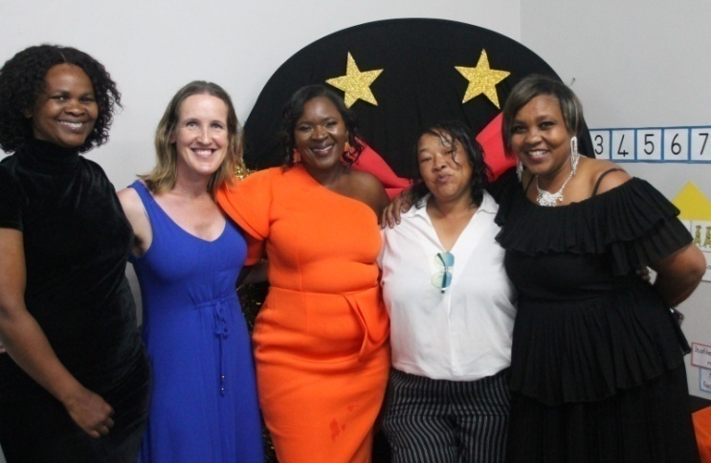
We wish them all the best for the future and hope they will shine just as bright as they did here at Siyabulela Pre Primary! We know they are ready for Grade 1!

We would also like to thank their teachers, Glenda Mojaki and Natashia Robite and classroom assistants Reese and Miranda for all their hard work and dedication during the year.

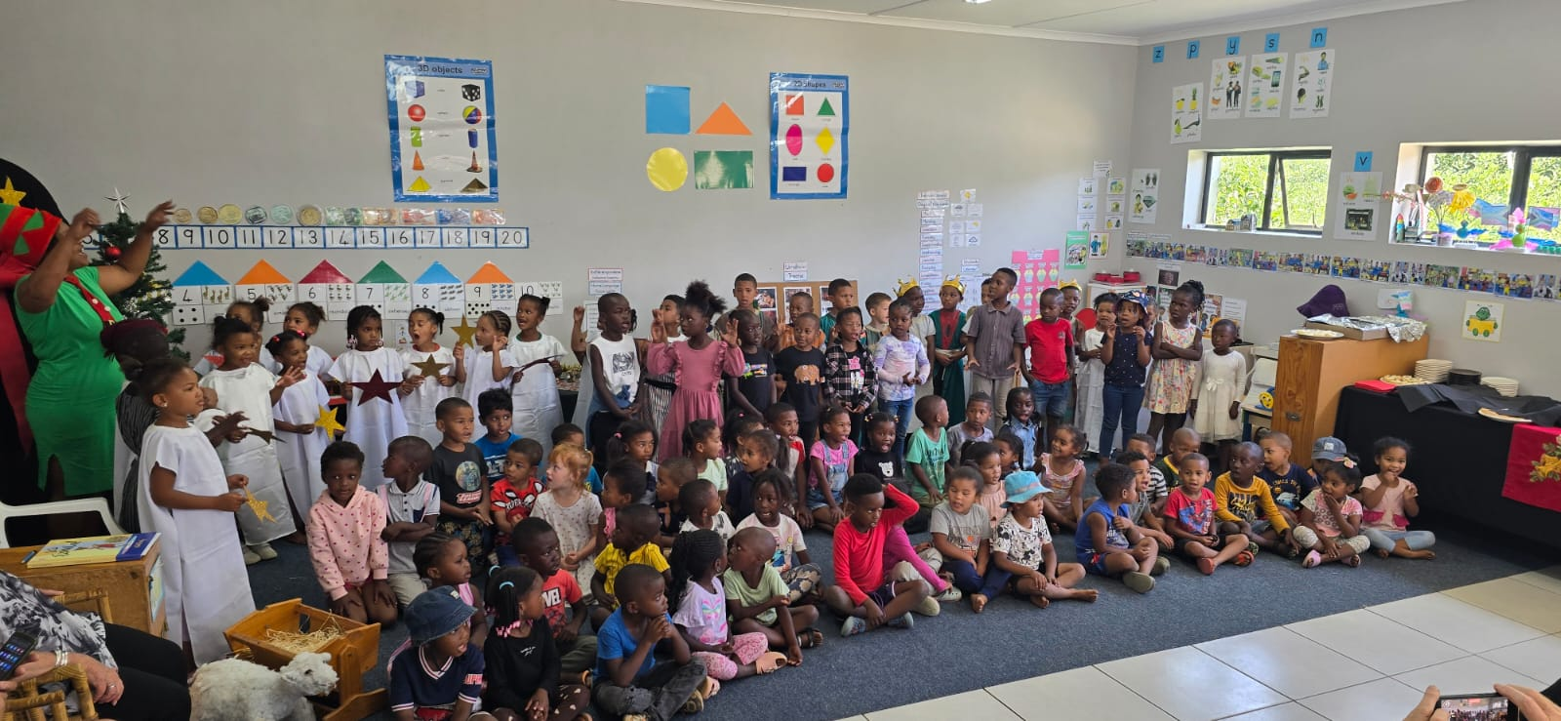

Our children wishing everyone a Merry Christmas and a Happy New Year at our donors’ tea.
Our donors’ tea is always a very special occasion where all the people involved at our school are invited to. The day is about saying thank you to each one’s footprints at Siyabulela. And there are a lot of people who is part of our story.

We say thank you to ‘Vriende Van Afrikaans’ for the tannies that comes to read at our school on Mondays, they are helping with developing their Home Language and listening skills. The ladies at Concept Repeat Boutique who puts in a lot of time to sort through their stuff and give us second hand clothes for our shop. All the other donors’ who donates toward our shop, helping us with fundraising and helping the community to buy clothes for cheap.

Our people who have sponsored children’s school fees over the years. It is so important to give these children the opportunity to be in school every day. It is always the children who needs to be in school most, getting food, education and love here, who gets sponsored. The sponsorships are such an important part of the school.

Our people who donate towards much needed projects and maintenance at the school. These projects always benefit our children and the maintenance is so important to keep the school going for generations to come. Family and friends who are there for emotional support. No matter how big or small the contribution, it makes a difference.

You all enable us to create a safe and magical space where our children can play, learn and grow. Donating is not just about giving, it’s about making a difference and you all make a difference.

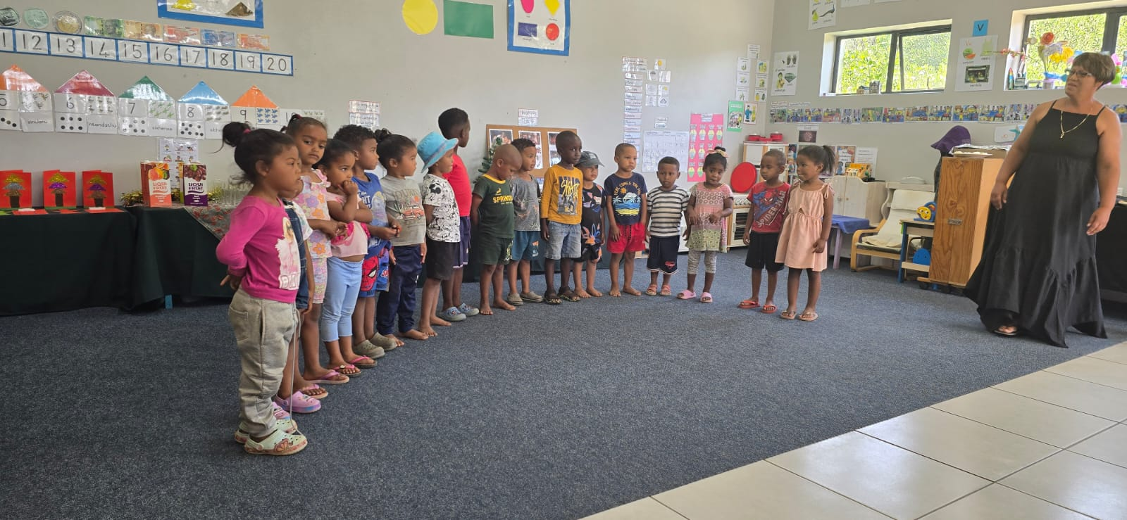

Our 3-4 Afrikaans class.

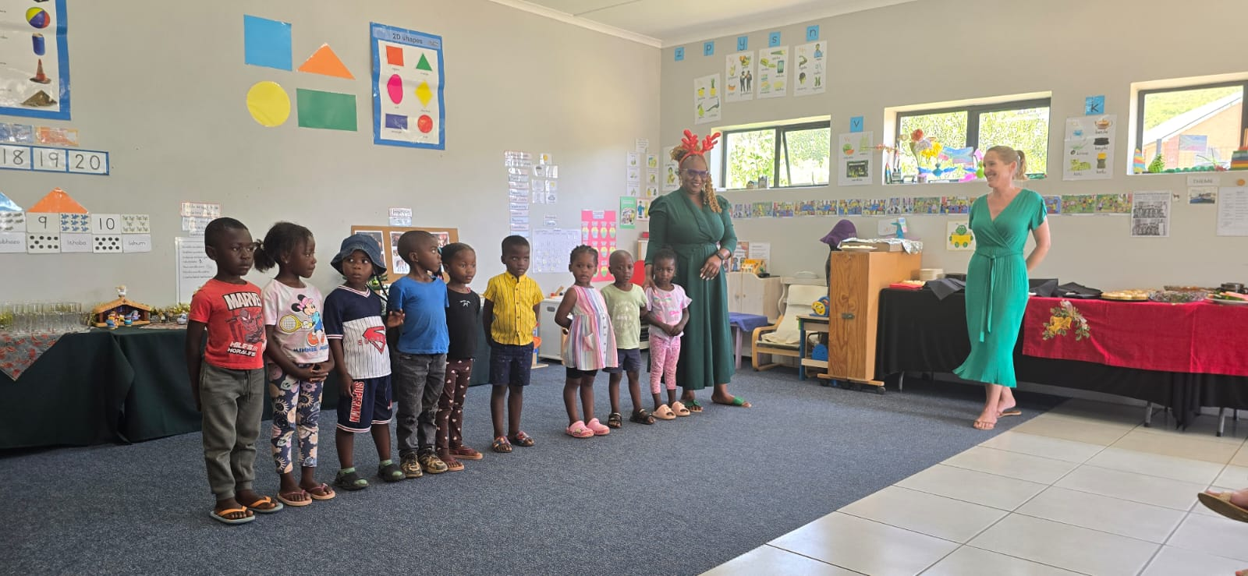

Our 3-4 year isiXhosa class.

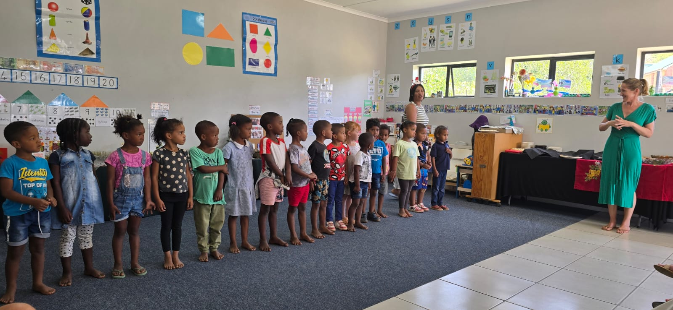

Our 4-5 year Afrikaans class.

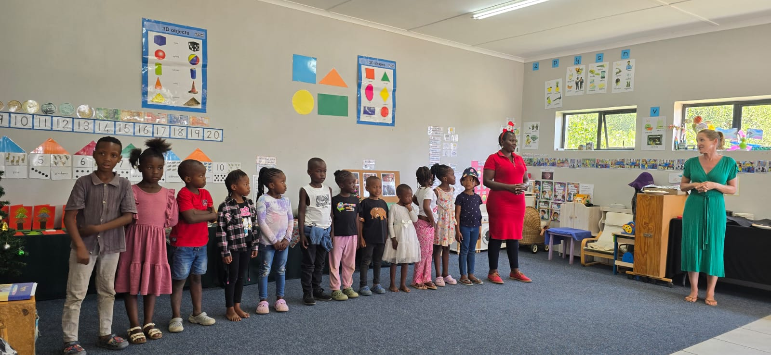

Our isiXhosa Grade R class.

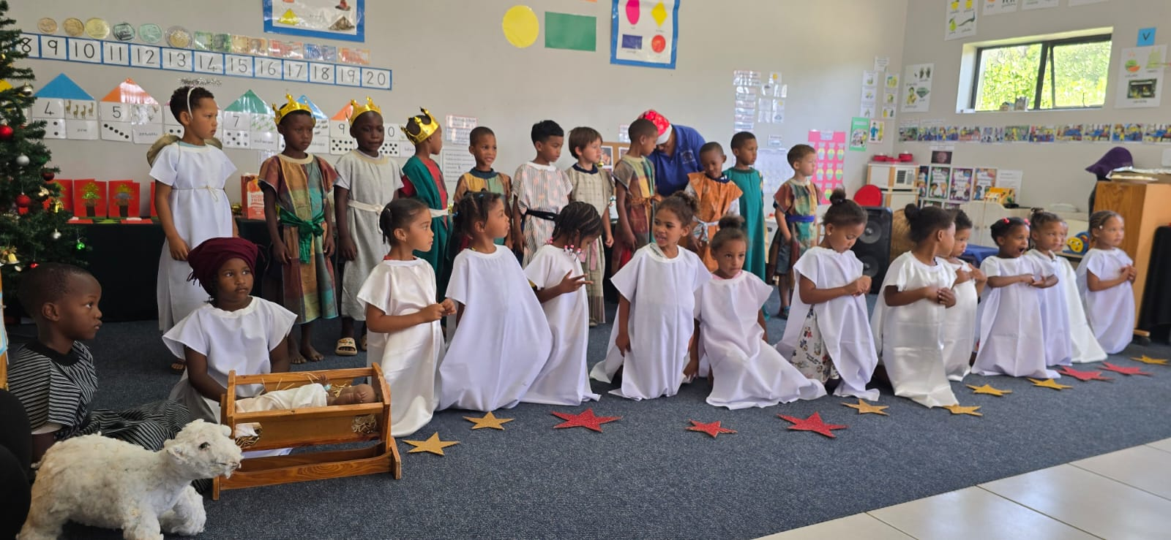

Our Afrikaans Grade R class.

Our last event for the year was our Christmas party for our children. We always make this a special occasion and a memorable day for our children. Santa Clause and his helpers came to visit us and handed out sweet packets.

We also had some sprayers running and our children enjoyed getting wet. We ended the day by handing out their Santa shoe boxes. This is one of their highlights off the year. We would like to say a special thank you to Laerskool Kleinmond for helping us with the Santa shoe boxes.

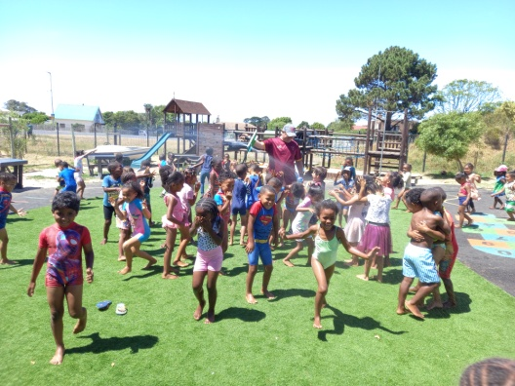
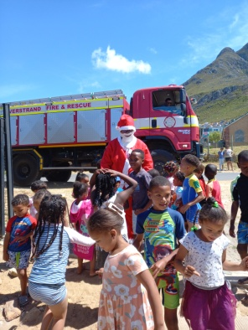
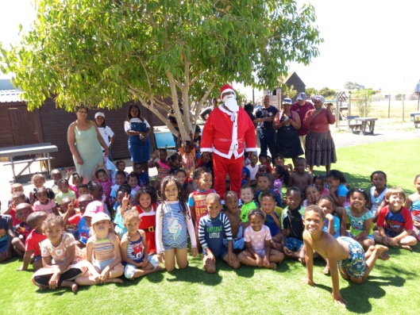

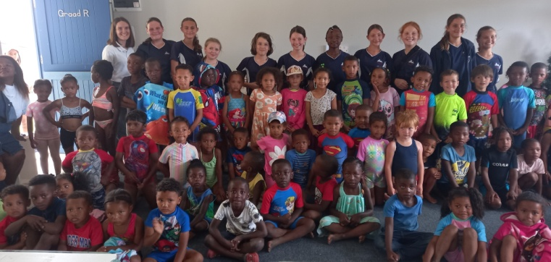
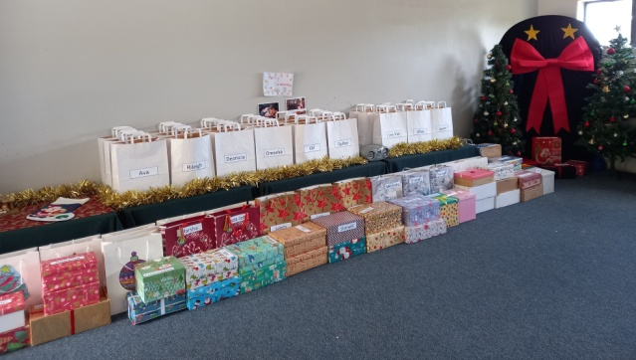

A big thank you to my dedicated staff for all the hard work they do every day. Without them all we do at the school will not be possible. I appreciate each and every one of them.

A Merry Christmas and a Happy New Year to all.

Season’s greetings,

Alta, the staff and children of Siyabulela Pre-Primary

Our wish list:
- Phase 2 of our Grade R playground (R285 400).
- New see saws for our other playground (R7 600).
- Aluminium window frames to replace the old wooden frames (R37 000).
- Puzzles and house corner furniture for our 3-5 year classes.
- Carpets for some classrooms.
- Shading for our ‘outside’ classroom (R15 000).
- Compost for our grass (R5 000).
- Small toilet for 3-4 year class.
- Second hand items for our shop (old bedding, towels, kitchenware,
clothes etc.)
- Mural for Grade R classrooms’ wall (still need R10 0000).
- Mud kitchen for outside play area (still need around R5 000).


Golf Day 2026 loading...

6 March.

